Supplementary Information

Role of Cystathionine Gamma-Lyase in Immediate Renal Impairment and Inflammatory Response in Acute Ischemic Kidney Injury

Lajos Markó^{1,2} MD, PhD, István Szijártó¹ MD, Milos R. Filipovic³ PhD, Mario Kaßmann¹ PhD, András Balogh^{1,2} MD, PhD, Joon-Keun Park⁴ PhD, Lukasz Przybyl¹ MSc, Gabriele N’diaye¹, Stephanie Krämer⁵ PhD, Juliane Anders¹, Isao Ishii⁶ PhD, Dominik N. Müller^{1,2,8} PhD, Maik Gollasch^{1,7,8} MD, PhD

¹Experimental and Clinical Research Center, a joint cooperation between the Charité Medical Faculty and the Max-Delbrück Center (MDC) for Molecular Medicine, Berlin, Germany
²Max-Delbrück Center (MDC) for Molecular Medicine, Berlin, Germany
³Friedrich-Alexander-University of Erlangen-Nürnberg, Department of Chemistry and Pharmacy, Erlangen, Germany
⁴Hannover Medical School, Hannover, Germany
⁵German Institute of Human Nutrition, Potsdam-Rehbrücke, Germany
⁶Department of Biochemistry, Graduate School of Pharmaceutical Sciences, Keio University, Tokyo, Japan
⁷Charité Campus Virchow, Nephrology/Intensive Care, Berlin, Germany;
⁸equal contribution as senior authors

The authors have declared that no conflict of interest exists.

Corresponding Authors:
Dr. Lajos Markó, Experimental and Clinical Research Center, Lindenberger Weg 80, 13125 Berlin, Germany, Tel: +49 30-450-540-558, Fax: +49 30-450-540-944, E-mail: lajosmarko@yahoo.com
Dr. Maik Gollasch, Experimental and Clinical Research Center, Lindenberger Weg 80, 13125 Berlin, Germany, Tel: +49 30-450-540-177, Fax: +49 30-450-553-916, E-mail: maik.gollasch@charite.de

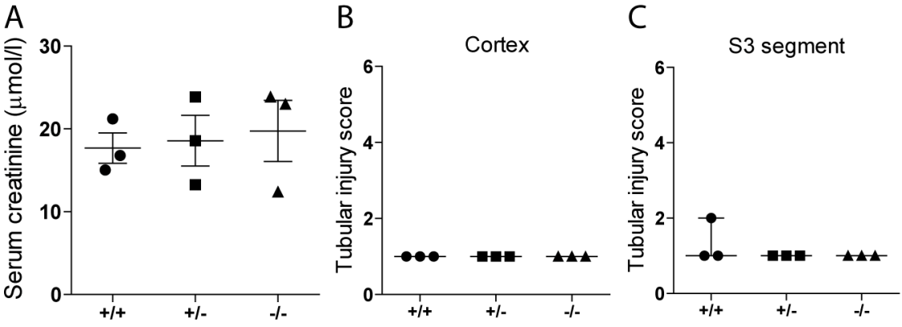
Supplementary Figure 1. (A) Serum creatinine levels in Cth^{+/+}, Cth^{+/-} and Cth^{-/-} mice 24 hours after sham surgery (n=3 in each group). (B) Semi-quantification of cortical and (C) S3 segment tubular injury in mice underwent sham surgery.

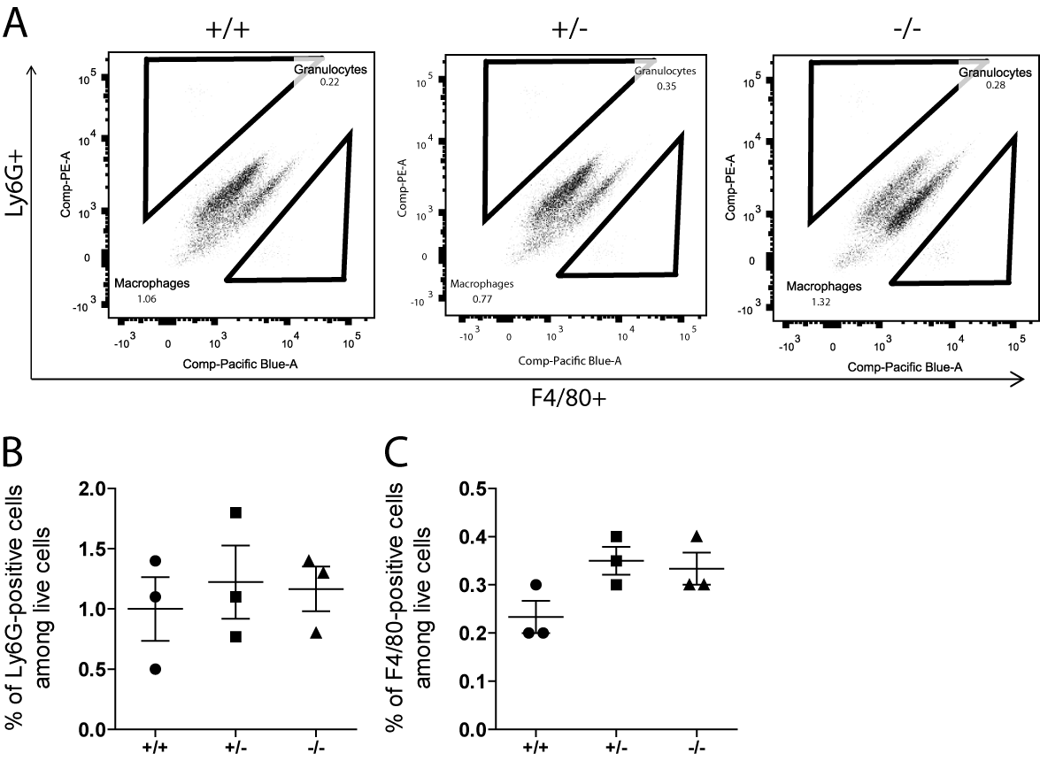
Supplementary Figure 2. Flow cytometric detection of immune cells in sham-operated mice. (A) Representative flow cytometry data of Ly6G-positive cells (granulocytes) and F4/80-positive cells (macrophages) in kidneys of Cth^{+/+}, Cth^{+/-} and Cth^{-/-} mice 24 hours after sham surgery. Quantification of infiltrating (B) Ly6G-positive cells and (C) F4/80-positive cells. Values plotted are mean ± SEM (n=3 in each group).

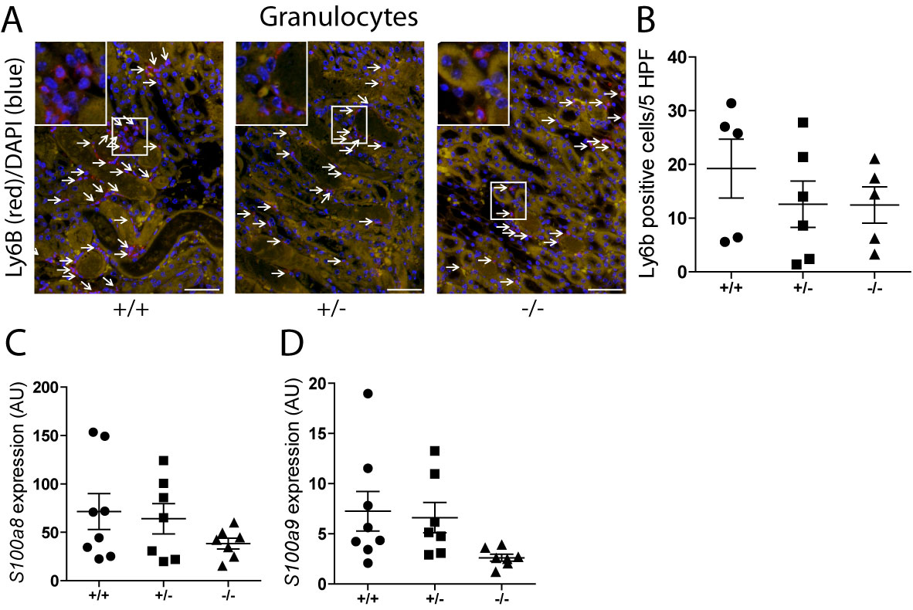
Supplementary Figure 3. Immunofluorescent detection of Ly6B-positive cell infiltration. (A) Immunofluorescent detection of Ly6B-positive cells (granulocytes) in ischemia/reperfusion (I/R)-injured kidneys of Cth^{+/+}, Cth^{+/-} and Cth^{-/-} mice (×200). (B) Quantification of Ly6B-positive cells. Values plotted are mean ± SEM (n=5 in each group). Gene expression levels of (C) S100a8 and (D) S100a9 in I/R-injured kidneys of Cth^{+/+}, Cth^{+/-} and Cth^{-/-} mice. Values plotted are mean ± SEM (n=8 in Cth^{+/+}, n=7 in Cth^{+/-} and n=8 in Cth^{-/-} group). P=0.28 and P=0.09 for main ANOVA for S100a8 and S100a9, respectively. AU, arbitrary units. HPF, high-power field.

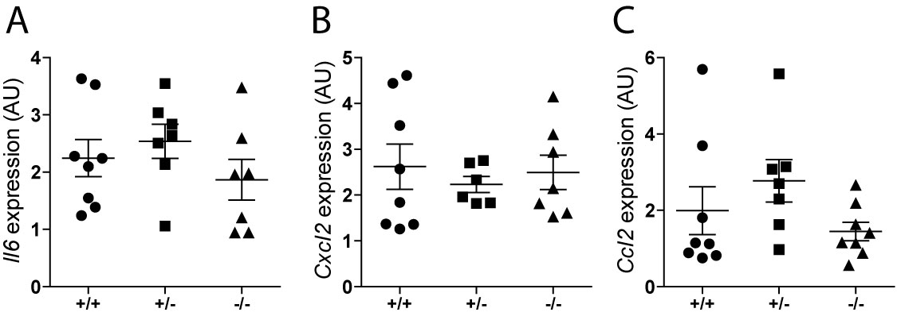
Supplementary Figure 4. Renal gene expression of cytokines and chemokines. Gene expression levels of (A) interleukin(Il)6, (B) chemokine (C-X-C motif) ligand (Cxcl)2 and (C) chemokine (C-C motif) ligand (Ccl)2 in ischemia/reperfusion-injured kidneys of Cth^{+/+}, Cth^{+/-} and Cth^{-/-} mice. Values plotted are mean ± SEM (n=8 in Cth^{+/+}, n=7 in Cth^{+/-} and n=8 Cth^{-/-} group). AU, arbitrary units.
Supplementary Table 1. Primer sequences used in quantitative real-time PCR.
Gene | Forward | Probe | Reverse
18s | 5'-ACATCCAAGGAAGGCAGCAG-3' | 5'-FAM-CGCGCAAATTACCCACTCCCGAC-TAMRA-3' | 5'-TTTTCGTCACTACCTCCCCG-3'
Cbs | 5'-GCAGCGCTGTGTGGTCATC-3' | - | 5'-CATCCATTTGTCACTCAGGAACTT-3'
Ccl2 | 5'-GGCTCAGCCAGATGCAGTTAA-3' | 5'-FAM-CCCCACTCACCTGCTGCTACTCATTCA-TAMRA-3' | 5'-CCTACTCATTGGGATCATCTTGCT-3'
Cth | 5'-GGCTTCCTGCCTAGTTTCCA-3' | 5'-FAM-CATTTCGCCACTCAGGCCATCCA-TAMRA-3' | 5'-TCCATTGCTCAGGCTCTTGTC-3'
Cxcl2 | 5'-GGGCGGTCAAAAAGTTTGC-3' | 5'-FAM-TTGACCCTGAAGCCCCCCTGGT-TAMRA-3' | 5'-TGTTCAGTATCTTTTGGATGATTTTCTG-3'
Havcr1 | 5'-CTGGAGTAATCACACTGAAGCAATC-3' | 5'-FAM-CTCCAGGGAAGCCGCAGAAAAACC-TAMRA-3' | 5'-GATGCCAACATAGAAGCCCTTAGT-3'
Il1b | 5'-AGAAGAGCCCATCCTCTGTGACTCATGG-3' | 5'-FAM-AGAAGAGCCCATCCTCTGTGACTCATGG-TAMRA-3' | 5'-CACACACCAGCAGGTTATCATCA-3'
Icam1 | 5'- CAGTCCGCTGTGCTTTGAGA-3' | 5'-FAM- CTGTGGCACCGTGCAGTCGTCC-TAMRA-3' | 5'- CGGAAACGAATACACGGTGAT -3'
Il6 | 5'- TGTCTCGAGCCCACCAGG-3' | 5'-FAM-CGAAAGTCAACTCCATCTGCCCTTCAGG-TAMRA-3' | 5'- TGCGGAGAGAAACTTCATAGCTG-3'
Lcn2 | 5'-TGATCCCTGCCCCATCTCT-3' | 5'-FAM-TCACTGTCCCCCTGCAGCCAGA-TAMRA-3' | 5'-GGAACTGATCGCTCCGGAA-3'
Mpst | 5'-CGCAGCTGGCCGTTTC-3' | - | 5'-TGTTTACTGAGCCAGGGATGTG-3'
S100a8 | 5'-TCACCATGCCCTCTACAAGA-3' | - | 5'-CCAATTCTCTGAACAAGTTTTCG-3'
S100a9 | 5'-TCAGACAAATGGTGGAAGCA-3' | - | 5'-GTCCAGGTCCTCCATGATGT-3'
Tnf | 5'-GGTCCCCAAAGGGATGAGAA-3' | 5'-FAM-TTCCCAAATGGCCTCCCTCTCATCA-TAMRA-3' | 5'-TGAGGGTCTGGGCCATAGAA-3'
Vcam1 | 5'- CTACAAGTCTACATCTCTCCCAGGAA-3' | 5’-FAM-ACAACGATCTCTGTACATCCCTCCACAAGG-TAMRA-3’ | 5'-CACAGCACCACCCTCTTGAA-3'

