Supplementary data:
Histopathology methods
The muscle biopsy of patient 1 (Figure 2A) was performed at the Neuromuscular Disease Center at the Tepecik Training and Research Hospital in İzmir, Turkey. The muscle biopsy sample of patient 3 was obtained at the Hacettepe University of Ankara, Turkey. Both muscle biopsies samples were frozen in isopentane cooled in liquid nitrogen and 8 to 12-micron cryosections from the biopsy material were prepared. Slides were stained with hematoxylin & eosin (HE), modified Gomori’s trichrome (Engel-Cunningham modification), oil red-O, Periodic Acid Shiff (PAS) and D-PAS, Congo red dyes.
Following histopathological analyses (Scoto et al., 2013; Wang et al., 2018) were carried out for both patients: Enzyme histochemical techniques consist of nicotinamide adenine dinucleotide tetrazolium reductase (NADH-TR), myophosphorylase, succinate dehydrogenase (SDH), Cytochrome oxidase (COX) and combined COX- SDH stains. Spectrin (Novocastra, UK, NCL-spec1), dystrophin N-terminus (Novocastra, UK, NCL-dys3), adhalin (Novocastra, UK, NCL-a-sarc), other sarcoglycans (beta, delta, gamma; Novocastra, UK, NCL-b-d-g-sarc), laminin alpha-2 chain (Novocastra, UK, NCL-merosin), myotilin (Novocastra, UK, NCL-myotilin), collagen VI (Novocastra, UK, NCL-COLL-VI), β-dystroglycan (Novocastra, UK, NCL-b-DG), HLA Class 1 (Novocastra, UK, NCL-HLA-ABC), NCAM (ThermoScientific, CA, USA, CD56), nitric oxide Synthase-1 (Novocastra, UK, NCL-NAS-1), emerin (Novocastra, UK, NCL-emerin), caveolin 3 (Navus Biologicals, CA, USA, NB110-5029), calpain 3 (Abcam, Cambridge, UK, ab103250), desmin (1:50; NCL-Des, Novocastra) and dysferlin (Novocastra, UK, NCL-Hamlet-2) antibodies were used for immunohistochemistry. Myosin heavy chain fast and slow (Novocastra, UK, NCL-MHCf/ MHCs) antibodies were used for discriminating of fiber type and myosin heavy chain (Novocastra, UK, NCL-MHCn) antibody was used for identification of immature fibers.
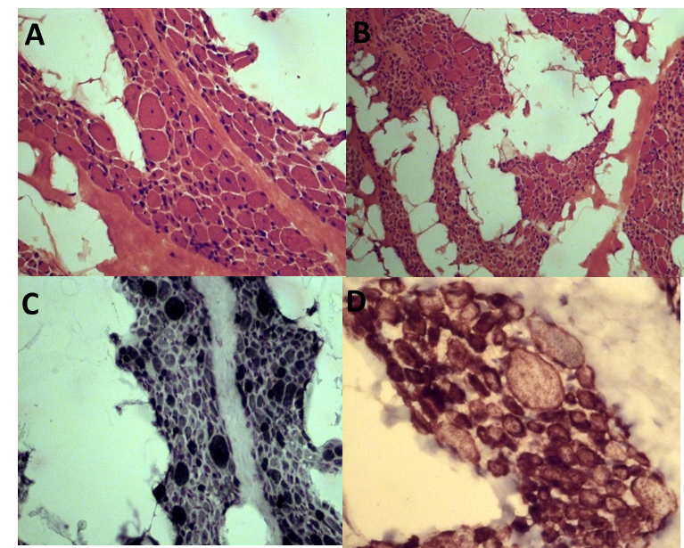
Supplementary Fig. 1:
Muscle biopsy of P3 (A-D) (A,B) showing large fiber size variability, severe fatty infiltration in the perimysium, variation in fiber size with a predominance of atrophic fibers, and internal nuclei in most fibers. A mild increase in endomysial connective tissue is also present (H&E staining). (C) ATPase stain (pH9,4) reveals atrophic fibers being of type 1. (D) Desmin stain showing irregular aggregates in many atrophic fibers. (A: original magnification x20, B-D: original magnification x40).

Interpretation of the muscle biopsy from P3 above:
Muscle biopsy revealed prominent interstitial fatty infiltration and marked variation in fiber size. Fascicles were composed of mainly atrophic and few normotrophic fibers. Internal nuclei, multiple in some fibers, was another striking feature (Fig A-B). Mild endomysial fibrosis and occasional degenerating fibers were also detected. Myofibrillar architecture was normal by oxidative enzyme stains, core-like areas were not present. There was type 1 fiber predominance with atrophic fibers being type 1 (Fig C). Immunohistochemical staining with desmin showed intense irregular staining, mainly in atrophic fibers (Fig D).

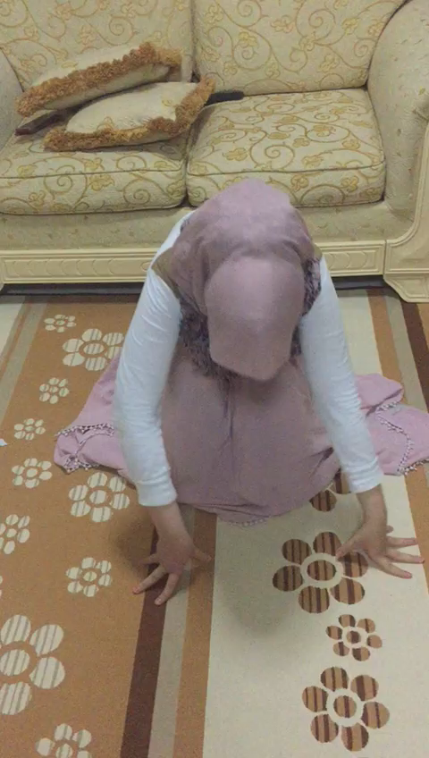
Supplementary Video 1: Patient 1 is seen, how she tries to stand up, and the proximal weakness implicating Gower´s sign.

- Genomic analysis
After Whole Exome Sequencing (WES) we filtered the data of patient 1 and patient 3 for rare, homozygous, or heterozygous variants. Found variants were listed in Supplementary Table 2-3 for patient 1 and Supplementary Table 4-5 for patient 3. All variants were checked on different databases like gnomAD 2.0 (http://gnomad.broadinstitute.org/gene/), or GME (http://igm.ucsd.edu/gme/data-browser.php). Variants were also checked if they have been reported before in ClinVar (https://www.ncbi.nlm.nih.gov/clinvar/), and for pathogenicity in following prediction tools: SIFT, PPH2, GERP++, and CADDV1.4 by using wANNOVAR (http://wannovar.wglab.org) and Mutpred (http://mutpred.mutdb.org/) (Supplementary Table 2-5). These findings of the variants lead us to the classification by the ACMG criteria and guidelines for the Mendelian diseases (Richards et al., 2015). Non-Mendelian variants were separately checked and excluded as shown in Supplementary Table 2-5. The resulting scores for each variant were shown in Supplementary Table 2-5 and associated Supplementary Table 1 for the evaluation of the variants. (Definitions for Tables: NA=Not available, VUS= Variant of Undetermined Significance).

  - Haplotype analysis
For haplotype analysis of the mutation NM_024854.3:c.464A>G (chr12:21452130) on chromosome12 at cytoband number p12.1 we used different markers. First, we used microsatellites with fluorescent-tagged forward primers for DS12S1654 (HEX), DS12S1945 (6-FAM, not informative, data not shown), and additional microsatellites created by using the repeat masker software for SCM3 (6-FAM) and SCM4 (HEX). The primers and genomic positions were listed in the Supplementary Table 6. Polymerase chain reactions (PCR) were done by using Mytaq DNA Polymerase (Bioline, London, UK) on the Veriti cycler (Applied Biosystems). The PCR products were diluted (1:40 to 1:200) and genotyped on the ABI 3730XL Sequencer (Applied Biosystems). Genemarker Software (Gene Marker Version 1.51) was used for fragment data analysis. Secondly, we also used Single Nucleotide Polymorphisms (SNP`s): IAPP (Islet Amyloid Polypeptide) and ABCC9 (ATP-binding cassette, sub-family C (CFTR/MRP), member 9) were selected from the exome data of the index cases, and additional ones as following: rs7957200, rs2058464, rs11046076, rs10161132 and rs2417991 all listed in Supplementary Table 7. The genotyping of the SNP`s was performed by dideoxy-sequencing for all family members (Supplementary Table 7, Supplementary Fig. 2-6), by using Mytag DNA Polymerase (Bioline, London, UK) on the Veriti cycler (Applied Biosystems). Detailed PCR conditions were given in Supplement Table 8. The haplotype reconstruction was performed manually and visualized by Haplopainter (http://haplopainter.sourceforge.net/) for both families (Figure 3) for all data from the microsatellites and the SNP`s (Supplementary Table 6 and 7).

- Systematic literature survey and statistical analyses
First, we checked all publications about PYROXD1 reported in Pubmed (https://www.ncbi.nlm.nih.gov/pubmed/) and found for publications (Lornage et al., 2019; O'Grady et al., 2016; Saha et al., 2018; Sainio et al., 2019). All published patients were listed in Table 1 with all pheno- and genotype informations. In total, with the here reported three patients, we summarized 23 patients. We have performed a descriptive statistical analysis for all the 23 PYROXD1 patients (Table 3). The younger brother of P1 from Lornage et al., 2019 study was excluded from our statistical analysis (Lornage et al., 2019), who has been deceased, having the same genotype as the older brother (P2) but without detailed information’s on the patient. Additionally, all details on reported muscle biopsy results for the patients (14/23) were summarized in Table 2, and also included in the statistical analysis. Here, 14 out of the 23 patients were included and the percentage (%) for each aspect in the muscle biopsies was calculated.

Tool | highly pathogenic | pathogenic/probably damaging | likely pathogenic/possible damaging | likely benign/benign | benign/ unknown /VUS
SIFT rankscore |  | >0.5
PPH2 rankscore |  | >0.5
CADD phred | >30 | >20 | 15-20 | <15 | <10
GERD ++  rankscore |  | >0.5
Mutpred2 |  | >0.5
ACMG criterias and classification[5] |  | 1 very strong (PVS1) and 1 strong (PS1-PS4) or  2 strong or 1 strong and 3 moderate (PM1-PM6) | 1 very strong and 1 moderate or 1 strong and 1 moderate or 1 strong and 2 supporting (PP1-PP5) | 1 strong (BSA-BS4) and 1 supporting (BP1-BP7) or 2 supporting | 1 stand-alone (BA1) or 2 strong
Supplementary Table 1: Scores and interpretation of the used prediction tools and for the ACMG criteria (VUS= variant of uncertain significance).

Supplementary Table 2: Rare homozygous variants for patient 1 (1:II-2).
Chr:position  (Human GRCh37/hg19) | Gene (OMIM) | RefSeq | GERP | SIFT | PPH | CADD | ExAc/ 1000g | MutPred | Clinvar | gnomAD (Allele frequency) | ACMG Criteria (classification) | Exclusion criteria
6:30995080 | MUC22 (* 613917) | c.1872G>C, p.E624D, NM_001198815.1 | 0.09 | 0.40524 | 0.806 | 0.182 | NA | 0.042 | NA | 0.0001049 | NA | Benign
12:70954546 | PTPRB (* 176882) | c.3413G>A, p.R1138Q, NM_001206972.1 | 0.53 | 0.15075 | 0.347 | 23 | NA | 0.345 | NA | NA | NA | Benign
1:33430102 | RNF19B (* 610872) | c.185A>C, p.Q62P, NM_153341.2 | 0.1 | 0.29918 | 0.454 | 6.34 | NA | 0.125 | NA | NA | NA | Benign
9:111929420 | FRRS1L (* 604574) | c.151_152delCGinsGC, p.R51A, NM_014334.2 | NA | 0.11 | NA | NA | NA | NA | 476298 (Benign) |  | BA1, BP4, BP6 | Benign
  1.000
19:18544505 | SSBP4 (* 607391) | c.955-15G>C, NM_004977.2 | NA | NA | NA | NA | NA | NA | NA |  | BA1, BS1 | Benign
  1.000
19:50832152 | KCNC3 (* 176264) | c.188A>G, p.D63G, NM_138693.2 | 0.161 | 0.52 | 0.523 | 8.62 | 2/0 hom | 0.186 | 193297 (Benign) | 0.9891 | BA1, BS1, BS2 | Benign
7:130418720 | KLF14 (* 609393) | c.141T>G, p.H47Q, NM_024854.3 | NA | 0.74 | 0.998 | NA | 9/0 het.1090/2504 hom | 0.063 | NA | 0.9994 | NA | Benign
12:21605064 | PYROXD1 (* 617220) | c.464A>G, p.N155S, NM_001256947.1 | 0.62 | 0.91219 | 0.970 | 26.5 | 7/0 het | 0.76 | 372281 (Pathogenic) | 0.00004624 | PS3, PS4, PM5, PP3 Pathogenic) | None
7:150783921 | AGAP3 (* 616813) | c.93_94delCTins(G)2, p.C32G, NM_031946.4 | NA | 0.71 | NA | 0.002 | NA | NA | NA | NA |  | Benign
First, we filtered for homozygous variants based on the consanguineous parents. In total, we found 9 homozygous variants in patient 1 but only one variant classified as pathogenic by the used prediction tools and databases, the others one classified as benign. The ACMG criteria were used to classify all found variants. The only pathogenic variant left was PYROXD1 known to be the disease-causing gene for congenital myopathy in early or adult age (O'Grady et al., 2016; Saha et al., 2018; Sainio et al., 2019). All of the tools, GERP, CADD, and Mutpred indicate a pathogenic variant in this gene. This variant was proofed by Sanger Sequencing for patient 1 and 2, and parents. (NA = not available, VUS = variant of uncertain significance).

Supplementary Table 3: Compound heterozygous variants in patient 1(1:II-2).
Chr:Region (Human GRCh37/hg19) | Gene (OMIM) | RefSeq | GERP++ | SIFT rankscore | PPH2 score | CADD phred | ExAc/ 1000G | Mutpred 2 | ClinVar (ID) | gnomAD (AF) | ACMG | Classification
20-239781 | DEFB132 (NA) | NM_207469.2: c.122G>C, p.Trp41Ser | 0.020 | 0.336 | 0.026 | 2.11 | 15/3 het | 0.132 | NA | 0.0001379 | NA | Low prediction scores and high AF. (Benign)
20-239867 | DEFB132 (NA) | NM_207469.2: c.208C>T, p.Leu70Phe | 0.122 | 0.296 | 0.254 | 0.86 | 12/3 het | 0.035 | NA | 0.0001202 | NA | Low prediction scores and high AF. (Benign)
10- 5789145 | FAM208B (NA) | NM_017782.4: c.3761C>T, p.Ala1254Val | 0.306 | 0.598 | 0.147 | 11.18 | 4/0 het | 0.059 | NA | 0.00002853 | NA | Really low CADD-scores.
10- 5790738 | FAM208B (NA) | NM_017782.4: c.5354G>A, p.Cys1785Tyr | 0.334 | 0.242 | 0.200 | 3.63 | 242/5 het, 1/0 hom | 0.217 | NA | 0.002090 | NA | Low CADD-scores and hom. Mutation found in 1000G-project
11-6652006 | DCHS1 (* 603057) | NM_003737.3: c.4019C>T, p.Thr1340Ile | 0.710 | 0.214 | 0.464 | 12.58 | NA | 0.31 | NA | NA | NA | Phenotype did not fit.
11-6652040 | DCHS1 (* 603057) | NM_003737.3: c.3985C>T, p.Pro1329Ser | 0.367 | 0.089 | 0.012 | 12.10 | NA | 0.104 | NA | NA | NA | Phenotype did not fit.
1-47725974 | STIL (* 181590) | NM_003035.2: c.3064G>T, p.Val1022Leu | 0.467 | 0.506 | 0.875 | 24.5 | 13/4 het, 1/0 hom | 0.237 | VUS | 0.00009557 | NA | Phenotype did not fit.
1-47746485 | STIL (* 181590) | NM_003035.2: c.1645G>A, p.Glu549Lys | 0.357 | 0.223 | 0.063 | 14.21 | NA | 0.097 | NA | 0.00002829 | NA | Phenotype did not fit.
3- 54958975 | LRTM1 (NA) | NM_020678.3: c.1013_1014delAG, p.Glu338Alafs*3 | NA | NA | NA | NA | NA | N/A | NA | NA | NA | No scores and unknown variant.
3- 54958975 | LRTM1 (NA) | NM_020678.3: c.275G>C, p.Gly92Ala | 0.070 | 0.178 | 0.103 | 0.001 | 189/2het 1/0 hom | 0.1 | NA | NA | NA | AF is too high and low scores in all prediction tools.
6- 25917035 | SLC17A2 (* 611049) | NM_005835.3: c.808G>C, p.Val270Leu | 0.185 | 0.009 | 0.092 | 0.045 | 154/6 het | 0.289 | NA | 0.001389 | BP4 (benign) | Benign
6- 25917225 | SLC17A2 (* 611049) | NM_005835.3: c.740A>G, p.Glu247Gly | 0.574 | 0.720 | 0.560 | 26.0 | 154/6 het | 0.199 | NA | 0.001389 | BP4 (benign) | Benign
1-120459203 | NOTCH2 (*618026) | NM_024408.3: c.6142G>C, p.Asp2048His | 0.896 | 0.912 | 0.818 | 27.5 | NA | 0.821 | NA | NA | NA | High scores, but no phenotype associated.
1-120468285 | NOTCH2 (*618026) | NM_024408.3: c.4154A>G, p.His1385Arg | 0.961 | 0.332 | 0.197 | 20.7 | NA | 0.434 | NA | NA | NA | Non-pathogenic scores. No phenotype associated.
14-70990410 | ADAM20 (*603712) | NM_003814.4: c.1215G>C, p.Gln405His | 0.006 | 0.324 | 0.063 | 0.006 | 3/1 het | 0.428 | NA | 0.00002481 | NA | benign
14-70990595 | ADAM20 (*603712) | NM_003814.4: c.1030G>A, p.Asp344Asn | 0.550 | 0.485 | 0.715 | 24.8 | 35/9 het | 0.783 | NA | 0.00003340 | NA | High scores, but to many heterozygous cases found in databases.
17-78318686 | RNF213 (*613768) | NM_001256071.2: c.6551A>G, p.Gln2184Arg | 0.112 | 0.028 | 0.026 | 0.005 | 285/8 het 1/0 hom | 0.452 | NA | 0.002464 | BP4 (VUS) | Benign
17-78234664 | RNF213 (*613768) | NM_001256071.2: c.7861G>A, p.Ala2621Thr | 0.422 | 0.362 | 0.166 | 20.30 | NA | 0.218 | NA | NA | BP6 (VUS) | Benign
2-179396782 | TTN (*188840) | NM_001267550.2: c.104560G>C, p.Val34854Leu | 0.579 | 0.564 | 0.197 | 19.49 | 597/12 het 1/0 hom | NA | Conflicting interpretations of pathogenicity (47674) | NA | PP3, BP6 (VUS) | VUS
2-179403946 | TTN (*188840) | NM_001267550.2: c.98716G>A, p.Val32906Ile | 0.288 | 0.129 | 0.079 | 16.09 | 88/0 het | NA | Conflicting interpretations of pathogenicity (196643) | NA | PM2, BP6 (VUS) | VUS
2-179486037 | TTN (*188840) | NM_001267550.2: c.45408G>T, p.Lys15136Asn | 0.377 | 0.490 | 0.616 | 22.3 | 548/11 het 1/0 hom | NA | Conflicting interpretations of pathogenicity (46988) | NA | PS3, PM2, PP3 (likely pathogenic) | Excluded by Dideoxy sequencing, lack of co-segregation
2-179639837 | TTN (*188840) | NM_001267550.2: c.6601C>T, p.Pro2201Ser | 0.785 | 0.598 | 0.970 | 21.8 | 1/0 het | NA | NA | NA | PS4, PM2, PP3 (likely pathogenic) | Excluded by Dideoxy sequencing, lack of co-segregation
Secondly, we filtered for compound heterozygous variants in patient 2, despite the consanguineous parents. Based on this analyzed data, we defined one of them as likely pathogenic TTN (Titin), which is one of the largest known genes, is associated with congenital myopathy. This was analyzed by using dideoxy sequencing for the TTN variants (data not shown) but excluded by no co-segregation. This proofed to us, that PYROXD1 is the pathogenic and disease-causing variant in this patient (Supplementary Table 3).
(OMIM=Online Mendelian Inheritance in Man (https://www.omim.org/about), ClinVar ID = unique Identifier, NA = not available, VUS = variant of uncertain significance, AF=Allele frequency)

Supplementary Table 4: Rare homozygous variants for patient 3.
Chr:position  (Human GRCh37/hg19) | Gene (#OMIM) | RefSeq | GERP++ | SIFT | PPH2 | CADD | ExAc/1000G | MutPred 2 | ClinVar (ID) | gnomAD  AF (SNP) | ACMG criteria (classification) | Exclusion criteria
1:2255550 | MORN1 | NM_024848: c.1283C>T, p.A428V | 0.077 | 0.27 | 0.452 | 7.81 | 5/0 het | 0.156 | NA | 0.0001885 | NA | Low prediction scores. (Benign)
1:2267935 | MORN1 | NM_024848: c.1223C>T, p.T408M | 0.214 | 0.06 | 0.985 | 17.83 | 14/0 het | 0.175 | NA | 0.00006468 | NA | Low prediction scores.(Benign)
1:152681693 | LCE4A (*612618) | NM_178356: c.142_147delTGTGGT | 0.252 | NA | NA | NA | NA | N/A | NA | 0.00003235 | NA | Low prediction scores. No associated phenotype (Benign)
1:152681717 | LCE4A (*612618) | NM_178356: c.166G>T, p.G56C | 0.775 | NA | NA | NA | NA | 0.276 | NA | NA | NA | Low prediction scores. No associated phenotype (Benign)
1:155030589 | ADAM15 (*605548) | NM_207197: c.1679G>A, p.C560Y | 0.769 | 0.784 | 0.970 | 11.5 | 1/0 het | 0.276 | NA | NA | NA | Low CADD and Mutpred2-score.
1:155033921 | ADAM15 (*605548) | NM_207197: c.2308C>T, p.P770S | NA | 0.681 | 0.898 | 28.1 | 3/0 het | 0.919 | NA | 0.0005785  (rs199706846) | NA | SNP, high AF, even 1 hom. Case in gnomAD
2:85662149 | SH2D6 (NA) | NM_198482: c.71A>C, p.H24P | 0.056 | 0.32 | 0.204 | 0.002 | 26/0 het | 0.287 | NA | NA | NA | Low prediction scores. (Benign)
2:85662154 | SH2D6 (NA) | NM_198482: c.76A>C, p.T26P | 0.099 | 0.4 | 0.183 | 0.054 | 21/0 het | 0.119 | NA | NA | NA | Low prediction scores (Benign)
2:140995759 | LRP1B (*608766) | NM_018557.2: c.13522G>A, p.G4508S | 0.221 | 0.23 | 0.278 | 2.5 | 2/0 het | 0.933 | NA | 0.00002065  (rs758586821) | NA | Low prediction scores (Benign)
2:141459716 | LRP1B (*608766) | NM_018557.2: c.6296C>T, p.S2099F | 0.813 | 0.07 | 0.985 | 26.4 | NA | 0.158 | NA |  | NA | Mutpred2 low, no associated phenotype.
  0.00003233
2:168106060 | XIRP2 (NA) | NM_001199144.1: c.7492C>T, p.H2498Y, | 0.338 | 0.316 | 0.039 | 0.173 | 9/0 het | 0.988 | NA | 0.00006940  (rs369448394) | NA | Prediction scores too low, AF high.SNP (Benign)
2:168115199 | XIRP2 (NA) | NM_001199145.1: c.1477G>T, p.V493F, | 0.593 | 0.150 | 0.326 | 1.184 | NA | 0.035 | NA | 0.00002025 | NA | Prediction score too low.(Benign)
2:179455631 | TTN | NM_001267550.1: c.60821C>T, p.P11401L, | 0.991 | 0.598 | 0.636 | 17.65 | 435/15 het. 9/0 hom | 0.606 | NA | NA | PP2, PP3 | VUS
2:179603991 | TTN | NM_001267550.1: c.13969A>C, p.N4294H, | 0.63 | 0.379 | 0.483 | 16.00 | 352/15 het. 7/0 hom | 0.352 | NA | NA | PP2, BP4 | VUS
3:52412645 | DNAH1 (*60332) | NM_015512.4:c.7226C>T, p.T2409M, | 0.071 | 0.23 | 0.260 | 15.85 | 2/0 het | 0.05 | NA | NA | NA | Phenotype did not fit.
3:52420842 | DNAH1 (*603332) | NM_015512.4c.8976C>G, p.F2992L, | 0.378 | 0.23 | 0.366 | 22.8 | NA | 0.846 | NA | 0.00003100 (rs372111356) | NA | Phenotype did not fit.
12:21602540 | PYROXD1 (*612720) | NM_024854.3c.329_332del(TCTG) p.L112Vfs*8, | NA | NA | NA | NA | N/A | NA | NA | NA | PS4, PM4, PM2, PP2 (likely pathogenic) | none
12:21605064 | PYROXD1 (*612720) | NM_024854.3c.464A>G, p.N155S, | 0.62 | 0.74 | 0.967 | 26.5 |  | 0.760 | Pathogenic (359188) | (rs781565158) | PS3, PS4, PM2, PM5, PP2, PP3, PP5 (pathogenic) | none
  0.00004624
We filtered for compound heterozygous variants in patient 3 based on the consanguineous background. After the classification by the prediction tools, we have one gene with two variants to be pathogenic. PYROXD1, which is a known gene causing congenital myopathy, with early and adult onset phenotype published with similar phenotype to patient 3 (O'Grady et al., 2016; Saha et al., 2018; Sainio et al., 2019). Our patient here, has a known variant c.464A>G, p.Asn166Ser and a second, novel frameshift mutation c.329_332delTCTG, p.L112Vfs*8. Both variants were confirmed by co-segregation (Figure 2). Another interesting gene is TTN, which is classified as VUS, and known to be the cause of congenital myopathy, but excluded as the disease-causing gene here by to many reported cases in the ExAc databases. (OMIM= Online Mendelian Inheritance in Man (https://www.omim.org/about)AF=Allele frequency, ClinVar ID= unique identifier, NA = not available, VUS = variant of uncertain significance, SNP=Single Nucleotide Polymorphism)

Supplementary Table 5: Heterozygous variants in patient 3 (2:II-1).
Chr:position  (Human GRCh37/hg19) | Gene (OMIM) | RefSeq | GERP++ | SIFT | PPH2 | CADD  phred | ExAc/1000G | MutPred2 | ClinVar | gnomAD (AF, SNP) | ACMG  Criteria (classification) | Exclusion criteria
7:150783919 | AGAP3 (*616813) | NM_001042535.1: c.91insG,p.V31Gfs*99 | NA | NA | NA | NA | NA | 0.467 | NA | NA | NA | Benign
5:72743300 | FOXD1 (*601091) | NM_004472.2: c.888_889insGC, p.R297Afs*170 | NA | NA | NA | NA | 0/81 het, 1/2423 homa | 0.156 | NA | NA | NA | Benign
6:32487309 | HLA-DRB5 (*604776) | NM_002125.3: c.490A>T, p.S164C | 0.418 | 0.01 | 0.02 | 0.006 | NA | 0.494 | NA | 0.000005186 | NA | Benign
10:17659149 | PTPLA (NA) | NM_014241.3: c.190G>T, p.E64* | NA | NA | NA | NA | NA | 0.678 | NA | 0.09929 | NA | High AF. (Benign)
14:23299135 | MRPL52 (*611856) | NM_178336.2: c.14G>C, p.G5A | 0.076 | 0.427 | 0.322 | 7.07 | NA | 0.101 | NA | NA | NA | Benign.
11:134151975 | GLB1L3 (NA) | NM_001080407.2: c.488G>A, p.R163H | 0.504 | 0.01 | 0.013 | 18.45 | 2/0 het | 0.789 | NA | 0.000009202 | NA | Low prediction scores.Benign.
17:33680840 | SLFN11 (*614953) | NM_152270.3: c.1437A>T,p.Q479H | NA | NA | NA | NA | NA | 0.164 | NA | NA | NA | Benign.
17:16470993 | ZNF287 (NA) | NM_020653.2: c.53T>G, p.L18R | 0.208 | 0.408 | 0.063 | 11.27 | 236/21 het, 3/0 hom | 0.320 | NA | 0.001652 | NA | Benign.
6:46108822 | ENPP4 (*617000) | NM_014936.4: c.860G>A, p.R51G | 0.991 | 0.614 | 0.916 | 24.6 | NA | 0.754 | NA | NA | NA | No associated phenotype.
1:33430102 | RNF19B (NA) | NM_153341.2: c.185A>C, p.Q62P | 0.15 | 0.04 | 0.013 | 6.43 | NA | 0.125 | NA |  | NA | AF too high. Benign.
  1.000
20:45317777 | TP53RK (*608679) | NM_033550.3: c.277C>T, p.R93C | 0.407 | 0.784 | 0.693 | 33 | NA | 0.495 | NA | 0.00007253 | NA | Phenotype did not fit.
6:131904935 | ARG1 (*608313) | NM_000045.3: c.856C>A, p.P286T | 0.362 | 0.384 | 0.261 | 17.34 | 4/1 het | 0.237 | NA | NA | NA | Phenotype did not fit. Low scores.
6:144769802 | UTRN (*128240) | NM_007124.2: c.1969C>A, p.R657S | 0.454 | 0.04 | 0.04 | 19.51 | NA | 0.09 | NA | NA | NA | Low scores. Benign.
15:32322802 | CHRNA7 (*118511) | NM_000746.5: c.5G>A, p.R2H | 0.0360 | 0.527 | 0.063 | 23.4 | 71/8 het | 0.268 | NA | 0.001056 | NA | Phenotype did not fit. Low scores
6:41900137 | BYSL (*603871) | NM_004053.3: c.1007G>T, p.G336V | 0.784 | 0.912 | 0.971 | 32 | NA | 0.87 | NA | NA | NA | No associated phenotype, VUS
Secondly, we filtered for homozygous variants for patient 3. The homozygous variants for patient 3 (2:II-1) show no pathogenic/ likely pathogenic variants. One gene showed the highest prediction scores, BYSL (Bystin), which is required for processing of 20S pre-rRNA precursor and the 40S ribosomal subunits. It is also known that it is required for trophinin-dependent regulation of cell adhesion during implantation of human embryos. It is evolutionary conserved and has a role in growing cells, found by overexpressed bystin in cancer cells (Miyoshi, Okajima, Matsuda, Fukuda, & Nadano, 2007). Another interesting study tries to define BYSL as an early biomarker for severe hypoxic-ischemic changes in the neuropathological examination of forensic cases, but more time is required (Olczak et al., 2018). No known phenotype was associated with this gene yet, and we consider this variant of unknown significance. (OMIM=Online Mendelian Inheritance in Man (https://www.omim.org/about), ClinVar ID = unique Identifier, NA = not available, VUS = variant of uncertain significance, AF=Allele frequency).

Supplementary Table 6: Fluorescent labeled microsatellites used for haplotype analysis.

Microsatellites | Sequences | Fluorescence Label at 5`prime | Size (bp) | Coordinates (GRCh37/hg19)
DS121654_F | AGCTCATTTTACCTTGGAA | HEX | 185 | chr12:21569156-21569340
DS121654_R | GCGAGTGATTTATTGTCTTT |  | 185 | chr12:21569156-21569340
DS121945_F | CATGTGCTGCATGAAGAGCT | 6-FAM | 350 | chr12:21689532-21689881
DS121945_R | AAGCTGCATAAATAGTAAGCAAAGG |  | 350 | chr12:21689532-21689881
SCM3_F | CACCCTTCTCTGCTCTCCAA | 6-FAM | 245 | chr12:21661778-21661981
SCM3_R | TGTTACAGTCACCCCACAGT |  | 245 | chr12:21661778-21661981
SCM4_F | TAGTGGTAGGTAGGTCGGTC | HEX | 204 | chr12:21661778-21661981
SCM4_R | CCTGCTCAAAATCTCCCATAGT |  | 204 | chr12:21661778-21661981
The name, sequence, used fluorescence label at 5`primer, the size of the PCR product in base pairs (bp), and the coordinates on the human genome (GRCh37/hg19).

Supplementary Table 7: Single Nucleotide Polymorphism (SNP) variation
SNP | (GRCh38/hg38) | Forward Primer | Reverse Primer | Size (bp)
rs7957200 | 12:21433265T>C | CCTCCAGCTCCATCCATGTC | GCCTCATTCAGCGACGTCAT | 283
rs2058464 | 12:21437687T>C | ATGAGTAGTGTGAGCTCCCG | GACCACCACGAACTTCCCT | 195
rs11046076 | 12:21471375A>T | TGCGCAGTAATTCTTAACACATT | TCTGGAGAAGATTATTGCACACT | 296
rs10161132 | 12:21474353A>G | TGAGACTCTACTGGCCTTTGG | GCTCAGTAACGTGCCACCTT | 298
rs2417991 | 12:21506683C>A | GCGAGAGAGCTTTTCAGGAGG | ACAGGTACCCAACATTGCAGG | 230
The Single Nucleotide Polymorphism (SNP) coordinates on the human genome (GRCh37/hg19), the forward and reverse primer sequence, and the size of the PCR product in base pairs (bp).

Supplementary Table 8: PCR materials and conditions.
Temperature (°C) | Time (seconds) | cycles
95 | 360 | 1x
95 | 30 | 30x
60 | 45 | 30x
72 | 45 | 30x
72 | 6000 | 1x

A
B
Materials | Amount
DANN | 15-20ng
FW-Primer (10µM) | 0.5µl
RV-Primer (10µM) | 0.5µl
Mytag polymerase (500U) | 0.15µl
Mytag Buffer (5x) | 5µl
dH2O | up to 25µl

- Represents used materials for the Polymerase chain reaction (PCR) and the amount in ng for DNA samples, and 0.5µl of each primer (10µM), 0.15µl of the Mytag polymerase (500 Units), 5µl Buffer and up to 25µl nuclease-free water. (B) Representing the PCR condition: temperature [°C], time [s] and the cycles.

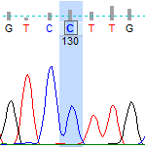
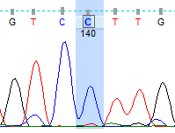
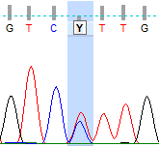
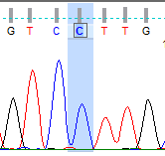
Family 1
Family 2

I:1
I:2
I:1
I:2

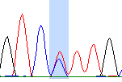
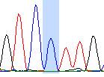

II:1

II:6
II:2
II:1
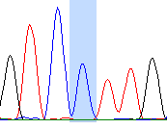

Supplementary Fig. 2: Dideoxy sequencing analysis for the following SNP: rs7957200 in both families. Healthy siblings of Family 1 not shown. Analysis shown change T/C in the fathers (heterozygous) and the index patients and both mothers were homozygous.

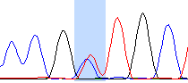
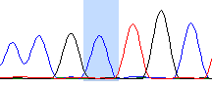
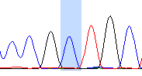
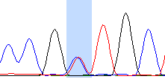

I:1
I:2
I:1
I:2

II:6
II:2
II:1
II:1

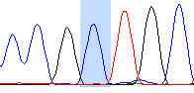
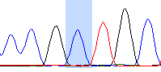
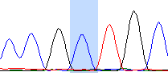

Supplementary Fig. 3: Dideoxy sequencing analysis for the following SNP: rs2058464 in both families. Healthy siblings of Family 1 not shown. Analysis shown change T/C in the fathers (heterozygous) and the index patients and both mothers were homozygous.

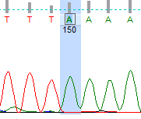
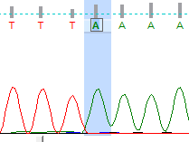
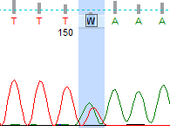
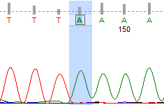
Family 1
Family 2
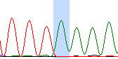
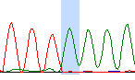
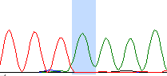

I:1
II:2
II:1
I:2
I:2
I:1

II:1
II:6

Supplementary Fig. 4: Dideoxy sequencing analysis for the following SNP: rs11046076 in both families. Healthy siblings of Family 1 not shown. The analysis has shown change T/A in the father of family 1 (heterozygous) and the index patients and both mothers were homozygous.

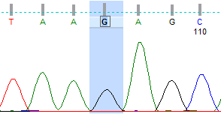
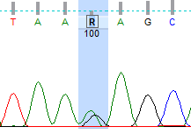
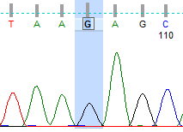
Family 1
Family 2
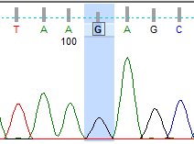
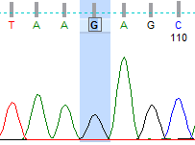
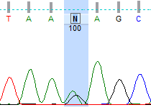
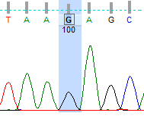

I:1
II:5
II:1
I:2
I:1
I:2

II:1

II:6

Supplementary Fig. 5: Dideoxy sequencing analysis for the following SNP: rs10161132 in both families. Healthy siblings of Family 1 not shown. Analysis has shown change A/G in the fathers (heterozygous) and the index patients and both mothers were homozygous (G/G).

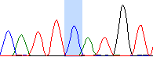
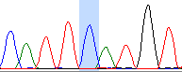
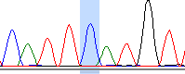
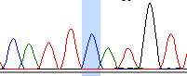
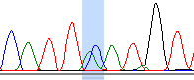
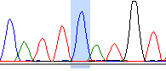
Family 2
Family 1

I:1
II:5
II:1
I:2
I:1
I:2

II:1
II:6

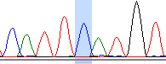

Supplementary Fig. 6: Dideoxy sequencing analysis for the following SNP: rs10161132 in both families. Healthy siblings of Family 1 not shown. The analysis shown change A/C in the father of family 1 (heterozygous) and the index patients, father of family 2, and both mothers were homozygous (G/G).
 | bp coordinates (GRCh38/hg38) | Family1 II:1 | Family1 II:6 | Family2 II:1
IAPP | 12:21373538 | G G | G G | A G
D12S1654 | 12:21416171 | 187 187 | 185 187 | 185 182
SCM3 | 12:21430286 | 246 246 | 246 246 | 246 246
rs795727200 | 12:21433264 | C C | C C | C C
rs2058464 | 12: 21437687 | C C | C C | C C
c.329_332del | 12:21449596 | - - | - - | + -
c.464A>G | 12:21452130 | G G | G G | G A
rs11046076 | 12:21471375 | A A | A A | A A
rs10161132 | 12:21474352 | G G | G G | G G
rs2417991 | 12: 21506683 | C C | C C | C C
SCM4 | 12:21661778 | 206 206 | 206 206 | 206 206
ABCC9 | 12:21852069 | G G | G G | T G
Supplementary Table 9: Coordinates of used microsatellite and SNP markers

Haplotypes analyses of the three index patients, two female siblings of family 1(II:1 and II:6), and the boy of family 2 (II:1). Demonstrated by the used microsatellites: D12S1654, SCM3, SCM4, the SNP’s: IAPP, rs795727200, rs2058464, rs11046076, rs2417991 and ABCC9 and the two mutations in PYROXD1: c.329_332del and c.464A>G. The coordinates on chromosome 12 on the human genome (GRCh38/hg38) and the found haplotypes for the patients.

Supplementary Table 10: Haplotype analysis of patients compared to the published homozygous region.
Chr12:  (Human GRCh37/hg19) | O`Grady (O'Grady et al., 2016) | P1 (Family 1:II:6) | P3 (Family 2:II:1) | Chr12:  (Human GRCh38/hg38)
21331987 | C | T | C | 21179053
21375063 | NA | C | C | 21222129
21583220 | NA | 246 | 246 | 21430286
21586198 | NA | C | C | 21433264
21590621 | NA | C | C | 21437687
21590788 | A | A | A | 21437854
21593404 | C | C | C | 21440470
21600953 | A | A | A | 21448019
21603038 | NA | T | T | 21450104
21603039 | NA | A | A | 21450105
21605064 | G (N155S) | G (N155S) | G (N155S) | 21452130
21605157 | NA | C | C | 21452223
21605366 | NA | T | T | 21452432
21608891 | C | C | C | 21455957
21609127 | C | C | C | 21456193
21609684 | G | G | G | 21456750
21609733 | G | G | G | 21456799
21609761 | AACT | AACT | AACT | 21456827
21609907 | A | A | A | 21456973
21609936 | G | G | G | 21457002
21614142-21614146 | - | - | - | 21461208-21461212
21615664 | C | C | C | 21462730
21621737 | G | G | G | 21468803
21624309 | - | - | - | 21471375
21628320 | T | T | T | 21475386
21628336 | A | A | A | 21475402
21628791 | C | C | C | 21475857
21628812 | A | A | A | 21475878
21629987 | C | C | C | 21477053
21629993 | C | C | C | 21477059
21644666 | C | C | C | 21491732
21654831 | G | G | G | 21501897
21657591 | T | T | T | 21504657
21659973 | C | C | C | 21507039
21661508 | G | G | G | 21508574
21665207 | G | G | G | 21512273
21679911 | A | A | A | 21526977
21680609 | G | G | G | 21527675
21814712 | NA | 206 | 206 | 21661778
Haplotype analysis by comparing the published SNPs in the patients reported in O`Grady (O'Grady et al., 2016) to our two patients (patient 1:II:2 and patient 2:II:1) reported here. The position of the SNPs in the Human Genome (GRCh 37/hg19) was reported in O`Grady (O'Grady et al., 2016), the positions in the Human Genome (GRCh 38/hg38) was converted by using Liftover (https://genome.ucsc.edu/cgi-bin/hgLiftOver). Patients NGS data was downloaded as Bam files by using our in-house Database “Varbank” and was analyzed in the Integrative Genomics Viewer (IGViewer) software (https://software.broadinstitute.org/software/igv/download). The first column (GRCh 37/hg19) shows the position on chromosome 12 of the analyzed SNP´s, and 2nd column shows the found SNPs in the Turkish patients by O`Grady (O'Grady et al., 2016) and the 3rd (patient 1) and 4th (patient 3) column the reported patients here. The last column shows the position of the SNPs in the human genome GRCh38/hg38 on chromosome 12, plus the SNPs and microsatellites used for the haplotype analysis in this publication. The grey marked row at Chr12:21605064 displays the founder mutation c.464A>G, p.N155S defined in all patients. SNPs that are not known for the published patients (O'Grady et al., 2016) are labeled with Not Available (NA). The blue marked rows show the homozygous region between the published haplotype (O'Grady et al., 2016) and our reported patients here, which comes up to a homozygous region of 89.987bp. The orange rows showed the homozygous region (start: 21375063 and end: 21814712) defined by the haplotype analyses reported here and shows a homozygous region of 439.649bp.
(NA=not available, “-“ = deletion at this position)

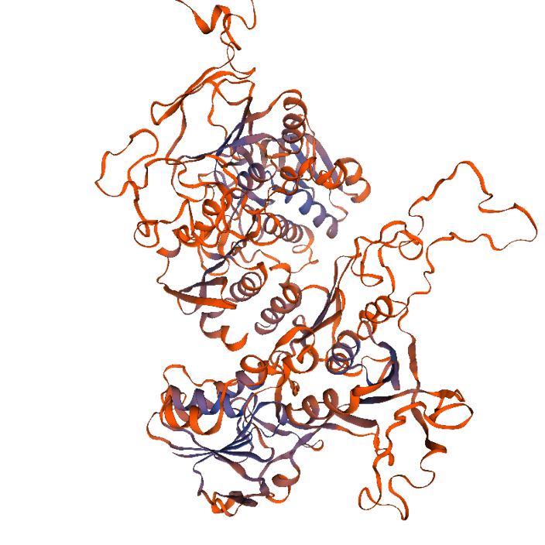
B
A
C
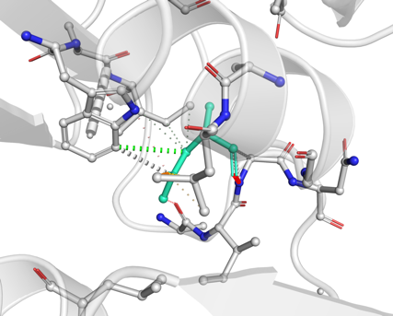
C
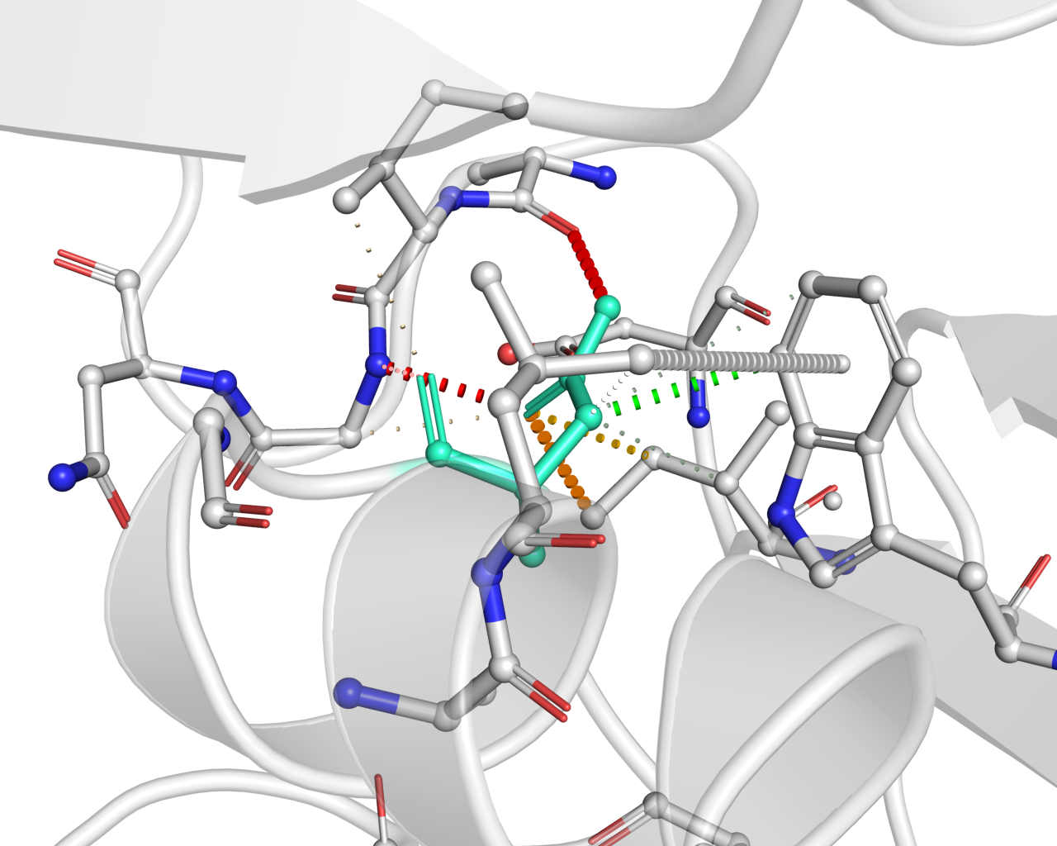

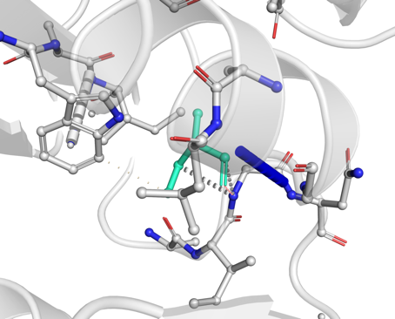
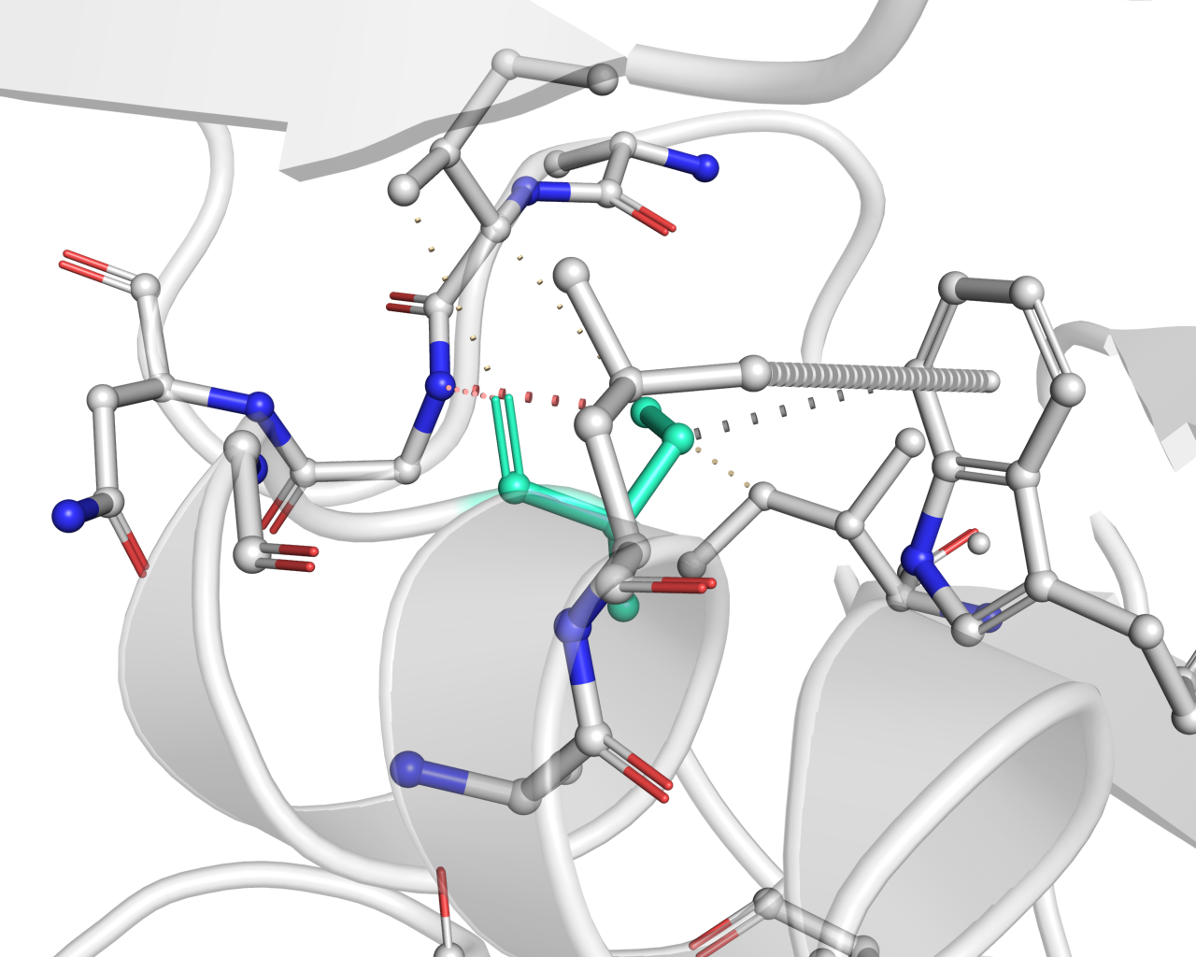
E
D

Supplementary Fig. 7: Protein modelling and Dynamut prediction analysis
Protein modelling was done by using the SWISS-modeling tool (https://swissmodel.expasy.org/) and creating the PYROXD1 wildtype protein model (A) with the Coenzyme A disulfide reductase (20% identity) of the Staphylococcus aureus bound with the covalent inhibitor MeVS-CoA. The similarities to PYROXD1 suggesting same outcomes by impact of any mutations. The PDB file of this construction was used for generating a consensus prediction on protein stability impact by a mutation by using the prediction tool “DynaMut” (http://biosig.unimelb.edu.au/dynamut/). DynaMut, a web server, can be used for the analysis and visualization of protein dynamics by sampling conformations and assess the impact of mutations on protein dynamics and stability. Calculations are done by evaluating the impact of mutations on protein conformation and stability by entropy changes. Predicting the effects of mutations on protein stability and flexibility (P-value < 0.001), achieving a correlation of up to 0.70 on blind tests. For more details see publication on Dynamut (Rodrigues, Pires, & Ascher, 2018). Entering the PDB number (Q8WU10) and the protein change from Asp to Ser at position 155 on chain A on the DynaMut website revealed following prediction in (B-C) the PYROXD1 wildtype with the Asparagine at position 155 shown in light green at the beginning of the α-helix structure of PYROXD1. Several bindings are shown (gray dashed line) but one particular binding, to maintain the α-helix structure, suggesting the main one, colored in green (green dashed line) to the Tryptophan. Asparagine is a polar amino acid, found mostly in different motifs maintaining this by forming hydrogen bond interactions with the peptide backbone. In (D-E) the amino acid at position 155 is changed to Serine (colored in green) and the prediction shows that several interactions including an H-bridges (red), van der Waals (grey), leading to a destabilizing protein (ΔΔG: -0.433 kcal/mol) by weakening the α-helix interaction with the opposing beta-turn. Interestingly Serine as well is a polar aa which is found at the beginning of α-helix structure and as a part of different motifs. Many similarities between both amino acids, which affect the protein minor than major, leaving PYROXD1 mostly functional.

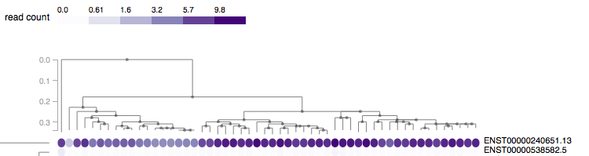
A
Isoform I (NM_024854.5)
Isoform II (NM_001350912.1)
B
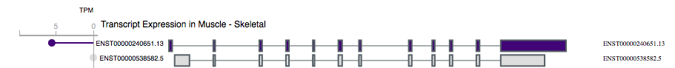
Isoform I (NM_024854.5)
Isoform II (NM_001350912.1)

Supplementary Fig. 8: Expression levels of different isoforms of PYROXD1 in skeletal muscle from GTEx Portal
Different isoforms of PYROXD1 were checked by using NCBI (https://www.ncbi.nlm.nih.gov/gene/79912), which reported 3 isoforms for PYROXD1. The longest isoform, known as isoform 1 and in this report used isoform (isoform 1, NM_024854.5, ENST00000240651.13, Figure 2C) and isoform 2 (NM_001350912.1, ENST00000538582.5), with shorter domains compared to isoform 1. The other isoform called isoform 3 (NM_001350913.2) with only one domain and no further details (data not shown). We used this information’s to see the expression levels of isoform 1 and 2 in skeletal muscle by using Genotype-Tissue Expression (GTEx) database (https://gtexportal.org/home/). Expression levels of the known PYROXD1 isoforms 1 (ENST00000240651.13) and 2 (ENST00000538582.5) from the Genotype-Tissue Expression (GTEx) project showing the expression levels of PYRXOD1 in different tissues. This website https://gtexportal.org/home/ is a public resource with open access to find tissue-specific gene expressions with collected samples from 54 non-diseases tissue sites, coming up to nearly 1000 individuals. In (A) the expression levels of the two isoforms 1 and 2 were presented, which directly show the high expression levels of isoform 1 and no expression at all for isoform 2. Isoform 3 was not reported. The red box marked the expression levels of skeletal muscle in isoform 1 and 2. The arrowhead pointing to the two different isoforms. (B) The protein sequence of both isoforms showing the exons in purple boxes for isoform 1, also showing the expression levels of skeletal muscle and in grey boxes for isoform 2 the shortened N-terminus. This suggests, that the shortened N-terminus led to the different expression levels in isoform 2.

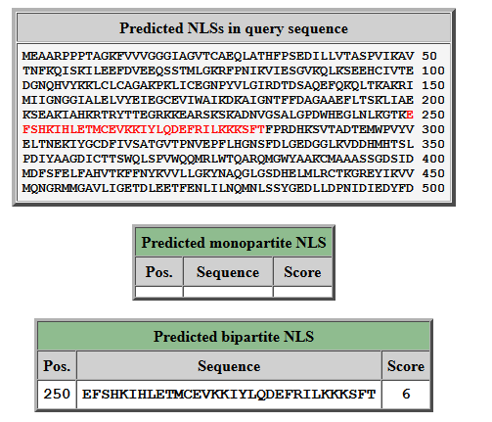
A
B
Supplementary Fig. 9: Online prediction for nuclear localization signals (NLSs) in PYROXD1
We used the protein sequence of PYROXD1 and uploaded it to the cNLS Mapper website (http://nls-mapper.iab.keio.ac.jp/cgi-bin/NLS_Mapper.cgi#appendix). The search of any nuclear localization signal (NLSs) was done for the entire region of PYROXD1. The output, shown in the Supplementary Fig. 9A-B. (A) Showed the input sequence, in red, the predicted nuclear localization signal sequence is highlighted. The predicted region starts at amino acid (aa) position 250-282, interestingly, no mutation in this region was reported for PYROXD1, only before (founder mutation at position 155) or after that region. (B) Two different classes of NLSs can be predicted, monopartite, representing a single cluster of basic residues with a sequence length of up to 16 aa residues. The second class is bipartite NLS with around 26-28 aa residues, very long bipartite sequence would be around 26-36 aa residues long. Bipartite sequences contain two clusters of basic residues of either Lysine (K) or arginine (R) at least 3 of 5 consecutive aa separated by 10-12 aa as the following example (K/R)(K/R)X10-12(K/R)3/5. Here, for PYROXD1 a 32 aa residue long sequence was predicted, classifying the sequence as a long bipartite NLS like shown here: EFSHKIHLETMCEVKKIYLQDEFRILKKKSFT. In PYROXD1 the sequence represents 3 Lysines (K, highlighted in bold) following by 10 random aa residues (highlighted in red) and again 3 Lysine’s (K, highlighted in bold), matching the described prediction analysis. Each NLS sequence additionally gets a score, which represents the localization of the protein. Scores from 9-10, predict a stronger NLS activity and only localized to the nucleus. A score from 7-8 shows only a partial localization to the nucleus, scores under 5 can be localized to both, nucleus and cytoplasm. Under 2, it will be only localized to the cytoplasm. For PYROXD1 a score of 6 was predicted, which is in the middle of a partial localization to the nucleus and represents also a localization to the cytoplasm. These results suggest that PYROXD1 could be localized to both, the nucleus and the cytoplasm. Further details to the cNLS Mapper: (Kosugi et al., 2008; Kosugi, Hasebe, Matsumura, et al., 2009; Kosugi, Hasebe, Tomita, & Yanagawa, 2009).

References
Kosugi, S., Hasebe, M., Entani, T., Takayama, S., Tomita, M., & Yanagawa, H. (2008). Design of peptide inhibitors for the importin alpha/beta nuclear import pathway by activity-based profiling. Chem Biol, 15(9), 940-949. doi: 10.1016/j.chembiol.2008.07.019
Kosugi, S., Hasebe, M., Matsumura, N., Takashima, H., Miyamoto-Sato, E., Tomita, M., & Yanagawa, H. (2009). Six classes of nuclear localization signals specific to different binding grooves of importin alpha. J Biol Chem, 284(1), 478-485. doi: 10.1074/jbc.M807017200
Kosugi, S., Hasebe, M., Tomita, M., & Yanagawa, H. (2009). Systematic identification of cell cycle-dependent yeast nucleocytoplasmic shuttling proteins by prediction of composite motifs. Proc Natl Acad Sci U S A, 106(25), 10171-10176. doi: 10.1073/pnas.0900604106
Lornage, X., Schartner, V., Balbueno, I., Biancalana, V., Willis, T., Echaniz-Laguna, A., . . . Bohm, J. (2019). Clinical, histological, and genetic characterization of PYROXD1-related myopathy. Acta Neuropathol Commun, 7(1), 138. doi: 10.1186/s40478-019-0781-8
Miyoshi, M., Okajima, T., Matsuda, T., Fukuda, M. N., & Nadano, D. (2007). Bystin in human cancer cells: intracellular localization and function in ribosome biogenesis. Biochem J, 404(3), 373-381. doi: 10.1042/BJ20061597
O'Grady, G. L., Best, H. A., Sztal, T. E., Schartner, V., Sanjuan-Vazquez, M., Donkervoort, S., . . . Cooper, S. T. (2016). Variants in the Oxidoreductase PYROXD1 Cause Early-Onset Myopathy with Internalized Nuclei and Myofibrillar Disorganization. Am J Hum Genet, 99(5), 1086-1105. doi: 10.1016/j.ajhg.2016.09.005
Olczak, M., Chutoranski, D., Kwiatkowska, M., Samojlowicz, D., Tarka, S., & Wierzba-Bobrowicz, T. (2018). Bystin (BYSL) as a possible marker of severe hypoxic-ischemic changes in neuropathological examination of forensic cases. Forensic Sci Med Pathol, 14(1), 26-30. doi: 10.1007/s12024-017-9942-x
Richards, S., Aziz, N., Bale, S., Bick, D., Das, S., Gastier-Foster, J., . . . Committee, A. L. Q. A. (2015). Standards and guidelines for the interpretation of sequence variants: a joint consensus recommendation of the American College of Medical Genetics and Genomics and the Association for Molecular Pathology. Genet Med, 17(5), 405-424. doi: 10.1038/gim.2015.30
Rodrigues, C. H., Pires, D. E., & Ascher, D. B. (2018). DynaMut: predicting the impact of mutations on protein conformation, flexibility and stability. Nucleic Acids Res, 46(W1), W350-W355. doi: 10.1093/nar/gky300
Saha, M., Reddy, H. M., Salih, M., Estrella, E., Jones, M. D., Mitsuhashi, S., . . . Kang, P. B. (2018). The impact of PYROXD1 deficiency on cellular respiration and correlations with genetic analyses of limb-girdle muscular dystrophy in Saudi Arabia and Sudan. Physiol Genomics. doi: 10.1152/physiolgenomics.00036.2018
Sainio, M. T., Valipakka, S., Rinaldi, B., Lapatto, H., Paetau, A., Ojanen, S., . . . Tyynismaa, H. (2019). Recessive PYROXD1 mutations cause adult-onset limb-girdle-type muscular dystrophy. J Neurol, 266(2), 353-360. doi: 10.1007/s00415-018-9137-8
Scoto, M., Cullup, T., Cirak, S., Yau, S., Manzur, A. Y., Feng, L., . . . Muntoni, F. (2013). Nebulin (NEB) mutations in a childhood onset distal myopathy with rods and cores uncovered by next generation sequencing. Eur J Hum Genet, 21(11), 1249-1252. doi: 10.1038/ejhg.2013.31
Wang, H., Schanzer, A., Kampschulte, B., Daimaguler, H. S., Logeswaran, T., Schlierbach, H., . . . Cirak, S. (2018). A novel SPEG mutation causes non-compaction cardiomyopathy and neuropathy in a floppy infant with centronuclear myopathy. Acta Neuropathol Commun, 6(1), 83. doi: 10.1186/s40478-018-0589-y

