Supplementary material
Table S1. Results of bivariate correlation analysis between all investigated biomarkers (Spearman’s correlation coefficient is given in each field; significant correlations are highlighted in bold; * p<0.05; ** p<0.01)
 | L-Arg | Homoarginine | SDMA | ADMA | L-Arg/ADMA | Endothelin-1 | Copeptin | MR-proADM | NT-proBNP | hsCRP
L-Arg | 1 | 0.299* | 0.210 | 0.297* | 0.773** | 0.150 | -0.021 | 0.078 | -0.087 | 0.079
Homoarginine | 0.299* | 1 | 0.079 | 0.180 | 0.222 | 0.130 | -0.070 | -0.055 | -0.275* | -0.071
SDMA | 0.210 | 0.079 | 1 | 0.549** | -0.151 | 0.233* | 0.381** | -0.130 | 0.291* | 0.221
ADMA | 0.297* | 0.180 | 0.549** | 1 | -0.298* | 0.250* | 0.083 | -0.093 | 0.083 | 0.303**
L-Arg/ADMA | 0.773** | 0.222 | -0.151 | -0.298* | 1 | -0.034 | -0.108 | 0.155 | -0.148 | -0.081
Endothelin-1 | 0.150 | 0.130 | 0.233* | 0.250* | -0.034 | 1 | 0.091 | 0.282* | 0.346** | 0.199
Copeptin | -0.021 | -0.070 | 0.381** | 0.083 | -0.108 | 0.091 | 1 | -0.117 | 0.283* | 0.225
MR-proADM | 0.078 | -0.055 | -0.130 | -0.093 | 0.155 | 0.282* | -0.117 | 1 | 0.001 | 0.061
NT-proBNP | -0.087 | -0.275* | 0.291* | 0.083 | -0.148 | 0.346** | 0.283* | 0.001 | 1 | 0.156
hsCRP | 0.079 | -0.071 | 0.221 | 0.303** | -0.081 | 0.199 | 0.225 | 0.061 | 0.156 | 1
L-Arg, L-arginine; SDMA, symmetric dimethylarginine; ADMA, asymmetric dimethylarginine; MR-proADM, mid-regional fragment of pro-adrenomedullin; NT-proBNP, N-terminal pro-B-type natriuretic peptide; hsCRP, high sensitivity C-reactive protein.
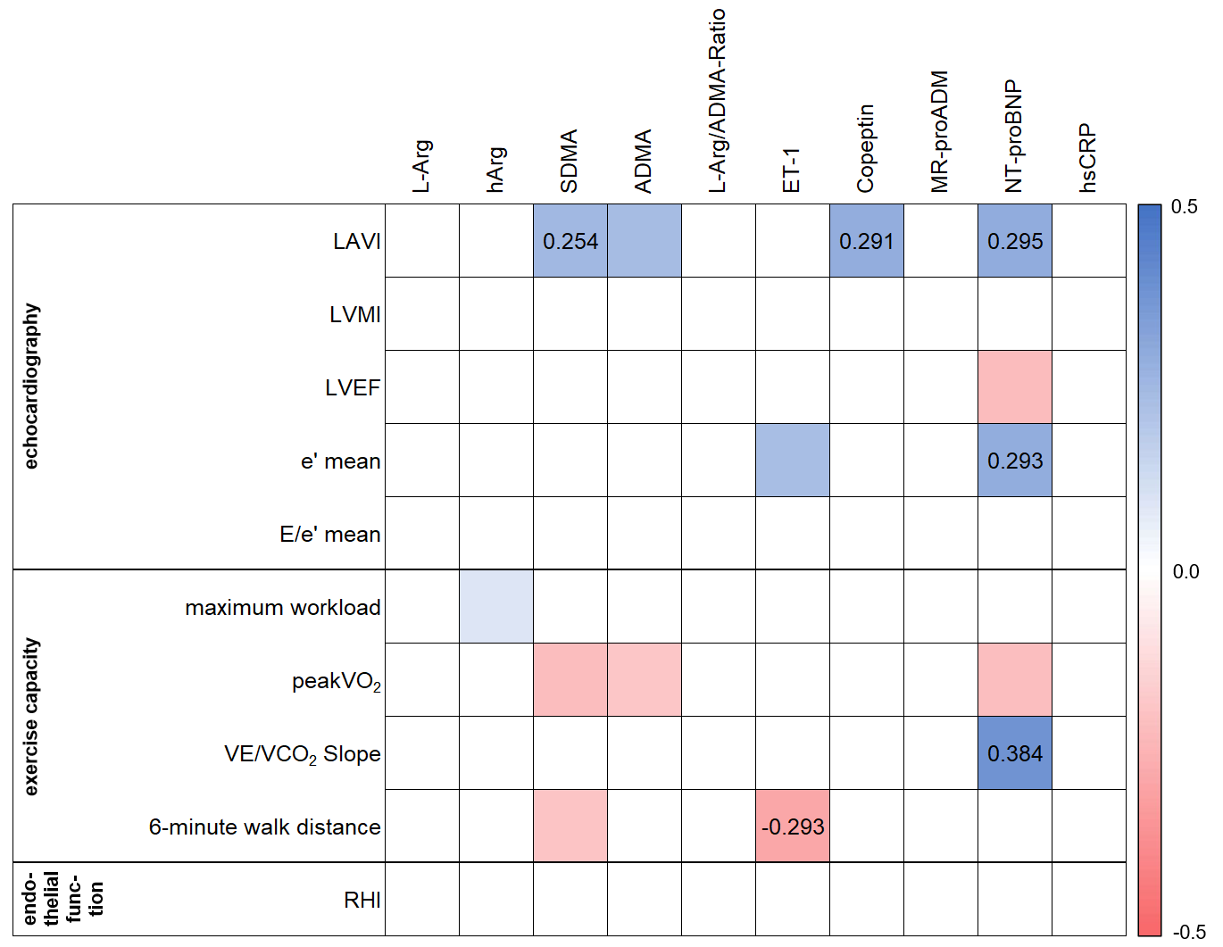
Figure S1. Heatmap for the multiple linear regression analysis between biomarkers and clinical characteristics, adjusted for age and sex (model 2). Scale for the regression coefficient β from 0.5 to -0.5; in cases of significance (p-value <0.05), β is given in the corresponding field. L-Arg, L-arginine; hArg, homoarginine; SDMA, symmetric dimethylarginine; ADMA, asymmetric dimethylarginine; ET-1, endothelin-1; MR-proADM, midregional proadrenomedullin; NT-proBNP, N-terminal pro brain natriuretic peptide; hsCRP, high sensitivity C-reactive protein; LAVI, left atrial volume index; LVMI, left ventricular mass index; LVEF, left ventricular ejection fraction; e’ mean, mean early diastolic mitral annulus velocity; E/e’ mean, left ventricular filling index; peakVO₂, peak oxygen uptake; VE/VCO₂ Slope, exercise ventilatory efficiency; RHI, reactive hyperaemia index.
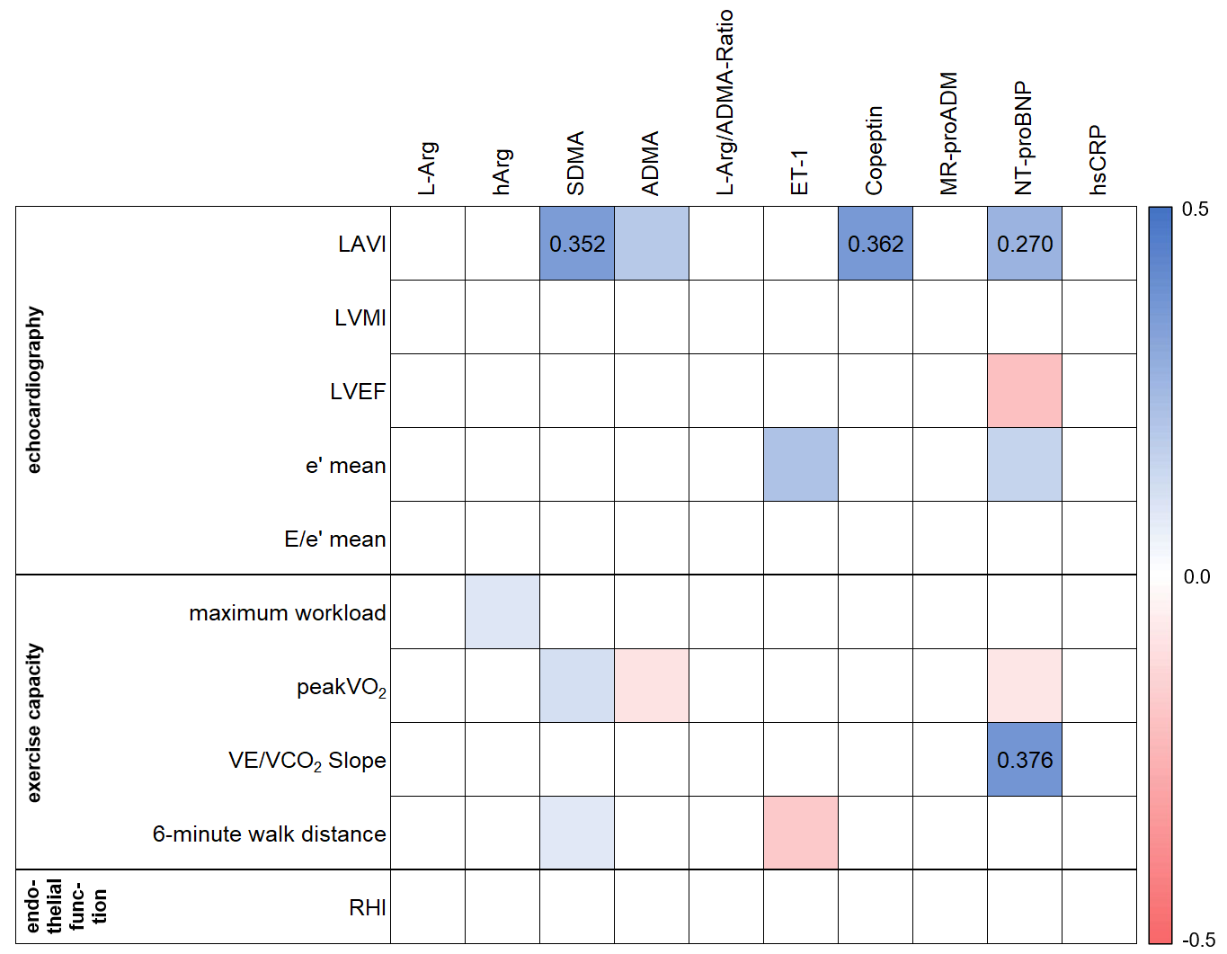
Figure S2. Heatmap for the multiple linear regression analysis between biomarkers and clinical characteristics, adjusted for age, sex, body mass index, atrial fibrillation, estimated glomerular filtration rate and haemoglobin (model 3). Scale for the regression coefficient β from 0.5 to -0.5; in cases of significance (p-value <0.05), β is given in the corresponding field. L-Arg, L-arginine; hArg, homoarginine; SDMA, symmetric dimethylarginine; ADMA, asymmetric dimethylarginine; ET-1, endothelin-1; MR-proADM, midregional proadrenomedullin; NT-proBNP, N-terminal pro brain natriuretic peptide; hsCRP, high sensitivity C-reactive protein; LAVI, left atrial volume index; LVMI, left ventricular mass index; LVEF, left ventricular ejection fraction; e’ mean, mean early diastolic mitral annulus velocity; E/e’ mean, left ventricular filling index; peakVO₂, peak oxygen uptake; VE/VCO₂ Slope, exercise ventilatory efficiency; RHI, reactive hyperaemia index.

