Table S1. Contributions of participating centres.
Participating centres | Patients, n
University Hospital Salzburg | 342
Hanusch Hospital, Vienna | 175
University Hospital Innsbruck | 128
Klinikum Wels | 124
University Hospital Graz | 104
Ordensklinikum Linz, Elisabethinen | 92
Klinik Donaustadt, Vienna | 77
LKH Hochsteiermark, Leoben | 61
LKH Feldkirch | 51
Ordensklinikum Linz, Barmherzige Schwestern | 46
Kepler University Hospital Linz | 45
University Hospital Krems | 40
Klinik Ottakring, Vienna | 36
Zagreb | 28
Klinikum Klagenfurt | 23
Klinik Hietzing, Vienna | 25
AKH Wien,Vienna | 20
LKH Fürstenfeld | 12
Klinikum Steyr | 11
Klinik Landstraße, Vienna | 2
University Hospital St.Pölten | 0

Table S2. Patient characteristics at azacitidine start.
 | Total cohort  (n=1441) | MDS  (N=522) | CMML  (N=132) | AML  (N=787) | p-value
Initial diagnosis: MDS, n (%)  CMML  AML⁴  CMPD  Unknown | 649 (45.0)  135 (9.4)  587 (40.7)  45 (3.1)  25 (1.7) | 488 (93.5)  4 (0.8)  7 (1.3)  6 (1.1)  17 (3.3) | 16 (12.1)  105 (79.5)  1 (0.8)  4 (3.0)  6 (4.5) | 145 (18.4)  26 (3.3)  579 (73.6)  35 (4.4)  2 (0.3) | <.0001
Mean year of initial diagnosis (SD), years  Median (IQR)  Min-max  Unknown, n (%) | 2012.4 (3.8)  2012 (2010-2015)  1995-2020  0 (0.0) | 2012.9 (3.9)  2013 (2010-2016)  1997-2020  0 (0.0) | 2012.3 (3.5)  2012 (2009-2015)  2003-2019  0 (0.0) | 2012.1 (3.8)  2012 (2010-2015)  1995-2020  0 (0.0) | 0.0009
Diagnosis at azacitidine start: MDS, n (%)  CMML  AML¹  Unknown | 522 (36.2)  132 (9.2)  787 (54.6)  0 (0.0) | 522 (100)  0 (0.0)  0 (0.0)  0 (0.0) | 0 (0.0)  132 (100)  0 (0.0)  0 (0.0) | 0 (0.0)  0 (0.0)  787 (100)  0 (0.0) | <.0001
Mean year of azacitidine start (SD), years  Median (IQR)  Min-max  Unknown, n (%) | 2013.4 (3.2)  2013 (2011-2016)  2006-2020  0 (0.0) | 2013.9 (3.4)  2014 (2011-2017)  2006-2020  0 (0.0) | 2013.4 (3.2)  2013 (2011-2016)  2007-2020  0 (0.0) | 2013.2 (3.1)  2013 (2011-2016)  2007-2020  0 (0.0) | 0.0003
Mean age (SD), years  Median (IQR)  Min-max  ≥ 75 years, n (%)  Unknown | 71.8 (9.95)  73.0 (67.0-78.0)  23.0-99.0  617 (42.8)  0 (0.0) | 71.8 (9.69)  72.0 (66.0-78.0)  36.0-99.0  224 (42.9)  0 (0.0) | 73.1 (7.85)  74.0 (69.0-79.0)  38.0-87.0  60 (45.5)  0 (0.0) | 71.7 (10.42)  73.0 (67.0-79.0)  23.0-93.0  333 (42.3)  0 (0.0) | 0.4882  0.7950
Sex: Female, n (%)  Male  Unknown | 563 (39.1)  878 (60.9)  0 (0.0) | 185 (35.4)  337 (64.6)  0 (0.0) | 50 (37.9)  82 (62.1)  0 (0.0) | 328 (41.7)  459 (58.3)  0 (0.0) | 0.0737
ECOG-PS: 0-1, n (%)  2-4  Unknown | 1103 (76.5)  338 (23.5)  0 (0.0) | 419 (80.3)  103 (19.7)  0 (0.0) | 107 (81.1)  25 (18.9)  0 (0.0) | 577 (73.3)  210 (26.7)  0 (0.0) | 0.0064
HCT-CI: Low, n (%)  Intermediate  High  Unknown | 445 (30.9)  516 (35.8)  478 (33.2)  2 (0.1) | 174 (33.3)  188 (36.0)  158 (30.3)  2 (0.4) | 41 (31.1)  44 (33.3)  47 (35.6)  0 (0.0) | 230 (29.2)  284 (36.1)  273 (34.7)  0 (0.0) | 0.3962
Treatment-related disease: No, n (%)  Yes  Unknown | 1227 (85.1)  209 (14.5)  5 (0.3) | 430 (82.4)  92 (17.6)  0 (0.0) | 119 (90.2)  10 (7.6)  3 (2.3) | 678 (86.1)  107 (13.6)  2 (0.3) | 0.0096
IPSS cytogenetic risk: Good, n (%)  Intermediate  Poor  Not evaluable  Not done | 896 (62.2)  210 (14.6)  153 (10.6)  94 (6.5)  88 (6.1) | 331 (63.4)  64 (12.3)  64 (12.3)  30 (5.7)  33 (6.3) | 93 (70.5)  22 (16.7)  7 (5.3)  7 (5.3)  3 (2.3) | 472 (60.0)  124 (15.8)  82 (10.4)  57 (7.2)  52 (6.6) | 0.1536
R-IPSS cytogenetic risk: Very good, n (%)  Good  Intermediate  Poor  Very poor  Not evaluable  Not done | 33 (2.3)  876 (60.8)  230 (16.0)  101 (7.0)  19 (1.3)  94 (6.5)  88 (6.1) | 11 (2.1)  326 (62.5)  71 (13.6)  43 (8.2)  8 (1.5)  30 (5.7)  33 (6.3) | 0 (0.0)  93 (70.5)  23 (17.4)  6 (4.5)  0 (0.0)  7 (5.3)  3 (2.3) | 22 (2.8)  457 (58.1)  136 (17.3)  52 (6.6)  11 (1.4)  57 (7.2)  52 (6.6) | 0.1818
IPSS lower-risk,² n (%)  IPSS higher-risk  Unknown | 385 (26.7)  999 (69.3)  57 (4.0) | 224 (42.9)  263 (50.4)  35 (6.7) | 77 (58.3)  52 (39.4)  3 (2.3) | 84 (10.7)  684 (86.9)  19 (2.4) | <.0001
R-IPSS lower-risk,³ n (%)  R-IPSS higher-risk  Unknown | 149 (10.3)  1219 (84.6)  73 (5.1) | 67 (12.8)  422 (80.8)  33 (6.3) | 31 (23.5)  94 (71.2)  7 (5.3) | 51 (6.5)  703 (89.3)  33 (4.2) | <.0001
Bone marrow blasts, %: Mean (SD)  Median (IQR)  Min-Max  Unknown, n (%) | 26.5 (26.1)  15.0 (7.0-35.5)  0.0-98.0  26 (1.8) | 9.7 (8.0)  8.0 (3.0-14.5)  0.0-65.0  8 (1.5) | 8.7 (9.4)  7.0 (3.0-14.0)  0.0-95.5  0 (0.0) | 40.8 (27.4)  35.0 (20.0-65.0)  0.0-98.0  18 (2.3) | <.0001
BME during azacitidine treatment: Yes, n (%)  No  Unknown | 699 (48.5)  742 (51.5)  0 (0.0) | 281 (53.8)  241 (46.2)  0 (0.0) | 75 (56.8)  57 (43.2)  0 (0.0) | 343 (43.6)  444 (56.4)  0 (0.0) | 0.0002
Mean cycle of first BME (SD), cycle number  Median (IQR)  Min-max | 6.0 (4.8)  5.0 (3.0-7.0)  1.0-47.0 | 6.5 (4.9)  6.0 (4.0-7.0)  1.0-33.0 | 7.5 (5.2)  6.0 (4.0-8.0)  2.0-33.0 | 5.3 (4.6)  5.0 (3.0-6.0)  1.0-47.0 | <.0001
CMPD indicates chronic myeloproliferative diseases; ECOG-PS, Eastern Cooperative Oncology Group Performance Status; HCT-CI, Haematopoietic Cell Transplantation-specific Comorbidity Index; IPSS indicates International Prognostic Scoring System; R-IPSS, revised IPSS; BME, bone marrow evaluation.
¹As defined by WHO-2016: ≥20% bone marrow or peripheral blood blasts. ²IPSS lower-risk comprises IPSS low and intermediate-1 risk categories. ³R-IPSS lower-risk comprises R-IPSS very low and low risk categories.
Table S3. Differential blood count and transfusion dependence assessed at azacitidine start.
 | Total cohort  (n=1441) | MDS  (N=522) | CMML  (N=132) | AML  (N=787) | p-value
Peripheral blood blasts, %: Mean (SD)  Median (IQR)  Min-Max  Unknown, n (%) | 10.1 (20.1)  1.0 (0.0-9.0)  0.0-98.0  33 (2.3) | 2.6 (6.4)  0.0 (0.0-2.0)  0.0-74.0  13 (2.5) | 2.1 (3.5)  0.0 (0.0-2.0)  0.0-16.0  1 (0.8) | 16.5 (25.0)  3.0 (0.0-23.5)  0.0-98.0  19 (2.4) | <.0001
White blood cell count, x 10³/µl: Mean (SD)  Median (IQR)  Min-Max  Unknown, n (%) | 10.4 (21.1)  3.5 (1.9-8.8)  0.1-389.4  1 (0.1) | 6.7 (21.0)  2.9 (1.8-4.8)  0.4-389.4  0 (0.0) | 24.6 (27.8)  15.9 (6.8-33.2)  1.9-183.0  0 (0.0) | 10.5 (18.8)  3.5 (1.8-9.5)  0.1-185.0  1 (0.1) | <.0001
Absolute neutrophil count, x 10³/µl: Mean (SD)  Median (IQR)  Min-Max  Unknown, n (%) | 4.1 (20.9)  1.2 (0.5-3.0)  0.0-719.0  54 (3.7) | 2.9 (9.0)  1.2 (0.6-2.2)  0.0-167.5  19 (3.6) | 11.1 (13.8)  7.2 (2.5-13.1)  0.0-77.0  2 (1.5) | 3.6 (26.7)  0.9 (0.4-2.5)  0.0-719.0  33 (4.2) | <.0001
Neutropenia (ANC <10³/µl): No, n (%)  Yes  Unknown | 826 (57.3)  615 (42.7)  0 (0.0) | 303 (58.0)  219 (42.0)  0 (0.0) | 122 (92.4)  10 (7.6)  0 (0.0) | 401 (51.0)  386 (49.0)  0 (0.0) | <.0001
Monocytes, %: Mean (SD)  Median (IQR)  Min-Max  Unknown, n (%) | 13.1 (15.1)  8.0 (3.0-17.0)  0.0-98.0  41 (2.8) | 10.4 (12.3)  7.0 (3.0-12.0)  0.0-98.0  15 (2.9) | 28.4 (16.1)  25.0 (16.5-36.5)  0.0-81.0  0 (0.0) | 12.3 (15.1)  7.0 (2.0-15.0)  0.0-81.0  26 (3.3) | <.0001
Lymphocytes, x 10³/µl: Mean (SD)  Median (IQR)  Min-Max  Unknown, n (%) | 1.9 (3.8)  1.2 (0.7-1.9)  0.0-69.3  57 (4.0) | 1.5 (3.4)  1.1 (0.7-1.5)  0.0-69.3  23 (4.4) | 3.3 (5.6)  2.0 (1.4-3.2)  0.0-53.0  3 (2.3) | 1.9 (3.6)  1.2 (0.7-2.0)  0.0-59.0  31 (3.9) | <.0001
Haemoglobin, g/dL: Mean (SD)  Median (IQR)  Min-Max  Unknown, n (%) | 9.5 (1.8)  9.3 (8.4-10.5)  3.2-17.3  1 (0.1) | 9.2 (1.7)  9.0 (8.1-10.0)  4.5-17.1  0 (0.0) | 9.8 (1.8)  9.4 (8.5-10.7)  6.9-15.4  0 (0.0) | 9.7 (1.8)  9.6 (8.5-10.7)  3.2-17.3  1 (0.1) | <.0001
Mean corpuscular volume, fl: Mean (SD)  Median (IQR)  Min-Max  Unknown, n (%) | 95.2 (46.0)  92.0 (87.0-99.0)  27.0-971.0  9 (0.6) | 94.8 (36.4)  92.0 (87.0-99.0)  27.0-882.0  6 (1.1) | 99.3 (76.0)  92.0 (87.0-97.0)  74.0-961.0  0 (0.0) | 94.8 (45.0)  92.0 (87.0-99.0)  28.0-971.0  3 (0.4) | 0.7745
Mean corpuscular haemoglobin, pg: Mean (SD)  Median (IQR)  Min-Max  Unknown, n (%) | 32.1 (15.8)  31.0 (29.0-33.0)  3.0-345.0  10 (0.7) | 31.2 (3.6)  31.0 (29.0-33.0)  20.0-52.0  6 (1.1) | 32.8 (25.8)  30.0 (29.0-32.0)  22.0-325.0  0 (0.0) | 32.5 (18.2)  31.0 (29.0-33.0)  3.0-345.0  4 (0.5) | 0.0061
Anaemia (Hb <11.0 g/dL): No, n (%)  Yes  Unknown | 263 (18.3)  1178 (81.7)  0 (0.0) | 73 (14.0)  449 (86.0)  0 (0.0) | 27 (20.5)  105 (79.5)  0 (0.0) | 163 (20.7)  624 (79.3)  0 (0.0) | 0.0068
Red blood cell transfusion dependence: No, n (%)  Yes  Unknown | 849 (58.9)  592 (41.1)  0 (0.0) | 282 (54.0)  240 (46.0)  0 (0.0) | 84 (63.6)  48 (36.4)  0 (0.0) | 483 (61.4)  304 (38.6)  0 (0.0) | 0.0155
Number of red blood cell transfusions, n: Mean (SD)  Median (IQR)  Min-Max | 2.2 (3.7)  0.0 (0.0-4.0)  0.0-32.0 | 2.3 (3.6)  0.0 (0.0-4.0)  0.0-32.0 | 1.7 (2.7)  0.0 (0.0-3.0)  0.0-12.0 | 2.3 (3.9)  0.0 (0.0-3.0)  0.0-24.0 | 0.0617
Platelet count, x 10⁶/µl: Mean (SD)  Median (IQR)  Min-Max  Unknown, n (%) | 94 (123)  55 (29-114)  1-1270  1 (0.1) | 91 (123)  56 (30-101)  1-1184  0 (0.0) | 117 (133)  63 (35-142)  5-802  0 (0.0) | 93 (121)  53 (27-115)  1-1270  1 (0.1) | 0.0325
Thrombocytopenia (platelet count <100 x 10³/µL): No, n (%)  Yes  Unknown | 421 (29.2)  1020 (70.8)  0 (0.0) | 135 (25.9)  387 (74.1)  0 (0.0) | 52 (39.4)  80 (60.6)  0 (0.0) | 234 (29.7)  553 (70.3)  0 (0.0) | 0.0084
Platelet transfusion dependence: No, n (%)  Yes  Unknown | 1154 (80.1)  287 (19.9)  0 (0.0) | 439 (84.1)  83 (15.9)  0 (0.0) | 114 (86.4)  18 (13.6)  0 (0.0) | 601 (76.4)  186 (23.6)  0 (0.0) | 0.0005
Number of platelet transfusions, n: Mean (SD)  Median (IQR)  Min-Max | 1.1 (3.3)  0.0 (0.0-0.0)  0.0-30.0 | 0.6 (2.0)  0.0 (0.0-0.0)  0.0-17.0 | 0.4 (1.4)  0.0 (0.0-0.0)  0.0-10.0 | 1.6 (4.1)  0.0 (0.0-0.0)  0.0-30.0 | <.0001

Table S4. Laboratory values assessed at azacitidine start.
 | Total cohort  (n=1441) | MDS  (N=522) | CMML  (N=132) | AML  (N=787) | p-value
Ferritin, µg/L: Mean (SD)  Median (IQR)  Min-Max  Unknown, n (%) | 1370 (2340)  833 (366-1700)  0-46061  715 (49.6) | 991. (1115)  637 (257-1387)  1-8050  258 (49.4) | 1002 (1287)  570 (218-1339)  0-7600  70 (53.0) | 1676 (2944)  976 (483-1917)  2-46061  387 (49.2) | <.0001
Lactate dehydrogenase, U/L: Mean (SD)  Median (IQR)  Min-Max  Unknown, n (%) | 322 (277)  242 (185-345)  1-3338  46 (3.2) | 285 (216)  230 (180-317)  77-2737  30 (5.7) | 343 (252)  266 (196-400)  81-1611  4 (3.0) | 342 (311)  246 (188-363)  1-3338  12 (1.5) | 0.0007
Cholinesterase, U/L: Mean (SD)  Median (IQR)  Min-Max  Unknown, n (%) | 11.8 (176)  5.4 (4.1-6.6)  0.3-4933  657 (45.6) | 22.6 (290.4)  5.6 (4.1-6.6)  1.1-4933  234 (44.8) | 5.1 (1.9)  4.9 (3.7-6.0)  1.4-10.6  48 (36.4) | 5.6 (1.9)  5.5 (4.2-6.6)  0.3-11.7  375 (47.6) | 0.0405
Glutamate oxaloacetate transaminase, U/L: Mean (SD)  Median (IQR)  Min-Max  Unknown, n (%) | 29.6 (22.3)  24.0 (18.0-33.0)  5.0-300.0  59 (4.1) | 27.1 (15.0)  23.0 (18.0-31.0)  7.0-137.0  31 (5.9) | 29.1 (15.0)  25.0 (18.0-35.0)  9.0-85.0  6 (4.5) | 31.4 (26.7)  25.0 (18.0-35.0)  5.0-300.0  22 (2.8) | 0.0834
Glutamate pyruvate transaminase, U/L: Mean (SD)  Median (IQR)  Min-Max  Unknown, n (%) | 29.2 (30.9)  20.0 (14.0-32.0)  1.0-400.0  52 (3.6) | 26.2 (28.0)  19.0 (13.0-28.0)  2.0-400.0  24 (4.6) | 25.1 (21.0)  19.0 (13.0-27.0)  3.0-107.0  6 (4.5) | 31.9 (33.6)  22.0 (15.0-36.0)  1.0-315.0  22 (2.8) | <.0001
Creatinine, mg/dL: Mean (SD)  Median (IQR)  Min-Max  Unknown, n (%) | 1.0 (0.52)  1.0 (0.8-1.2)  0.4-8.9  29 (2.0) | 1.0 (0.6)  0.9 (0.8-1.1)  0.4-8.9  16 (3.1) | 1.2 (0.4)  1.1 (0.9-1.3)  0.5-2.5  4 (3.0) | 1.0 (0.5)  0.9 (0.8-1.2)  0.4-6.1  9 (1.1) | <.0001
Bilirubin, mg/dL: Mean (SD)  Median (IQR)  Min-Max  Unknown, n (%) | 0.8 (0.6)  0.6 (0.5-0.9)  0.0-7.2  85 (5.9) | 0.8 (0.6)  0.7 (0.5-1.0)  0.1-7.2  35 (6.7) | 0.8 (0.7)  0.6 (0.5-0.9)  0.3-4.6  9 (6.8) | 0.7 (0.5)  0.6 (0.4-0.9)  0.0-5.6  41 (5.2) | 0.0009
Albumin, g/dL: Mean (SD)  Median (IQR)  Min-Max  Unknown, n (%) | 3.9 (0.8)  3.9 (3.4-4.2)  1.0-8.0  576 (40.0) | 4.0 (0.9)  4.0 (3.6-4.3)  2.0-8.0  247 (47.3) | 4.0 (1.0)  3.8 (3.5-4.1)  2.0-8.0  48 (36.4) | 3.8 (0.8)  3.8 (3.3-4.2)  1.0-7.3  281 (35.7) | <.0001
Serum erythropoietin: < 50 IU/L, n (%)  50 < 500  ≥ 500  Unknown | 105 (7.3)  180 (12.5)  40 (2.8)  1116 (77.4) | 52 (10.0)  97 (18.6)  25 (4.8)  348 (66.7) | 21 (15.9)  16 (12.1)  2 (1.5)  93 (70.5) | 32 (4.1)  67 (8.5)  13 (1.7)  675 (85.8) | <.0001

Table S5. Comorbidities assessed at azacitidine start.
 | Total cohort  (n=1441) | MDS  (N=522) | CMML  (N=132) | AML  (N=787) | p-value
Comorbidities: 0, n (%)  1  2  3  ≥4  Unknown | 295 (20.5)  458 (31.8)  341 (23.7)  202 (14.0)  145 (10.1)  0 (0.0) | 117 (22.4)  167 (32.0)  125 (23.9)  75 (14.4)  38 (7.3)  0 (0.0) | 28 (21.2)  35 (26.5)  31 (23.5)  20 (15.2)  18 (13.6)  0 (0.0) | 150 (19.1)  256 (32.5)  185 (23.5)  107 (13.6)  89 (11.3)  0 (0.0) | 0.1196
Cardiac comorbidity, n (%) | 537 (37.3) | 181 (34.7) | 58 (43.9) | 298 (37.9) | 0.1265
Diabete mellitus, n (%) | 268 (18.6) | 96 (18.4) | 25 (18.9) | 147 (18.7) | 0.9859
Solid tumor, n (%) | 245 (17.0) | 93 (17.8) | 24 (18.2) | 128 (16.3) | 0.7122
Impaired renal function, n (%) | 240 (16.7) | 77 (14.8) | 36 (27.3) | 127 (16.1) | 0.0022
Pulmonary comorbidity, n (%) | 200 (13.9) | 71 (13.6) | 16 (12.1) | 113 (14.4) | 0.7687
Additional hematologic tumor, n (%) | 152 (10.5) | 65 (12.5) | 15 (11.4) | 72 (9.1) | 0.1547
Impaired hepatic function, n (%) | 142 (9.9) | 48 (9.2) | 17 (12.9) | 77 (9.8) | 0.4451
Thromboembolism, n (%) | 121 (8.4) | 36 (6.9) | 9 (6.8) | 76 (9.7) | 0.1670
Psychiatric disturbance, n (%) | 103 (7.1) | 26 (5.0) | 7 (5.3) | 70 (8.9) | 0.0222
Adipositas (BMI >35 kg/m²) , n (%) | 98 (6.8) | 37 (7.1) | 6 (4.5) | 55 (7.0) | 0.5568
Cerebrovascular disease, n (%) | 93 (6.5) | 27 (5.2) | 10 (7.6) | 56 (7.1) | 0.2196
Active infection, n (%) | 87 (6.0) | 15 (2.9) | 3 (2.3) | 69 (8.8) | <.0001
Rheumatologic comorbidity, n (%) | 59 (4.1) | 22 (4.2) | 6 (4.5) | 31 (3.9) | 0.4529
Peptic ulcer, n (%) | 32 (2.2) | 11 (2.1) | 4 (3.0) | 17 (3.2) | 0.4109
Inflammatory bowel disease, n (%) | 15 (1.0) | 5 (1.0) | 3 (2.3) | 7 (0.9) | 0.2246

Table S6. Azacitidine treatment characteristics.
 | Total cohort  (n=1441) | MDS  (N=522) | CMML  (N=132) | AML  (N=787) | p-value
Status at last follow-up: Dead, n (%)  Alive and still on treatment with azacitidine  Alive and no longer treated with azacitidine  Lost to follow-up | 1262 (87.6)  67 (4.6)  108 (7.5)  4 (0.3) | 428 (82.0)  37 (7.1)  56 (10.7)  1 (0.2) | 115 (87.1)  9 (6.8)  7 (5.3)  1 (0.8) | 719 (91.4)  21 (2.7)  45 (5.7)  2 (0.3) | <.0001
Still on azacitidine at last follow-up: No  Yes  Unknown | 1365 (94.7)  76 (5.3)  0 (0.0) | 480 (92.0)  42 (8.0)  0 (0.0) | 122 (92.4)  10 (7.6)  0 (0.0) | 763 (97.0)  24 (3.0)  0 (0.0) | 0.0002
Follow-up time from initial diagnosis, months: Mean (SD)  Median (IQR)  Min-Max  Unknown, n (%) | 29.8 (32.5)  18.8 (9.8-37.4)  0.5-283.5  4 (0.3) | 35.0 (34.2)  23.1 (12.0-45.1)  0.5-238.0  0 (0.0) | 33.2 (30.3)  25.5 (13.4-40.8)  1.3-165.1  3 (2.3) | 25.9 (31.2)  16.0 (8.1-30.1)  0.5-283.5  1 (0.1) | <.0001
Follow-up time from azacitidine start, months: Mean (SD)  Median (IQR)  Min-Max  Unknown, n (%) | 16.8 (19.9)  10.7 (4.1-21.1)  0.0-161.6  0 (0.0) | 22.4 (23.64)  15.0 (7.5-27.8)  0.2-161.6  0 (0.0) | 19.0 (16.7)  14.7 (6.9-25.6)  0.2-95.3  0 (0.0) | 12.7 (16.4)  7.9 (3.2-16.2)  0.0-134.0  0 (0.0) | <.0001
Duration of azacitidine treatment, months: Mean (SD)  Median (IQR)  Min-Max  Unknown, n (%) | 9.8 (13.7)  5.0 (1.9-12.1)  0.0-108.7  0 (0.0) | 12.0 (15.5)  6.6 (3.0-14.4)  0.0-102.2  0 (0.0) | 13.5 (16.3)  7.6 (3.4-17.2)  0.1-95.3  0 (0.0) | 7.7 (11.4)  3.9 (1.2-9.7)  0.0-108.7  0 (0.0) | <.0001
First cytopenias to azacitidine start, months: Mean (SD)  Median (IQR)  Min-Max  Unknown, n (%) | 19.8 (33.6)  5.7 (1.5-22.6)  0.1-268.9  427 (29.6) | 21.8 (35.4)  5.8 (1.7-27.6)  0.1-193.7  155 (29.7) | 27.4 (40.3)  11.3 (2.8-35.9)  0.2-213.9  40 (30.3) | 17.2 (30.7)  5.1 (1.3-17.3)  0.1-268.9  232 (29.5) | 0.0007
Initial diagnosis to azacitidine start, months: Mean (SD)  Median (IQR)  Min-Max  Unknown, n (%) | 13.1 (25.8)  3.0 (1.0-13.2)  0.0-278.9  4 (0.3) | 12.6 (23.9)  3.1 (1.2-13.0)  0.1-233.3  0 (0.0) | 14.2 (26.1)  3.4 (1.0-15.6)  0.0-151.2  3 (2.3) | 13.2 (27.0)  2.8 (0.9-13.0)  0.1-278.9  1 (0.1) | 0.1656
Time from azacitidine stop to death, months: Mean (SD)  Median (IQR)  Min-Max  Still alive  Unknown, n (%) | 5.6 (9.6)  2.4 (0.9-6.3)  0.0-125.4  175 (12.1)  4 (0.3) | 8.6 (13.4)  4.2 (1.3-9.6)  0.0-125.4  93 (17.8)  1 (0.2) | 5.8 (7.7)  3.0 (1.1-6.9)  0.0-35.7  16 (12.1)  1 (0.8) | 3.7 (6.1)  1.8 (0.8-4.3)  0.0-74.3  66 (8.4)  2 (0.3) | <.0001
Transformation to AML: During azacitidine n (%)  After azacitidine  AML at azacitidine start  No transformation  Unknown | 145 (10.1)  51 (3.5)  787 (54.6)  458 (31.8)  0 (0.0) | 126 (24.1)  37 (7.1)  0 (0.0)  359 (68.8)  0 (0.0) | 19 (14.4)  14 (10.6)  0 (0.0)  99 (75.0)  0 (0.0) | 0 (0.0)  0 (0.0)  787 (100)  0 (0.0)  0 (0.0) | <.0001
Time from azacitidine start to AML¹, months: Mean (SD)  Median (IQR)  Min-Max  AML at azacitidine start, n (%)  Unknown, n (%) | 18.9 (20.7)  12.2 (5.3-24.1)  0.0-161.6  787 (54.6)  0 (0.0) | 19.3 (21.7)  11.9 (5.0-24.3)  0.0-161.6  0 (0.0)  0 (0.0) | 17.5 (16.4)  12.9 (5.7-23.7)  0.1-95.3  0 (0.0)  0 (0.0) | NC  NC  NC  787 (100)  0 (0.0) | 0.7722
Time from AML¹ after azacitidine start to death, months: Mean (SD)  Median (IQR)  Min-Max | 7.5 (10.3)  4.3 (2.0-8.7)  0.2-81.6 | 8.0 (11.0)  4.6 (2.0-8.8)  0.2-81.6 | 5.4 (5.8)  4.0 (1.7-5.9)  0.3-28.1 | NC  NC  NC | 0.2902
Time to next treatment (TTNT) or death, months: Mean (SD)  Median (IQR)  Min-Max  No next treatment and dead, n (%)  No next treatment and alive, n (%) | 13.7 (16.4)  8.7 (3.7-17.7)  0.0-161.6  885 (61.4)  125 (8.7) | 18.1 (19.6)  11.9 (5.8-22.3)  0.2-161.6  297 (56.9)  68 (13.0) | 17.4 (17.0)  13.3 (5.9-22.5)  0.2-95.3  76 (57.6)  15 (11.4) | 10.2 (12.7)  6.1 (2.8-13.1)  0.0-108.7  512 (65.1)  42 (5.3) | <.0001
Death within 30 days after azacitidine start: Yes, n (%)  No  Unknown | 79 (5.5)  1362 (94.5)  0 (0.0) | 13 (2.5)  509 (97.5)  0 (0.0) | 4 (3.0)  128 (97.0)  0 (0.0) | 62 (7.9)  725 (92.1)  0 (0.0) | <.0001
Death within 60 days after azacitidine start: Yes, n (%)  No  Unknown | 144 (10.0)  1297 (90.0)  0 (0.0) | 23 (4.4)  499 (95.6)  0 (0.0) | 8 (6.1)  124 (93.9)  0 (0.0) | 113 (14.4)  674 (85.6)  0 (0.0) | <.0001
1 year survival after azacitidine start: Yes, n (%)  No  Unknown | 722 (50.1)  719 (49.9)  0 (0.0) | 330 (63.2)  192 (36.8)  0 (0.0) | 84 (63.6)  48 (36.4)  0 (0.0) | 308 (39.1)  479 (60.9)  0 (0.0) | <.0001
2 year survival after azacitidine start: Yes, n (%)  No  Unknown | 382 (26.5)  1059 (73.5)  0 (0.0) | 198 (37.9)  324 (62.1)  0 (0.0) | 48 (36.4)  84 (63.6)  0 (0.0) | 136 (17.3)  651 (82.7)  0 (0.0) | <.0001
3 year survival after azacitidine start: Yes, n (%)  No  Unknown | 269 (18.7)  1172 (81.3)  0 (0.0) | 147 (28.2)  375 (71.8)  0 (0.0) | 29 (22.0)  103 (78.0)  0 (0.0) | 93 (11.8)  694 (88.2)  0 (0.0) | <.0001
4 year survival after azacitidine start: Yes, n (%)  No  Unknown | 229 (15.9)  1212 (84.1)  0 (0.0) | 126 (24.1)  396 (75.9)  0 (0.0) | 23 (17.4)  109 (82.6)  0 (0.0) | 80 (10.2)  707 (89.8)  0 (0.0) | <.0001
¹For patients with a diagnosis of MDS or CMML at azacitidine start.
Table S7. Azacitidine schedule and dose characteristics.
 | Total cohort  (n=1441) | MDS  (N=522) | CMML  (N=132) | AML  (N=787) | p-value
Total number of azacitidine cycles, n | 13971 | 6171 | 1741 | 6059 | n.a.
Azacitidine cycles, n: Mean (SD)  Median (IQR)  Min-Max  Unknown, n (%) | 9.7 (12.4)  5.0 (2.0-12.0)  1.0-111.0  0 (0.0) | 11.8 (14.6)  6.0 (3.0-14.0)  1.0-111.0  0 (0.0) | 13.2 (15.2)  8.0 (4.0-16.5)  1.0-100.0  0 (0.0) | 7.7 (9.6)  4.0 (2.0-10.0)  1.0-75.0  0 (0.0) | <.0001
No. of received azacitidine cycles: ≤12  >12 | 1104 (76.6)  337 (23.4) | 367 (70.3)  155 (29.7) | 89 (67.4)  43 (32.6) | 648 (82.3)  139 (17.7) | <.0001
Azacitidine dose: <75 mg/m² d1-7  =75 mg/m² d1-7  >75 mg/m² d1-7  Unknown | 638 (44.3)  784 (54.4)  17 (1.2)  2 (0.1) | 275 (52.7)  243 (46.6)  3 (0.6)  1 (0.2) | 59 (44.7)  72 (54.5)  1 (0.8)  0 (0.0) | 304 (38.6)  469 (59.6)  13 (1.7)  1 (0.1) | <.0001
Azacitidine schedule: days 1-5  days 1-7  days 5-2-2  Others  Unknown | 279 (19.4)  685 (47.5)  326 (22.6)  149 (10.3)  2 (0.1) | 123 (23.6)  212 (40.6)  138 (26.4)  48 (9.2)  1 (0.2) | 29 (22.0)  58 (43.9)  32 (24.2)  13 (9.8)  0 (0.0) | 127 (16.1)  415 (52.7)  156 (19.8)  88 (11.2)  1 (0.1) | 0.0001
Azacitidine treatment days per cycle: Mean (SD)  Median (IQR)  Min-Max  Unknown, n (%) | 6.4 (1.0)  7.0 (5.0-7.0)  1.0-9.0  2 (0.1) | 6.3 (1.1)  7.0 (5.0-7.0)  1.0-8.0  1 (0.2) | 6.3 (1.0)  7.0 (5.0-7.0)  1.0-9.0  0 (0.0) | 6.5 (1.0)  7.0 (7.0-7.0)  1.0-9.0  1 (0.1) | <.0001
Azacitidine dose per cycle, mg: Mean (SD)  Median (IQR)  Min-Max  Unknown, n (%) | 821.8 (215.7)  875 (700-1000)  0.0-2009  1 (0.1) 1 | 800.5 (226.8)  840 (645-994)  0.0-1480  0 (0.0) 0 | 801.1 (201.3)  840 (700-980)  65.0-1330  0 (0.0) 0 | 849.5 (204.8)  903 (700-1000)  70.0-2009  1 (0.1) 1 | <.0001
Lines prior to azacitidine, n: Mean (SD)  Median (IQR)  Min-Max  Unknown, n (%) | 1.2 (1.3)  1.0 (0.0-2.0)  0.0-5.0  22 | 0.4 (0.8)  0.0 (0.0-1.0)  0.0-5.0  10 | 0.8 (0.7)  1.0 (0.0-1.0)  0.0-2.0  1 | 1.6 (1.3)  1.0 (1.0-3.0)  0.0-5.0  11 | <.0001
Lines post azacitidine, n: Mean (SD)  Median (IQR)  Min-Max  Unknown, n (%) | 9.4 (28.2)  1.0 (0.0-2.0)  0.0-102.0  0 (0.0) | 12.2 (32.0)  1.0 (0.0-2.0)  0.0-102.0  0 (0.0) | 15.6 (35.7)  1.0 (0.0-2.0)  0.0-102.0  0 (0.0) | 6.4 (23.2)  1.0 (0.0-2.0)  0.0-102.0  0 (0.0) | 0.0089
Allo-SCT post azacitidine, n: Yes  Still on AZA  No | 68 (4.7)  63 (4.4)  1309 (90.8) | 37 (7.1)  35 (6.7)  450 (86.2) | 7 (5.3)  9 (6.8)  116 (87.9) | 24 (3.0)  19 (2.4)  743 (94.4) | 0.0032  0.004  <.0001

Table S8. Azacitidine overall response characteristics.¹
 | Total cohort  (n=1441) | MDS  (N=522) | CMML  (N=132) | AML  (N=787) | p-value
BME performed: Yes n (%)  No | 699 (48.5)  742 (51.5) | 281 (54.0)  241 (46.2) | 75 (56.8)  57 (43.2) | 343 (43.6)  444 (56.4) | 0.0002
Best response in patients with BME: CR, n (%)  CRi/CRp  CRh  MLFS  PR  Marrow-SD  PD  Unknown | 116 (16.6)  65 (9.3)  3 (0.4)  115 (16.5)  13 (1.9)  329 (47.1)  58 (8.3)  0 (0.0) | 41 (14.6)  30 (10.7)  2 (0.7)  58 (20.6)  3 (1.1)  98 (34.9)  49 (17.4)  0 (0.0) | 18 (24.0)  8 (10.7)  0 (0.0)  16 (21.3)  1 (1.3)  23 (30.7)  9 (12.0)  0 (0.0) | 57 (16.6)  27 (7.9)  1 (0.3)  41 (12.0)  9 (2.6)  208 (60.6)  0 (0.0)  0 (0.0) | <.0001
Best response (delayed): patients with BME: CR, n (%)  CRi/CRp  CRh  MLFS  PR  Marrow-SD  PD  Unknown | 141 (20.2)  64 (9.2)  3 (0.4)  91 (13.0)  13 (1.9)  329 (47.1)  58 (8.3)  0 (0.0) | 49 (17.4)  32 (11.4)  2 (0.7)  48 (17.1)  3 (1.1)  98 (34.9)  49 (17.4)  0 (0.0) | 20 (26.7)  10 (13.3)  0 (0.0)  12 (16.0)  1 (1.3)  23 (30.7)  9 (12.0)  0 (0.0) | 72 (21.0)  22 (6.4)  1 (0.3)  31 (9.0)  9 (2.6)  208 (60.6)  0 (0.0)  0 (0.0) | <.0001
First response (all patients), n (%)  CR  CRi/CRp  MLFS  PR  HI-only²  PD  No response  Not given | 28 (1.9)  24 (1.7)  87 (6.0)  4 (0.3)  510 (35.4)  50 (3.5)  738 (51.2)  0 (0.0) | 7 (1.3)  11 (2.1)  42 (8.0)  0 (0.0)  221 (42.3)  20 (3.8)  221 (42.3)  0 (0.0) | 4 (3.0)  3 (2.3)  10 (7.6)  0 (0.0)  65 (49.2)  2 (1.5)  48 (36.4)  0 (0.0) | 17 (2.2)  10 (1.3)  35 (4.4)  4 (0.5)  224 (28.5)  28 (3.6)  469 (59.6)  0 (0.0) | 0.3667  0.4342  0.0205  0.1889  <.0001  0.4215  <.0001  1
Time to first response (all patients), cycle no.: Mean (SD)  Median (IQR)  Min-Max  Unknown, n (%) | 4.4 (4.0)  4.0 (2.0-5.0)  1.0-63.0  0 (0.0) | 4.3 (3.2)  4.0 (2.0-5.0)  1.0-31.0  0 (0.0) | 4.4 (3.2)  4.0 (2.0-5.0)  2.0-17.0  0 (0.0) | 4.5 (4.8)  3.0 (2.0-5.0)  1.0-63.0  0 (0.0) | 0.5528
Best response (delayed; all patients), n (%)  CR  CRi/CRp  MLFS  PR  HI-only²  PD  No response  Not given | 159 (11.0)  57 (4.0)  90 (6.2)  26 (1.8)  324 (22.5)  50 (3.5)  735 (51.0)  0 (0.0) | 57 (10.9)  30 (5.7)  45 (8.6)  4 (0.8)  145 (27.8)  20 (3.8)  221 (42.3)  0 (0.0) | 22 (16.7)  9 (6.8)  11 (8.3)  2 (1.5)  38 (28.8)  2 (1.5)  48 (36.4)  0 (0.0) | 80 (10.2)  18 (2.3)  34 (4.3)  20 (2.5)  141 (17.9)  28 (3.6)  466 (59.2)  0 (0.0) | 0.0872  0.0015  0.0041  0.0593  <.0001  0.4215  <.0001  1
Time to best response (delayed; all patients), cycle no.: Mean (SD)  Median (IQR)  Min-Max  Unknown, n (%) | 5.6 (4.9)  4.0 (3.0-7.0)  1.0-63.0  0 (0.0) | 5.7 (4.5)  4.0 (3.0-7.0)  1.0-33.0  0 (0.0) | 6.0 (4.1)  5.0 (3.0-7.0)  2.0-20.0  0 (0.0) | 5.5 (5.3)  4.0 (3.0-7.0)  1.0-63.0  0 (0.0) | 0.2611

BME indicates bone marrow evaluation; CR, complete remsission; Cri, CR with incomplete haematologic recovery, CRp, CR with incomplete platelet recovery; MLFS, morphologic leukaemia free state; PR, partial remission; SD, stable disease; PD, progressive disease; HI, haematologic improvement;
¹Response to azacitidine was assessed according to European leukemia net (ELN) criteria for acute myeloid leukemia¹ and according to International working group (IWG) criteria for myelodysplastic syndromes and chronic myelomonocytic leukemia.²
²HI-only indicates patients without CR/CRi/CRp/MLFS or PR but with at least one of the following responses: HI-E, HI-P, and/or HI-N.
Table S9. Azacitidine haematologic improvement characteristics.¹
 | Total cohort  (n=1441) | MDS  (N=522) | CMML  (N=132) | AML  (N=787) | p-value
Haematologic improvement-erythrocytes (HI-E), n (%)  Abnormal baseline with HI-E  Abnormal baseline without HI-E  Normal baseline without progression  Normal baseline with progression  Unknown | 406 (28.2)  807 (56.0)  150 (10.4)  78 (5.4)  0 (0.0) | 174 (33.3)  283 (54.2)  43 (8.2)  22 (4.2)  0 (0.0) | 51 (38.6)  54 (40.9)  23 (17.4)  4 (3.0)  0 (0.0) | 181 (23.0)  470 (59.7)  84 (10.7)  52 (6.6)  0 (0.0) | <.0001
Haematologic improvement-platelets (HI-P), n (%)  Abnormal baseline with HI-P  Abnormal baseline without HI-P  Normal baseline without progression  Normal baseline with progression  Unknown | 380 (26.4)  671 (46.6)  340 (23.6)  50 (3.5)  0 (0.0) | 155 (29.7)  234 (44.8)  114 (21.8)  19 (3.6)  0 (0.0) | 45 (34.1)  37 (28.0)  49 (37.1)  1 (0.8)  0 (0.0) | 180 (22.9)  400 (50.8)  177 (22.5)  30 (3.8)  0 (0.0) | <.0001
Haematologic improvement-neutrophils (HI-N), n (%)  Abnormal baseline with HI-N  Abnormal baseline without HI-N  Normal baseline without progression  Normal baseline with progression  Unknown | 215 (14.9)  422 (29.3)  720 (50.0)  84 (5.8)  0 (0.0) | 85 (16.3)  135 (25.9)  270 (51.7)  32 (6.1)  0 (0.0) | 5 (3.8)  6 (4.5)  114 (86.4)  7 (5.3)  0 (0.0) | 125 (15.9)  281 (35.7)  336 (42.7)  45 (5.7)  0 (0.0) | <.0001
Haematologic improvement-any (HI-Any)2, n (%)  Abnormal baseline with HI-Any  Abnormal baseline without HI-Any  Normal baseline without progression  Normal baseline with progression  Unknown | 621 (43.1)  756 (52.5)  41 (2.8)  23 (1.6)  0 (0.0) | 257 (49.2)  256 (49.0)  3 (0.6)  6 (1.1)  0 (0.0) | 76 (57.6)  47 (35.6)  7 (5.3)  2 (1.5)  0 (0.0) | 288 (36.6)  453 (57.6)  31 (3.9)  15 (1.9)  0 (0.0) | <.0001
Peripheral blood complete remission (PB-CR), n (%)  Abnormal baseline with PB-CR  Abnormal baseline without PB-CR  Normal baseline without progression  Normal baseline with progression  Unknown | 188 (13.0)  1227 (85.1)  11 (0.8)  15 (1.0)  0 (0.0) | 73 (14.0)  444 (85.1)  2 (0.4)  3 (0.6)  0 (0.0) | 27 (20.5)  104 (78.8)  1 (0.8)  0 (0.0)  0 (0.0) | 88 (11.2)  679 (86.3)  8 (1.0)  12 (1.5)  0 (0.0) | 0.0233
Time to PB-CR, months: Mean (SD)  Median (IQR)  Min-Max  Patients with PB-CR, n (%)  Unknown, n (%) | 5.9 (6.7)  4.6 (2.8-6.7)  0.9-63.9  188 (13.0)  0 (0.0) | 6.1 (4.8)  4.6 (2.9-7.3)  1.1-22.7  73 (14.0)  0 (0.0) | 5.0 (2.9)  4.0 (3.0-6,7)  0.9-13.6  27 (20.5)  0 (0.0) | 6.1 (8.6)  4.2 (2.7-6.7)  0.9-63.9  88 (11.2)  0 (0.0) | 0.5540

¹Haematologic improvement was assessed according to IWG-2006 criteria for MDS/CMML.²
²Haematologic improvement-any indicates patients with at least one of the following responses: haematologic improvement-erythrocytes, haematologic improvement-platelets, and/or haematologic improvement-neutrophils.

Table S10. Total BM evaluations with BM blast values and with PB-CR values.
BM response | PB-CR  (n=119) | No PB-CR  (n=1065) | Total  (n=1184)
Complete remission (CR), n (%)  Row %  Column % | 88 (7.4)  63.3  74.0 | 55 (4.3)  36.7  4.8 | 139 (11.7)
CR with incomplete platelet recovery (CRp), n (%)  Row %  Column % | 0 (0.0)  0.0  0.0 | 52 (4.4)  100.0  4.9 | 52 (4.4)
CR with incomplete neutrophil recovery (CRi), n (%)  Row %  Column % | 0 (0.0)  0.0  0.0 | 58 (4.9)  100.0  5.5 | 59 (4.9)
CR with partial hematologic recovery (CRh), n (%)  Row %  Column % | 0 (0.0)  0.0  0.0 | 10 (0.8)  100.0  0.9 | 10 (0.8)
Morphologic leukemia free state (MLFS), n (%)  Row %  Column % | 0 (0.0)  0.0  0.0 | 171 (14.4)  100.0  16.1 | 171 (14.4)
Partial response (PR), n (%)  Row %  Column % | 12 (1.0)  46.2  10.1 | 14 (1.2)  53.9  1.3 | 26 (2.2)
Marrow stable disease (SD), n (%)  Row %  Column % | 19 (1.6)  3.1  16.0 | 588 (49.7)  96.9  55.2 | 607 (51.3)
Progressive disease (PD), n (%)  Row %  Column % | 0 (0.0)  0.0  0.0 | 121 (10.2)  100.0  11.4 | 121 (10.2)
Total | 119 (10.0) | 1065 (90.0) | 1184 (100.0)

Table S11. Data per cycle for haemoglobin, platelet count, and transfusions.
 | Haemoglobin level, g/dL | Red blood cell transfusions, n | Platelet count,  x 10³/µL | Platelet transfusions, n
Cycle 1: mean (SD)  Median (IQR)  Min-max  Missing, n (%)  Total n, (%) | 9.5 (1.8)  9.3 (8.4-10.5)  3.2-17.3  1 (0.1)  1441 (100.0) | 2.2 (3.7)  0.0 (0.0-4.0)  0.0-32.0  0 (0.0)  1441 (100.0) | 94.3 (123.1)  55.0 (29.0-113.5)  1.0-1270  1 (0.1)  1441 (100.0) | 1.1 (3.3)  0.0 (0.0-0.0)  0.0-30.0  0 (0.0)  1441 (100.0)
Cycle 2: mean (SD)  Median (IQR)  Min-max  Missing, n (%)  Total n, (%) | 9.5 (1.7)  9.3 (8.4-10.3)  4.1-16.3  1 (0.1)  1226 (100.0) | 2.3 (3.1)  2.0 (0.0-4.0)  0.0-30.0  1 (0.1)  1226 (100.0) | 111.1 (141.0)  64.0 (28.0-136.0)  0.0-1837  1 (0.1)  1265 (100.0) | 1.3 (3.2)  0.0 (0.0-1.0)  0.0-47.0  1 (0.1)  1226 (100.0)
Cycle 3: mean (SD)  Median (IQR)  Min-max  Missing, n (%)  Total n, (%) | 9.8 (1.9)  9.6 (8.5-10.8)  4.6-16.0  2 (0.2)  1068 (100.0) | 2.0 (2.7)  1.0 (0.0-4.0)  0.0-24.0  3 (0.3)  1068 (100.0) | 130.2 (137.1)  86.0 (34.0-190.0)  2.0-1257  2 (0.2)  1068 (100.0) | 1.0 (2.7)  0.0 (0.0-1.0)  0.0-38.0  3 (0.3)  1068 (100.0)
Cycle 4: mean (SD)  Median (IQR)  Min-max  Missing, n (%)  Total n, (%) | 10.1 (2.1)  9.9 (8.7-11.4)  4.7-16.8  2 (0.2)  951 (100.0) | 1.5 (2.4)  0.0 (0.0-2.0)  0.0-23.0  3 (0.3)  951 (100.0) | 137.6 (129.6)  103.5 (41.0-193.0)  3.0-1017  3 (0.3)  951 (100.0) | 0.7 (2.3)  0.0 (0.0-0.0)  0.0-28.0  3 (0.3)  951 (100.0)
Cycle 5: mean (SD)  Median (IQR)  Min-max  Missing, n (%)  Total n, (%) | 10.6 (2.2)  10.4 (9.0-12.0)  4.2-17.5  3 (0.4)  821 (100.0) | 1.3 (2.6)  0.0 (0.0-2.0)  0.0-30.0  4 (0.5)  821 (10021) | 143.2 (134.4)  105.0 (46.0-205.0)  0.3-1354  3 (0.4)  821 (100.0) | 0.6 (2.6)  0.0 (0.0-0.0)  0.0-40.0  4 (0.5)  821 (100.0)
Cycle 6: mean (SD)  Median (IQR)  Min-max  Missing, n (%)  Total n, (%) | 10.8 (2.3)  10.5 (9.0-12.5)  5.5-16.8  2 (0.3)  716 (100.0) | 1.1 (2.5)  0.0 (0.0-2.0)  0.0-28.0  2 (0.3)  716 (100.0) | 148.9 (126.5)  118.5 (51.0-211.0)  2.0-785.0  2 (0.3)  716 (100.0) | 0.5 (1.8)  0.0 (0.0-0.0)  0.0-20.0  2 (0.3)  716 (100.0)
Cycle 7: mean (SD)  Median (IQR)  Min-max  Missing, n (%)  Total n, (%) | 11.0 (2.4)  11.0 (9.2-12.8)  4.6-17.6  0 (0.0)  619 (100.0) | 0.8 (1.8)  0.0 (0.0-1.0)  0.0-12.0  1 (0.2)  619 (100.0) | 148.3 (124.8)  118.0 (58.0-204.0)  2.0-820.0  0 (0.0)  619 (43.0) | 0.4 (1.4)  0.0 (0.0-0.0)  0.0-17.0  1 (0.2)  619 (100.0)
Cycle 8: mean (SD)  Median (IQR)  Min-max  Missing, n (%)  Total n, (%) | 11.1 (2.3)  11.1 (9.4-12.7)  5.2-16.8  0 (0.0)  562 (100.0) | 0.8 (2.1)  0.0 (0.0-0.0)  0.0-26.0  1 (0.2)  562 (100.0) | 146.2 (123.8)  120.0 (57.0-200.0)  3.0-1358  0 (0.0)  562 100.0) | 0.4 (1.7)  0.0 (0.0-0.0)  0.0-18.0  1 (0.2)  562 (100.0)
Cycle 9: mean (SD)  Median (IQR)  Min-max  Missing, n (%)  Total n, (%) | 11.1 (2.3)  11.1 (9.4-12.9)  4.4-16.9  0 (0.0)  500 (100.0) | 0.9 (2.5)  0.0 (0.0-0.0)  0.0-40.0  0 (0.0)  500 (100.0) | 146.4 (117.4)  121.0 (61.0-204.5)  4.0-908.0  0 (0.0)  500 (100.0) | 0.4 (1.5)  0.0 (0.0-0.0)  0.0-14.0  0 (0.0)  500 (100.0)
Cycle 10: mean (SD)  Median (IQR)  Min-max  Missing, n (%)  Total n, (%) | 11.2 (2.4)  11.2 (9.6-13.1)  4.9-17.0  0 (0.0)  444 (100.0) | 0.7 (2.0)  0.0 (0.0-0.0)  0.0-30.0  0 (0.0)  444 (100.0) | 146.7 (107.1)  130.0 (67.0-206.5)  2.0-701.0  0 (0.0)  444 (100.0) | 0.3 (1.1)  0.0 (0.0-0.0)  0.0-10.0  0 (0.0)  444 (100.0)
Cycle 11: mean (SD)  Median (IQR)  Min-max  Missing, n (%)  Total n, (%) | 11.3 (2.4)  11.2 (9.5-13.0)  5.1-17.8  0 (0.0)  404 (100.0) | 0.7 (1.6)  0.0 (0.0-0.0)  0.0-16.0  0 (0.0)  404 (100.0) | 151.0 (115.7)  130.0 (67.0-200.0)  2.0-825.0  0 (0.0)  404 (100.0) | 0.2 (0.9)  0.0 (0.0-0.0)  0.0-10.0  0 (0.0)  404 (100.0)
Cycle 12: mean (SD)  Median (IQR)  Min-max  Missing, n (%)  Total n, (%) | 11.2 (2.4)  11.2 (9.4-13.0)  3.4-17.5  0 (0.0)  376 (100.0) | 0.7 (1.6)  0.0 (0.0-0.0)  0.0-10.0  0 (0.0)  376 (100.0) | 145.0 (109.8)  120.0 (67.0-197.0)  3.0-791.0  0 (0.0)  376 (100.0) | 0.3 (1.1)  0.0 (0.0-0.0)  0.0-11.0  0 (0.0)  376 (100.0)
Cycles 13-18: mean (SD)  Median (IQR)  Min-max  Missing, n (%)  Total n, (%) | 11.3 (2.5)  11.4 (9.3-13.3)  4.1-18.0  0 (0.0)  1624 (100.0) | 0.7 (1.8)  0.0 (0.0-0.0)  0.0-21.0  1 (0.1)  1624 (100.0) | 150.4 (120.2)  126.0 (68.0-195.0)  3.0-1175  0 (0.0)  1624 (100.0) | 0.3 (1.4)  0.0 (0.0-0.0)  0.0-19.0  0 (0.0)  1624 (100.0)
Cycle 19-24: mean (SD)  Median (IQR)  Min-max  Missing, n (%)  Total n, (%) | 11.5 (2.6)  11.5 (9.4-13.6)  4.2-18.3  0 (0.0)  993 (100.0) | 0.8 (1.7)  0.0 (0.0-0.0)  0.0-13.0  0 (0.0)  993 (100.0) | 141.2 (94.4)  128.0 (66.0-197.0)  5.0-521.0  0 (0.0)  993 (100.0) | 0.2 (0.9)  0.0 (0.0-0.0)  0.0-12.0  0 (0.0)  993 (100.0)
Cycle ≥25: mean (SD)  Median (IQR)  Min-max  Missing, n (%)  Total n, (%) | 11.7 (2.6)  11.7 (9.6-13.6)  5.4-18.4  1 (0.0)  2226 (100.0) | 0.5 (1.7)  0.0 (0.0-0.0)  0.0-30.0  1 (0.0)  2226 (100) | 163.0 (127.8)  128.0 (74.0-217.0)  2.0-903.0  1 (0.0)  2226 (100.0) | 0.1 (0.8)  0.0 (0.0-0.0)  0.0-13.0  0 (0.0)  2226 (100.0)
Table S12. Data per cycle for white blood cell count, monocytes, peripheral blood blasts.
 | Absolute neutrophil count, x 10³/µL | White blood cell count, x 10³/µL | Monocytes,  x 10³/µL | Peripheral blood blasts, %
Cycle 1: mean (SD)  Median (IQR)  Min-max  Missing, n (%)  Total n, (%) | 4.1 (20.9)  1.2 (0.5-3.0)  0.0-719.0  54 (3.7)  1441 (100.0) | 10.4 (21.1)  3.5 (1.9-8.8)  0.1-389.4  1 (0.1)  1441 (100.0) | 1.8 (5.3)  0.3 (0.1-1.0)  0.0-97.0  41 (2.8)  1441 (100.0) | 10.2 (20.1)  1.0 (0.0-9.0)  0.0-98.0  33 (2.3)  1441 (100.0)
Cycle 2: mean (SD)  Median (IQR)  Min-max  Missing, n (%)  Total n, (%) | 2.8 (5.4)  1.0 (0.4-2.5)  0.0-63.0  85 (6.9)  1226 (100.0) | 6.4 (10.9)  2.9 (1.6-5.6)  0.2-103.0  1 (0.1)  1226 (100.0) | 0.9 (3.1)  0.2 (0.1-0.6)  0.0-58.3  91 (7.4)  1226 (100.0) | 6.4 (15.1)  0.0 (0.0-4.0)  0.0-98.0  84 (6.9)  1226 (100.0)
Cycle 3: mean (SD)  Median (IQR)  Min-max  Missing, n (%)  Total n, (%) | 2.6 (4.5)  1.2 (0.5-2.8)  0.0-45.2  85 (8.0)  1068 (100.0) | 5.8 (9.8)  3.0 (1.8-5.5)  0.2-117.7  2 (0.1)  1068 (100.0) | 0.7 (2.8)  0.2 (0.1-0.5)  0.0-53.0  82 (7.7)  1068 (100.0) | 4.9 (12.9)  0.0 (0.0-2.0)  0.0-94.0  86 (8.1)  1068 (100.0)
Cycle 4: mean (SD)  Median (IQR)  Min-max  Missing, n (%)  Total n, (%) | 2.5 (4.3)  1.3 (0.6-2.7)  0.0-55.0  59 (6.2)  951 (100.0) | 5.5 (9.3)  3.1 (1.8-5.2)  0.0-104.8  3 (0.2)  951 (100.0) | 0.6 (2.4)  0.2 (0.1-0.5)  0.0-48.7  71 (7.5)  951 (100.0) | 3.7 (11.3)  0.0 (0.0-1.0)  0.0-99.0  80 (8.4)  951 (100.0)
Cycle 5: mean (SD)  Median (IQR)  Min-max  Missing, n (%)  Total n, (%) | 2.6 (4.4)  1.4 (0.6-2.7)  0.0-62.0  39 (4.8)  821 (100.0) | 5.5 (10.3)  3.1 (2.0-5.1)  0.3-192.6  3 (0.2)  821 (100.0) | 0.6 (1.8)  0.2 (0.1-0.4)  0.0-33.9  43 (5.2)  821 (100.0) | 3.6 (11.9)  0.0 (0.0-1.0)  0.0-96.0  48 (5.8)  821 (100.0)
Cycle 6: mean (SD)  Median (IQR)  Min-max  Missing, n (%)  Total n, (%) | 2.8 (5.1)  1.5 (0.7-3.0)  0.0-69.9  36 (5.0)  716 (100.0) | 5.7 (10.7)  3.4 (2.1-5.5)  0.2-127.1  2 (0.1)  716 (100.0) | 0.7 (2.4)  0.2 (0.1-0.5)  0.0-43.2  48 (6.7)  716 (100.0) | 2.8 (10.0)  0.0 (0.0-1.0)  0.0-91.0  49 (6.8)  716 (100.0)
Cycle 7: mean (SD)  Median (IQR)  Min-max  Missing, n (%)  Total n, (%) | 2.7 (3.8)  1.6 (0.8-3.0)  0.0-40.0  28 (4.5)  619 (100.0) | 5.8 (9.6)  3.4 (2.3-5.6)  0.5-143.1  0 (0.0)  619 (100.0) | 0.8 (3.0)  0.2 (0.1-0.5)  0.0-47.2  35 (5.7)  619 (100.0) | 2.7 (9.2)  0.0 (0.0-0.0)  0.0-86.0  38 (6.1)  619 (100.0)
Cycle 8: mean (SD)  Median (IQR)  Min-max  Missing, n (%)  Total n, (%) | 2.7 (4.2)  1.5 (0.7-3.0)  0.0-55.0  25 (4.4)  562 (100.0) | 5.8 (10.0)  3.3 (2.2-5.6)  0.6-114.5  0 (0.0)  562 (100.0) | 0.7 (2.4)  0.2 (0.1-0.5)  0.0-41.0  30 (5.3)  562 (100.0) | 2.6 (10.5)  0.0 (0.0-0.0)  0.0-97.0  26 (4.6)  562 (100.0)
Cycle 9: mean (SD)  Median (IQR)  Min-max  Missing, n (%)  Total n, (%) | 2.8 (4.2)  1.7 (0.8-3.0)  0.0-40.9  27 (5.4)  500 (100.0) | 5.8 (8.7)  3.4 (2.3-5.7)  0.3-107.5  0 (0.0)  500 (100.0) | 0.7 (2.4)  0.2 (0.1-0.4)  0.0-33.3  32 (6.4)  500 (100.0) | 2.8 (10.0)  0.0 (0.0-0.0)  0.0-86.0  25 (5.0)  500 (100.0)
Cycle 10: mean (SD)  Median (IQR)  Min-max  Missing, n (%)  Total n, (%) | 2.9 (4.5)  1.6 (0.8-3.0)  0.0-43.7  23 (5.2)  444 (100.0) | 6.0 (10.2)  3.4 (2.3-5.6)  0.5-112.6  0 (0.0)  444 (100.0) | 0.6 (1.7)  0.2 (0.1-0.5)  0.0-20.4  30 (6.8)  444 (100.0) | 3.2 (11.7)  0.0 (0.0-0.0)  0.0-89.0  30 (6.8)  444 (100.0)
Cycle 11: mean (SD)  Median (IQR)  Min-max  Missing, n (%)  Total n, (%) | 2.7 (3.8)  1.5 (0.8-3.1)  0.0-34.7  19 (4.7)  404 (100.0) | 5.7 (8.7)  3.4 (2.3-5.6)  0.3-73.6  0 (0.0)  404 (100.0) | 0.7 (1.9)  0.2 (0.1-0.5)  0.0-20.6  22 (5.4)  404 (100.0) | 2.3 (9.0)  0.0 (0.0-0.0)  0.0-88.0  19 (1.3)  404 (100.0)
Cycle 12: mean (SD)  Median (IQR)  Min-max  Missing, n (%)  Total n, (%) | 2.5 (3.1)  1.7 (0.9-2.9)  0.0-22.6  18 (4.8)  376 (100.0) | 5.6 (9.3)  3.4 (2.3-5.1)  0.7-96.8  0 (0.0)  376 (100.0) | 0.6 (2.0)  0.2 (0.1-0.5)  0.0-29.4  21 (5.6)  376 (100.0) | 2.4 (9.3)  0.0 (0.0-0.0)  0.0-86.0  19 (4.7)  376 (100.0)
Cycles 13-18: mean (SD)  Median (IQR)  Min-max  Missing, n (%)  Total n, (%) | 2.6 (3.4)  1.7 (0.9-3.0)  0.0-38.8  59 (3.6)  1624 (100.0) | 5.5 (8.9)  3.5 (2.3-5.4)  0.2-150.0  0 (0.0)  1624 (100.0) | 0.6 (1.8)  0.2 (0.1-0.5)  0.0-30.3  72 (4.4)  1624 (100.0) | 2.4 (8.8)  0.0 (0.0-0.0)  0.0-84.0  72 (4.4)  1624 (100.0)
Cycle 19-24: mean (SD)  Median (IQR)  Min-max  Missing, n (%)  Total n, (%) | 3.4 (7.2)  1.8 (1.0-3.3)  0.0-111.4  37 (3.7)  993 (100.0) | 6.4 (12.4)  3.6 (2.5-5.6)  0.4-151.1  0 (0.0)  993 (100.0) | 0.7 (2.2)  0.2 (0.1-0.5)  0.0-35.3  37 (3.7)  993 (100.0) | 2.2 (8.8)  0.0 (0.0-0.0)  0.0-79.0  25 (2.5)  993 (100.0)
Cycle ≥25: mean (SD)  Median (IQR)  Min-max  Missing, n (%)  Total n, (%) | 3.1 (5.9)  1.7 (0.9-3.4)  0.0-83.6  90 (4.0)  2226 (100.0) | 5.4 (7.1)  3.6 (2.4-5.6)  0.3-96.7  1 (0.0)  2226 (100.0) | 0.6 (1.0)  0.3 (0.1-0.6)  0.0-14.2  116 (5.2)  2226 (100.0) | 0.9 (3.5)  0.0 (0.0-0.0)  0.0-50.0  65 (2.9)  2226 (100.0)
Table S13. Data per cycle for haematologic improvement and PB-CR.
 | HI-E | HI-P | HI-N | HI-any | PB-CR
Cycle 1: Yes, n (%)  No  Normal baseline  Not all data present  Total n, (%) | n.a.  n.a.  228 (15.8)  1213 (84.2)  1441 (100.0) | n.a.  n.a.  390 (27.1)  1051 (72.9)  1441 (100.0) | n.a.  n.a.  804 (55.8)  637 (44.2)  1441 (100.0) | n.a.  n.a.  64 (4.4)  1377 (95.6)  1441 (100.0) | n.a.  n.a.  26 (1.8)  1 (0.1)  1441 (100.0)
Cycle 2: Yes, n (%)  No  Normal baseline  Not all data present  Total n, (%) | 149 (12.2)  902 (73.6)  167 (13.6)  8 (0.7)  1226 (100.0) | 195 (15.9)  702 (57.3)  321 (26.2)  8 (0.7)  1226 (100.0) | 127 (10.4)  461 (37.6)  631 (51.5)  7 (0.6)  1226 (100.0) | 382 (31.2)  794 (64.8)  43 (3.5)  7 (0.6)  1226 (100.0) | 26 (2.1)  1190 (97.1)  6 (0.5)  4 (0.3)  1226 (100.0)
Cycle 3: Yes, n (%)  No  Normal baseline  Not all data present  Total n, (%) | 218 (20.4)  697 (65.3)  143 (13.4)  10 (0.9)  1068 (100.0) | 288 (27.0)  494 (46.3)  276 (25.8)  10 (0.9)  1068 (100.0) | 150 (14.0)  355 (33.2)  555 (52.0)  8 (0.7)  1068 (100.0) | 483 (45.2)  540 (50.6)  36 (3.4)  9 (0.8)  1068 (100.0) | 53 (5.0)  995 (93.2)  8 (0.7)  12 (1.1)  1068 (100.0)
Cycle 4: Yes, n (%)  No  Normal baseline  Not all data present  Total n, (%) | 261 (27.4)  552 (58.0)  131 (13.8)  7 (0.7)  951 (100.0) | 318 (33.4)  373 (39.2)  252 (26.5)  8 (0.8)  951 (100.0) | 142 (14.9)  290 (30.5)  512 (53.8)  7 (0.7)  951 (100.0) | 498 (52.4)  415 (43.6)  31 (3.3)  7 (0.7)  951 (100.0) | 86 (9.0)  848 (89.2)  6 (0.6)  11 (1.2)  951 (100.0)
Cycle 5: Yes, n (%)  No  Normal baseline  Not all data present  Total n, (%) | 297 (36.2)  393 (47.9)  123 (15.0)  8 (1.0)  821 (100.0) | 296 (36.1)  299 (36.4)  218 (26.6)  8 (1.0)  821 (100.0) | 142 (17.3)  230 (28.0)  443 (54.0)  6 (0.7)  821 (100.0) | 481 (58.6)  307 (37.4)  26 (3.2)  7 (0.9)  821 (100.0) | 105 (12.8)  702 (85.5)  6 (0.7)  8 (1.0)  821 (100.0)
Cycle 6: Yes, n (%)  No  Normal baseline  Not all data present  Total n, (%) | 284 (39.7)  311 (43.4)  116 (16.2)  5 (0.7)  716 (100.0) | 275 (38.4)  241 (33.7)  195 (27.2)  5 (0.7)  716 (100.0) | 139 (19.4)  181 (25.3)  391 (54.6)  5 (0.7)  716 (100.0) | 442 (61.7)  244 (34.1)  25 (3.5)  5 (0.7)  716 (100.0) | 120 (16.8)  580 (81.0)  5 (0.7)  11 (1.5)  716 (100.0)
Cycle 7: Yes, n (%)  No  Normal baseline  Not all data present  Total n, (%) | 278 (44.9)  231 (37.3)  107 (17.3)  3 (0.5)  619 (100.0) | 249 (40.2)  195 (31.5)  172 (27.8)  3 (0.5)  619 (100.0) | 133 (21.5)  142 (22.9)  342 (55.3)  2 (0.3)  619 (100.0) | 403 (65.1)  188 (30.4)  26 (4.2)  2 (0.3)  619 (100.0) | 106 (17.1)  496 (80.1)  7 (1.1)  10 (1.6)  619 (100.0)
Cycle 8: Yes, n (%)  No  Normal baseline  Not all data present  Total n, (%) | 253 (45.0)  204 (36.3)  102 (18.1)  3 (0.5)  562 (100.0) | 225 (40.0)  173 (30.8)  161 (28.6)  3 (0.5)  562 (100.0) | 110 (19.6)  141 (25.1)  309 (55.0)  2 (0.4)  562 (100.0) | 367 (65.3)  168 (29.9)  24 (4.3)  3 (0.5)  562 (100.0) | 113 (20.1)  441 (78.5)  4 (0.7)  4 (0.7)  562 (100.0)
Cycle 9: Yes, n (%)  No  Normal baseline  Not all data present  Total n, (%) | 221 (44.2)  185 (37.0)  92 (18.4)  2 (0.4)  500 (100.0) | 196 (39.2)  161 (32.2)  141 (28.2)  2 (0.4)  500 (100.0) | 116 (23.2)  109 (21.8)  273 (54.6)  2 (0.4)  500 (100.0) | 329 (65.8)  149 (29.8)  20 (4.0)  2 (0.4)  500 (100.0) | 99 (19.8)  393 (78.6)  1 (0.2)  7 (1.4)  500 (100.0)
Cycle 10: Yes, n (%)  No  Normal baseline  Not all data present  Total n, (%) | 210 (47.3)  142 (32.0)  90 (20.3)  2 (0.5)  444 (100.0) | 179 (40.3)  127 (28.6)  136 (30.6)  2 (0.5)  444 (100.0) | 87 (19.6)  105 (23.6)  250 (56.3)  2 (0.5)  444 (100.0) | 291 (65.5)  130 (29.3)  21 (4.7)  2 (0.5)  444 (100.0) | 95 (21.4)  339 (76.4)  2 (0.5)  8 (1.8)  444 (100.0)
Cycle 11: Yes, n (%)  No  Normal baseline  Not all data present  Total n, (%) | 193 (47.8)  128 (31.7)  81 (20.0)  2 (0.5)  404 (100.0) | 160 (39.6)  112 (27.7)  130 (32.2)  2 (0.5)  404 (100.0) | 85 (21.0)  92 (22.8)  225 (55.7)  2 (0.5)  404 (100.0) | 270 (66.8)  112 (27.7)  20 (5.0)  2 (0.5)  404 (100.0) | 87 (21.5)  312 (77.2)  1 (0.2)  4 (1.0)  404 (100.0)
Cycle 12: Yes, n (%)  No  Normal baseline  Not all data present  Total n, (%) | 167 (44.4)  126 (33.5)  81 (21.5)  2 (0.5)  376 (100.0) | 149 (39.6)  105 (27.9)  120 (31.9)  2 (0.5)  376 (100.0) | 78 (20.7)  76 (20.2)  220 (58.5)  2 (0.5)  376 (100.0) | 236 (62.8)  119 (31.6)  19 (5.1)  2 (0.5)  376 (100.0) | 84 (22.3)  287 (76.3)  3 (0.8)  2 (0.5)  376 (100.0)
Cycles 13-18: Yes, n (%)  No  Normal baseline  Not all data present  Total n, (%) | 700 (43.1)  519 (32.0)  392 (24.1)  13 (0.8)  1624 (100.0) | 648 (39.9)  403 (24.8)  561 (34.5)  12 (0.7)  1624 (100.0) | 337 (20.8)  319 (19.6)  956 (58.9)  12 (0.7)  1624 (100.0) | 1036 (63.8)  464 (28.6)  112 (6.9)  12 (0.7)  1624 (100.0) | 376 (23.2)  1215 (74.8)  11 (0.7)  22 (1.4)  1624 (100.0)
Cycles 19-24: Yes, n (%)  No  Normal baseline  Not all data present  Total n, (%) | 392 (39.5)  313 (31.5)  276 (27.8)  12 (1.2)  993 (100.0) | 385 (38.8)  238 (24.0)  358 (36.1)  12 (1.2)  993 (100.0) | 204 (20.5)  185 (18.6)  592 (59.6)  12 (1.2)  993 (100.0) | 615 (61.9)  284 (28.6)  82 (8.3)  12 (1.2)  993 (100.0) | 248 (25.0)  727 (73.2)  3 (0.3)  15 (1.5)  993 (100.0)
Cycle ≥25: Yes, n (%)  No  Normal baseline  Not all data present  Total n, (%) | 820 (36.8)  596 (26.8)  801 (36.0)  9 (0.4)  2226 (100.0) | 740 (33.2)  517 (23.2)  961 (43.2)  8 (0.4)  2226 (100.0) | 252 (11.3)  418 (18.8)  1548 (69.5)  8 (0.4)  2226 (100.0) | 1252 (56.2)  779 (35.0)  186 (8.4)  9 (0.4)  2226 (100.0) | 491 (22.1)  1692 (76.0)  9 (0.4)  34 (1.5)  2226 (100.0)

Table S14. Data per cycle for treatment with growth factors during azacitidine treatment.
 | ESA | TSA | G-CSF
Cycle 1: No, n (%)  Yes  Missing, n (%)  Total | 1338 (92.9)  103 (7.1)  0 (0.0)  1441 (100.0) | 1432 (99.4)  9 (0.6)  0 (0.0)  1441 (100.0) | 1256 (87.2)  185 (12.8)  0 (0.0)  1441 (100.0)
Cycle 2: No, n (%)  Yes  Missing, n (%)  Total | 1130 (92.2)  96 (7.8)  0 (0.0)  1226 (100.0) | 1219 (99.4)  7 (0.6)  0 (0.0)  1226 (100.0) | 986 (80.4)  240 (19.6)  0 (0.0)  1226 (100.0)
Cycle 3: No, n (%)  Yes  Missing, n (%)  Total | 972 (91.0)  96 (9.0)  0 (0.0)  1068 (100.0) | 1061 (99.3)  7 (0.7)  0 (0.0)  1068 (100.0) | 846 (79.2)  222 (20.8)  0 (0.0)  1068 (100.0)
Cycle 4: No, n (%)  Yes  Missing, n (%)  Total | 868 (91.3)  83 (8.7)  0 (0.0)  951 (100.0) | 945 (99.4)  6 (0.6)  0 (0.0)  951 (100.0) | 753 (79.2)  198 (20.8)  0 (0.0)  951 (100.0)
Cycle 5: No, n (%)  Yes  Missing, n (%)  Total | 750 (91.4)  71 (8.6)  0 (0.0)  821 (100.0) | 818 (99.6)  3 (0.4)  0 (0.0)  821 (100.0) | 648 (78.9)  173 (21.1)  0 (0.0)  821 (100.0)
Cycle 6: No, n (%)  Yes  Missing, n (%)  Total | 659 (92.0)  57 (8.0)  0 (0.0)  716 (100.0) | 713 (99.6)  3 (0.4)  0 (0.0)  716 (100.0) | 568 (79.3)  148 (20.7)  0 (0.0)  716 (100.0)
Cycle 7: No, n (%)  Yes  Missing, n (%)  Total | 576 (93.1)  43 (6.9)  0 (0.0)  619 (100.0) | 616 (99.5)  3 (0.5)  0 (0.0)  619 (100.0) | 500 (80.8)  119 (19.2)  0 (0.0)  619 (100.0)
Cycle 8: No, n (%)  Yes  Missing, n (%)  Total | 520 (92.5)  42 (7.5)  0 (0.0)  562 (100.0) | 558 (99.3)  4 (0.7)  0 (0.0)  562 (100.0) | 456 (81.1)  106 (18.9)  0 (0.0)  562 (100.0)
Cycle 9: No, n (%)  Yes  Missing, n (%)  Total | 463 (92.6)  37 (7.4)  0 (0.0)  500 (100.0) | 496 (99.2)  4 (0.8)  0 (0.0)  500 (100.0) | 411 (82.2)  89 (17.8)  0 (0.0)  500 (100.0)
Cycle 10: No, n (%)  Yes  Missing, n (%)  Total | 412 (92.8)  32 (7.2)  0 (0.0)  444 (100.0) | 442 (99.5)  2 (0.5)  0 (0.0)  444 (100.0) | 360 (81.1)  84 (18.9)  0 (0.0)  444 (100.0)
Cycle 11: No, n (%)  Yes  Missing, n (%)  Total | 377 (93.3)  27 (6.7)  0 (0.0)  404 (100.0) | 404 (100.0)  0 (0.0)  0 (0.0)  404 (100.0) | 329 (81.4)  75 (18.6)  0 (0.0)  404 (100.0)
Cycle 12: No, n (%)  Yes  Missing, n (%)  Total | 354 (94.1)  22 (5.9)  0 (0.0)  376 (100.0) | 375 (99.7)  1 (0.3)  0 (0.0)  376 (100.0) | 308 (81.9)  68 (18.1)  0 (0.0)  376 (100.0)
Cycles 13-18: No, n (%)  Yes  Missing, n (%)  Total | 1510 (93.0)  114 (7.0)  0 (0.0)  1624 (100.0) | 1620 (99.8)  4 (0.2)  0 (0.0)  1624 (100.0) | 1327 (81.7)  297 (18.3)  0 (0.0)  1624 (100.0)
Cycle 18-25: No, n (%)  Yes  Missing, n (%)  Total | 929 (93.6)  64 (6.4)  0 (0.0)  993 (100.0) | 993 (100.0)  0 (0.0)  0 (0.0)  993 (100.0) | 809 (81.5)  184 (18.5)  0 (0.0)  993 (100.0)
Cycle ≥25: No, n (%)  Yes  Missing, n (%)  Total | 2081 (93.5)  145 (6.5)  0 (0.0)  2226 (100.0) | 2226 (100.0)  0 (0.0)  0 (0.0)  2226 (100.0) | 1944 (87.3)  282 (12.7)  0 (0.0)  2226 (100.0)

Table S15. Data per cycle for no. of days with azacitidine treatment.
 | No. of days with azacitidine treatment, n | Cumulative azacitidine dose, mg | Cumulative azacitidine dose per body surface area, mg/m²
Cycle 1: mean (SD)  Median (IQR)  Min-max  Missing, n (%)  Total n, (%) | 6.7 (0.9)  7.0 (7.0-7.0)  1.0-9.0  2 (0.1)  1441 (100.0) | 902.7 (179.9)  945.0 (826.0-1025.5)  0.0-1400  1 (0.1)  1441 (100.0) | 486.0 (83.6)  518.0 (479.0-527.8)  0.0-720.6  3 (0.2)  1441 (100.0)
Cycle 2: mean (SD)  Median (IQR)  Min-max  Missing, n (%)  Total n, (%) | 6.6 (0.9)  7.0 (7.0-7.0)  1.0-9.0  0 (0.0)  1226 (100.0) | 877.1 (201.4)  910.0 (777.0-1008.0)  100.0-1431  0 (0.0)  1226 (100.0) | 471.0 (96.9)  515.8 (450.0-526.3)  52.6-894.4  2 (0.2)  1226 (100.0)
Cycle 3: mean (SD)  Median (IQR)  Min-max  Missing, n (%)  Total n, (%) | 6.6 (1.0)  7.0 (7.0-7.0)  1.0-9.0  0 (0.0)  1068 (100.0) | 860.7 (206.8)  910.0 (700.0-1001.0)  59.0-1400  0 (0.0)  1068 (100.0) | 462.7 (100.1)  505.6 (391.2-525.0)  34.7-687.5  2 (0.2)  1068 (100.0)
Cycle 4: mean (SD)  Median (IQR)  Min-max  Missing, n (%)  Total n, (%) | 6.5 (1.0)  7.0 (7.0-7.0)  1.0-7.0  0 (0.0)  951 (100.0) | 850.0 (209.6)  900.0 (700.0-1000.0)  70.0-1400  0 (0.0)  951 (100.0) | 456.9 (103.2)  504.7 (388.2-525.0)  25.0-687.5  2 (0.2)  951 (100.0)
Cycle 5: mean (SD)  Median (IQR)  Min-max  Missing, n (%)  Total n, (%) | 6.5 (1.0)  7.0 (7.0-7.0)  1.0-9.0  0 (0.0)  821 (100.0) | 845.9 (208.4)  900.0 (700.0-1000.0)  200.0-1815  0 (0.0)  821 (100.0) | 454.6 (101.8)  500.5 (381.3-525.0)  74.1-789.1  2 (0.2)  819 (100.0)
Cycle 6: mean (SD)  Median (IQR)  Min-max  Missing, n (%)  Total n, (%) | 6.5 (0.9)  7.0 (7.0-7.0)  1.0-8.0  0 (0.0)  716 (100.0) | 842.8 (208.5)  900.0 (700.0-1000.0)  173.0-1280  0 (0.0)  716 (100.0) | 451.8 (102.9)  500.0 (375.0-525.0)  75.2-687.5  2 (0.3)  714 (100.0)
Cycle 7: mean (SD)  Median (IQR)  Min-max  Missing, n (%)  Total n, (%) | 6.5 (1.0)  7.0 (7.0-7.0)  2.0-8.0  0 (0.0)  619 (100.0) | 842.2 (208.9)  900.0 (700.0-1000.0)  210.0-1302  0 (0.0)  619 (100.0) | 451.1 (102.2)  500.0 (375.0-525.0)  110.5-656.3  1 (0.2)  618 (100.0)
Cycle 8: mean (SD)  Median (IQR)  Min-max  Missing, n (%)  Total n, (%) | 6.4 (1.0)  7.0 (6.0-7.0)  2.0-8.0  0 (0.0)  562 (100.0) | 828.9 (209.2)  875.0 (700.0-1000.0)  180.0-1204  0 (0.0)  562 (100.0) | 445.4 (102.4)  498.2 (371.1-525.0)  94.7-656.3  1 (0.2)  561 (100.0)
Cycle 9: mean (SD)  Median (IQR)  Min-max  Missing, n (%)  Total n, (%) | 6.4 (1.0)  7.0 (5.0-7.0)  2.0-8.0  0 (0.0)  500 100.0) | 826.2 (209.1)  892.5 (700.0-1000.0)  234.0-1200  0 (0.0)  500 (100.0) | 443.6 (102.4)  497.4 (370.0-525.0)  106.3-625.0  1 (0.2)  499 (100.0)
Cycle 10: mean (SD)  Median (IQR)  Min-max  Missing, n (%)  Total n, (%) | 6.3 (1.0)  7.0 (5.0-7.0)  2.0-8.0  0 (0.0)  444 (100.0) | 816.5 (218.1)  875.0 (680.0-994.0)  248.0-1480  0 (0.0)  444 (100.0) | 438.2 (108.0)  490.0 (363.2-525.0)  145.9-779.0  1 (0.2)  443 (100.0)
Cycle 11: mean (SD)  Median (IQR)  Min-max  Missing, n (%)  Total n, (%) | 6.3 (1.1)  7.0 (5.0-7.0)  1.0-8.0  0 (0.0)  404 (100.0) | 800.6 (219.5)  843.5 (651.0-980.0)  100.0-1200  0 (0.0)  404 (100.0) | 431.1 (111.1)  476.2 (352.9-525.0)  43.5-656.3  1 (0.2)  403 (100.0)
Cycle 12: mean (SD)  Median (IQR)  Min-max  Missing, n (%)  Total n, (%) | 6.4 (1.1)  7.0 (5.0-7.0)  1.0-8.0  0 (0.0)  376 (100.0) | 806.3 (217.6)  840.0 (650.5-994.0)  137.0-1260  0 (0.0)  376 (100.0) | 434.7 (109.5)  486.1 (354.1-525.0)  68.5-663.2  1 (0.3)  375 (100.0)
Cycles 13-18: mean (SD)  Median (IQR)  Min-max  Missing, n (%)  Total n, (%) | 6.3 (1.1)  7.0 (5.0-7.0)  1.0-8.0  0 (0.0)  1624 (100.0) | 799.8 (218.5)  826.0 (651.0-980.0)  73.0-2009  0 (0.0)  1624 (100.0) | 431.9 (109.2)  477.3 (355.6-525.0)  36.5-873.5  1 (0.1)  1624 (100.0)
Cycle 19-24: mean (SD)  Median (IQR)  Min-max  Missing, n (%)  Total n, (%) | 6.2 (1.1)  7.0 (5.0-7.0)  2.0-8.0  0 (0.0)  993 (100.0) | 769.5 (220.9)  775.0 (600.0-973.0)  200.0-1204  0 (0.0)  993 (100.0) | 415.5 (113.4)  437.5 (315.0-521.5)  117.7-617.7  0 (0.0)  993 (100.0)
Cycle ≥25: mean (SD)  Median (IQR)  Min-max  Missing, n (%)  Total n, (%) | 6.0 (1.1)  6.0 (5.0-7.0)  1.0-8.0  0 (0.0)  2226 (100.0) | 731.5 (215.9)  740.0 (500.0-938.0)  65.0-1155  0 (0.0)  2226 (100.0) | 394.8 (114.7)  376.4 (277.8-514.7)  38.2-583.3  0 (0.0)  2226 (100.0)
Table S16. Univariate Cox regression analyses of baseline parameters present at azacitidine treatment start.¹
Parameter | Observations,  n | Events,  n | Censored,  n (%) | p
Age, yrs: continuous | 1441 | 1262 | 179 (12.4) | <.0001
Sex: male/female | 1441 | 1262 | 179 (12.4) | 0.2707
Diagnosis at azacitidine start: MDS, CMML, AML | 1441 | 1262 | 179 (12.4) | <.0001
Treatment-related disease: no, yes | 1436 | 1259 | 177 (12.3) | 0.0013
Body mass index: <18.5, 18.5<25, 25<30, 30<35, ≥35 kg/m² | 1441 | 1262 | 179 (12.4) | 0.0012
ECOG-PS: 1, 2, ≥3 | 1441 | 1262 | 179 (12.4) | <.0001
HCT-CI: low, intermediate, high | 1439 | 1261 | 178 (12.4) | <.0001
Number of comorbidities, n: continuous | 1441 | 1262 | 179 (12.4) | <.0001
R-IPSS: Lower-risk, higher-risk | 1368 | 1199 | 169 (12.4) | <.0001
Cytogenetic risk R-IPSS: very good, good, intermediate, poor, very poor | 1259 | 1106 | 153 (12.2) | <.0001
White blood cell count, x 10³/µl: continuous | 1440 | 1261 | 179 (12.4) | <.0001
Absolute neutrophil count, x 10³/µl: continuous | 1387 | 1220 | 167 (12.0) | 0.0014
Monocytes, x 10³/µl: continuous | 1400 | 1229 | 171 (1322) | 0.3872
Lymphocytes, x 10³/µl, continuous | 1384 | 1216 | 168 (12.1) | 0.0020
Haemoglobin <8.0, 8.0-11.0, >11.0 g/dL | 1440 | 1261 | 179 (12.4) | <.0001
Platelet count <30, 30<50, 50<100, ≥100 x 10⁶/µl | 1440 | 1261 | 179 (12.4) | <.0001
Number of red blood cell transfusions, n: continuous | 1441 | 1262 | 179 (12.4) | 0.0092
Number of platelet transfusions, n: continuous | 1441 | 1262 | 179 (12.4) | <.0001
Mean corpuscular hemoglobin, pg: continuous | 1431 | 1255 | 176 (12.3) | 0.0581
Mean corpuscular volume, fl: continuous | 1432 | 1256 | 176 (12.3) | 0.9215
Peripheral blood blasts, %: continuous | 1408 | 1239 | 169 (12.0) | <.0001
Bone marrow blasts, %: continuous | 1415 | 1239 | 176 (12.4) | <.0001
Lactate dehydrogenase, U/L: continuous | 1395 | 1225 | 170 (12.2) | <.0001
Azacitidine treatment line: continuous | 1441 | 1262 | 179 (12.4) | <.0001
Azacitidine dose in cycle 1, mg: continuous | 1439 | 1261 | 178 (12.4) | 0.0004
Azacitidine days in cycle 1, days: continuous | 1439 | 1261 | 178 (12.4) | 0.0011
Glutamate oxaloacetate transaminase, U/L | 1382 | 1215 | 167 (12.1) | 0.0058
Glutamate pyruvate transaminase, U/L | 1389 | 1219 | 170 (12.2) | 0.4860
ECOG-PS indicates Eastern Cooperative Oncology Group Performance Status; HCT-CI, Haematopoietic Cell Transplantation-specific Comorbidity Index.

¹Univariate Cox regression analyses of baseline parameters at azacitidine treatment start were performed for all variables available in ≥96 % of patients. Continuous parameters were used where possible and clinically reasonable.
Table S17. Variables remaining in the final multivariate Cox proportional hazards (CPH) model. Analysis of Maximum Likelihood Estimates.
Parameter | p-value | HR | 95% CI LL | 95% CI UL
Age, years: continuous | 0.0021 | 1.011 | 1.004 | 1.018
Diagnosis at azacitidine start: MDS vs AML  CMML vs AML | <.0001  0.0126 | 0.676  0.747 | 0.579  0.594 | 0.789  0.939
Treatment-related disease: no vs yes | 0.0299 | 0.814 | 0.676 | 0.980
Body mass index: <18.5 vs ≥35 kg/m²  18.5<25 vs ≥35 kg/m²  25<30 vs ≥35 kg/m²  30<35 vs ≥35 kg/m² | 0.0801  0.5479  0.1584  0.5079 | 1.560  0.894  0.768  0.875 | 0.948  0.620  0.531  0.590 | 2.567  1.289  1.109  1.299
ECOG-PS: 1 vs ≥3  2 vs ≥3 | <.0001  0.0153 | 0.671  0.822 | 0.559  0.701 | 0.807  0.963
Number of comorbidities, n: continuous | 0.0232 | 1.056 | 1.008 | 1.108
R-IPSS: Lower-risk, higher-risk | 0.0429 | 0.800 | 0.645 | 0.993
Cytogenetic risk R-IPSS: very good vs very poor  Good vs very poor  Intermediate vs very poor  Poor vs very poor | 0.0255  0.0002  0.0004  0.0062 | 0.489  0.379  0.385  0.466 | 0.261  0.227  0.227  0.270 | 0.916  0.632  0.653  0.805
White blood cell count, x 10³/µl: continuous | 0.0241 | 1.004 | 1.001 | 1.007
Absolute neutrophil count, x 10³/µl: continuous | 0.0970 | 1.002 | 1.000 | 1.005
Haemoglobin: <8.0 vs >11.0 g/dL  8.0-11.0 vs >11.0 g/dL | 0.0492  0.0005 | 1.255  1.374 | 1.001  1.149 | 1.575  1.642
Platelet count: <30 vs ≥100 x 10⁶/µl  30<50 vs ≥100 x 10⁶/µl  50<100 vs ≥100 x 10⁶/µl | <.0001  <.0001  0.0067 | 1.449  1.453  1.269 | 1.217  1.208  1.068 | 1.724  1.746  1.507
Mean corpuscular hemoglobin, pg: continuous | 0.0405 | 1.004 | 1.000 | 1.008
Peripheral blood blasts, %: continuous | 0.0002 | 1.006 | 1.003 | 1.010
Lactate dehydrogenase, U/L: continuous | <.0001 | 1.001 | 1.000 | 1.001
Azacitidine treatment line: continuous | <.0001 | 1.434 | 1.242 | 1.656
Azacitidine days in cycle 1, days: continuous | 0.0027 | 0.890 | 0.825 | 0.960
Removed parameters
HCT-CI: low, intermediate, high | >0.1 | removed | removed | removed
Lymphocytes, x 10³/µl, continuous | >0.1 | removed | removed | removed
Number of red blood cell transfusions, n: continuous | >0.1 | removed | removed | removed
Number of platelet transfusions, n: continuous | >0.1 | removed | removed | Removed
Bone marrow blasts, %: continuous | >0.1 | removed | removed | removed
Azacitidine dose in cycle 1, mg: continuous | >0.1 | removed | removed | removed

ECOG-PS indicates Eastern Cooperative Oncology Group Performance Status; HCT-CI, Haematopoietic Cell Transplantation-specific Comorbidity Index.
¹The CPH model was obtained by inserting all parameters with p<0.1 (univariate) into PROC PHREG in SAS, using the option SELECTION=STEPWISE under SLENTRY=0.1 SLSTAY=0.1. The starting point was an empty model. The procedure computes the score statistic for each parameter not yet in the model (starting with no parameters). Each score statistic is the chi-square statistic of the score test for testing the null hypothesis that the corresponding effect that is not in the model is null. If the largest of these statistics is significant at 0.1, the effect with the largest score statistic is added to the model. Effects are entered into and removed from the model in such a way that each forward selection step can be followed by one or more backward elimination steps. The stepwise selection process terminates if no further effect can be added to the model, or if the effect just entered in the model is the only effect that is removed in the subsequent backward elimination. CPH assumptions were checked through visual inspection of Kaplan-Meier and log-log survival curves and found not to be violated.

Table S18. PB-CR adds value to CR and CR/CRi.¹
 | Adjusted prognostic value of response types
 | Individual response types |  |  |  |  |  | Combined response types  (added value of PB-CR)
 | CR |  | CR/CRi |  | PB-CR |  | CR + PB-CR |  | CR/CRi + PB-CR
 | LHR | p | LHR | p | LHR | p | LHR | p | LHR | p
Time to next treatment | 193.9856 | <.0001 | 210.7320 | <.0001 | 224.8974 | <.0001 | 234.4098 | <.0001 | 246.6648 | <.0001
Overall survival | 189.6933 | <.0001 | 202.4897 | <.0001 | 209.2706 | <.0001 | 221.0597 | <.0001 | 229.4862 | <.0001
¹Adjusted for all 17 baseline covariates at azacitidine treatment start remaining in the final CPH model (Table S16).

Table S19. Concordance indices from permutation tests (by shuffled response types, endpoint and diagnosis).
ALL DIAGNOSES | CR shuffled  (PB-CR intact) | PB-CR shuffled  (CR intact) | p¹ | CR/CRi shuffled  (PB-CR intact) | PB-CR shuffled  (CR/CRi intact) | p¹
Time on treatment, Concordance Index [IQR] | 0.62 [0.61-0.63] | 0.59 [0.58-0.60] | <0.0001 | 0.62 [0.61-0.63] | 0.60 [0.60-0.61] | <0.0001
Time to next treatment, Concordance Index [IQR] | 0.65 [0.64-0.66] | 0.62 [062.-0.63] | <0.0001 | 0.65 [0.65-0.66] | 0.63 [0.62-0.63] | <0.0001
Overall survival, Concordance Index [IQR] | 0.62 [0.62-0.63] | 0.61 [0.60-0.62] | <0.0001 | 0.62 [0.62-0.63] | 0.61 [0.60-0.62] | <0.0001
MYELODYSPLASTIC NEOPLASIAS
Time on treatment, Concordance Index [IQR] | 0.63 [0.62-0.63] | 0.59 [0.58-0.60] | <0.0001 | 0.62 [0.62-0.63] | 0.60 [0.59-0.61] | <0.0001
Time to next treatment, Concordance Index [IQR] | 0.61 [0.60-0.62] | 0.59 [0.58-0.60] | <0.0001 | 0.61 [0.60-0.62] | 0.59 [0.58-0.60] | <0.0001
Overall survival, Concordance Index [IQR] | 0.60 [0.59-0.61] | 0.59 [0.58-0.60] | <0.0001 | 0.60 [0.59-0.61] | 0.59 [0.58-0.60] | <0.0001
CHRONIC MYELOMONOCYTIC LEUKAEMIA
Time on treatment, Concordance Index [IQR] | 0.64 [0.63-0.66] | 0.60 [0.59-0.62] | <0.0001 | 0.64 [0.63-0.66] | 0.59 [0.58-0.61] | <0.0001
Time to next treatment, Concordance Index [IQR] | 0.69 [0.68-0.71] | 0.66 [0.64-0.68] | <0.0001 | 0.69 [0.68-0.71] | 0.65 [0.64-0.66] | <0.0001
Overall survival, Concordance Index [IQR] | 0.63 [0.61-0.64] | 0.60 [0.59-0.62] | <0.0001 | 0.63 [0.61-0.64] | 0.60 [0.58-0.61] | <0.0001
ACUTE MYELOID LEUKAEMIA
Time on treatment, Concordance Index [IQR] | 0.59 [0.58-0.60] | 0.57 [0.56-0.57] | <0.0001 | 0.59 [0.59-0.60] | 0.58 [0.58-0.59] | <0.0001
Time to next treatment, Concordance Index [IQR] | 0.64 [0.64-0.65] | 0.61 [0.60-0.62] | <0.0001 | 0.644 [0.63-0.65] | 0.63 [0.62-0.63] | <0.0001
Overall survival, Concordance Index [IQR] | 0.60 [0.59-0.61] | 0.57 [0.56-0.58] | <0.0001 | 0.60 [0.59-0.61] | 0.58 [0.57-0.59] | <0.0001
¹Bonferroni corrected for multiple testing.
Figure S1. Reasons bone marrow evaluations may not be performed in clinical practice.

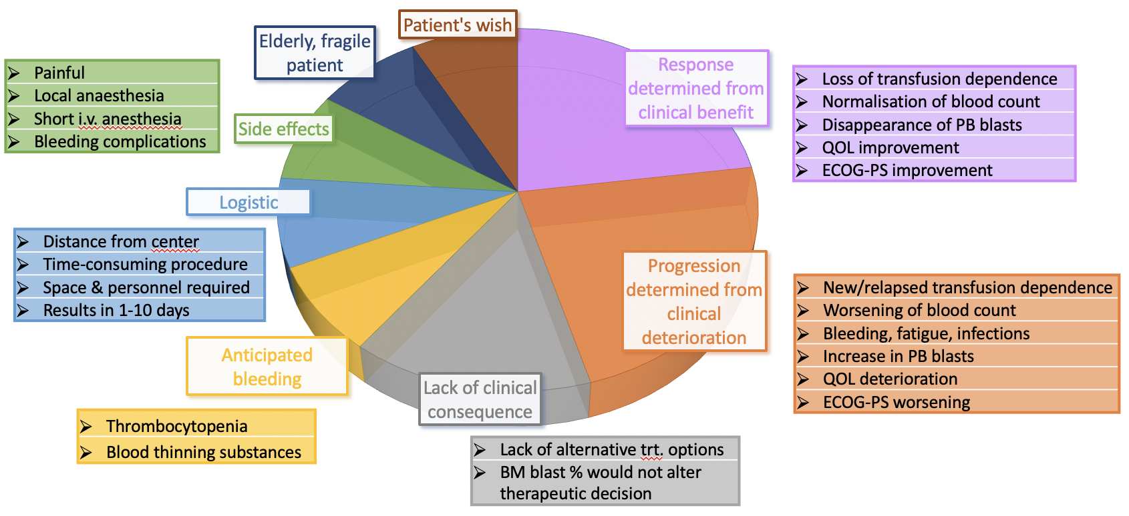

Reasons bone marrow evaluations may not be performed in clinical practice include (i) a lack of clinical consequences (e.g. due to lack of alternative treatment options or due to the fact that BM blast count would not alter therapeutic decisions), (ii) anticipated bleeding complications in thrombocytopenic patients or in patients requiring anticoagulants or antiplatelet drugs, (iii) anticipated side effects (painful procedure that requires local and/or short iv anesthesia), (iv) logistic reasons (e.g. distance from the center, time-consuming procedure that requires space and personnel), (v) elderly, fragile patients may not wish to undergo repetitive bone marrow evaluations, (vi) the fact that response can often be inferred from clinical benefit, e.g. improvement of performance status and quality of life, disappearance of peripheral blood blasts, loss of transfusion dependence, normalization of blood counts, and (vii) vice versa, disease progression can often be determined from clinical deterioration.
Figure S2. Five-fold cross-validation to determine overall model performance.
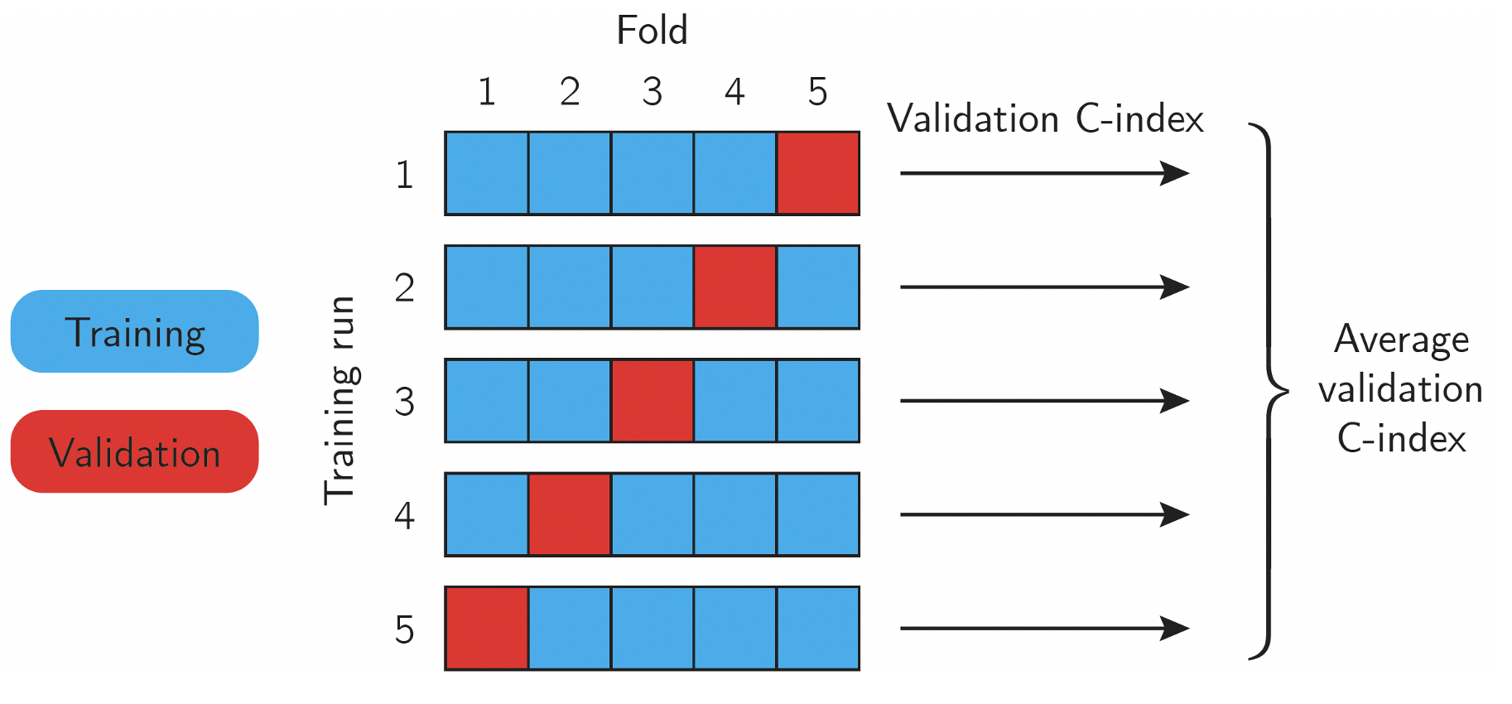

The patient cohort was divided into 5 folds (cohorts) with equal patient numbers. Five training runs were performed (one for each fold), in each of which the model was trained on the four training folds (=training sets; blue boxes) and tested (validated) on the 5th fold (=test set; red box). The overall model performance was then measured as the average validation C-index.

Figure S3. Dense neural network architecture.
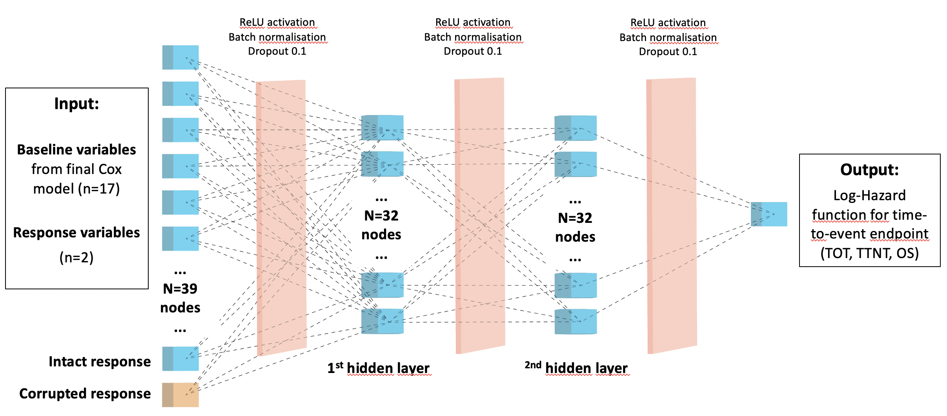
TOT indicates time on treatment; TTNT, time to next treatment; OS, overall survival; ReLu, Rectified Linear Unit.
Two hidden fully connected layers were used, each containing 32 nodes. For all layers, Rectified Linear Unit activation, batch normalisation and a dropout with a rate of 0.1 were applied. The fit was performed with the Adam optimiser and a constant learning rate of 0.1.
We followed the implementation given in the pycox package for Python,³ based on the PyTorch deep learning framework.⁴ In particular, a standard neural network architecture as suggested by Katzmann et al.⁵ was used, with two hidden fully connected dense layers consisting of 32 nodes each were used. For all layers, Rectified Linear Unit activation, batch normalisation and a dropout with a rate of 0.1 were applied. 39 input nodes consisted of the 17 (partially categorized) baseline variables from the final Cox model and two response variables: CR (with or without CRi) and PB-CR. The output was the Log-Hazard function for the time-to-event endpoint.
To assess which of the response types (CR, CR/CRi or PB-CR) has greater predictive value, we used a permutation-based feature importance approach. The permutation feature importance is defined to be the decrease in a model score when the value of a single variable (in our case the response type) is randomly shuffled. This procedure breaks the relationship between the variable and the time-to-event outcome. Therefore, a drop in the model score is indicative of how much the model depends on the variable.
1000 uniformly random permutations of the data indices were generated. For each, two corrupted versions of the data were generated – one, where the CR (or CR/CRi) response column was randomly reshuffled according to the permutation, and one where this was instead applied to the PB-CR response column, thus removing the information content of the respective response type. The DeepSurv model was then fitted to each corrupted dataset, resulting in a total of 60000 model fits across all endpoints. Optimization was performed using the Adam optimiser⁶ with a constant learning rate of 0.1.

Figure S4. Heatmaps. Multivariate-adjusted¹ likelihood ratios of PB-CR and CR or CR/CRi are similar (by endpoint). Comparison with patients with blood counts above IWG-2006 definitions of cytopenia. (A) Time to next treatment. (B) Overall survival.
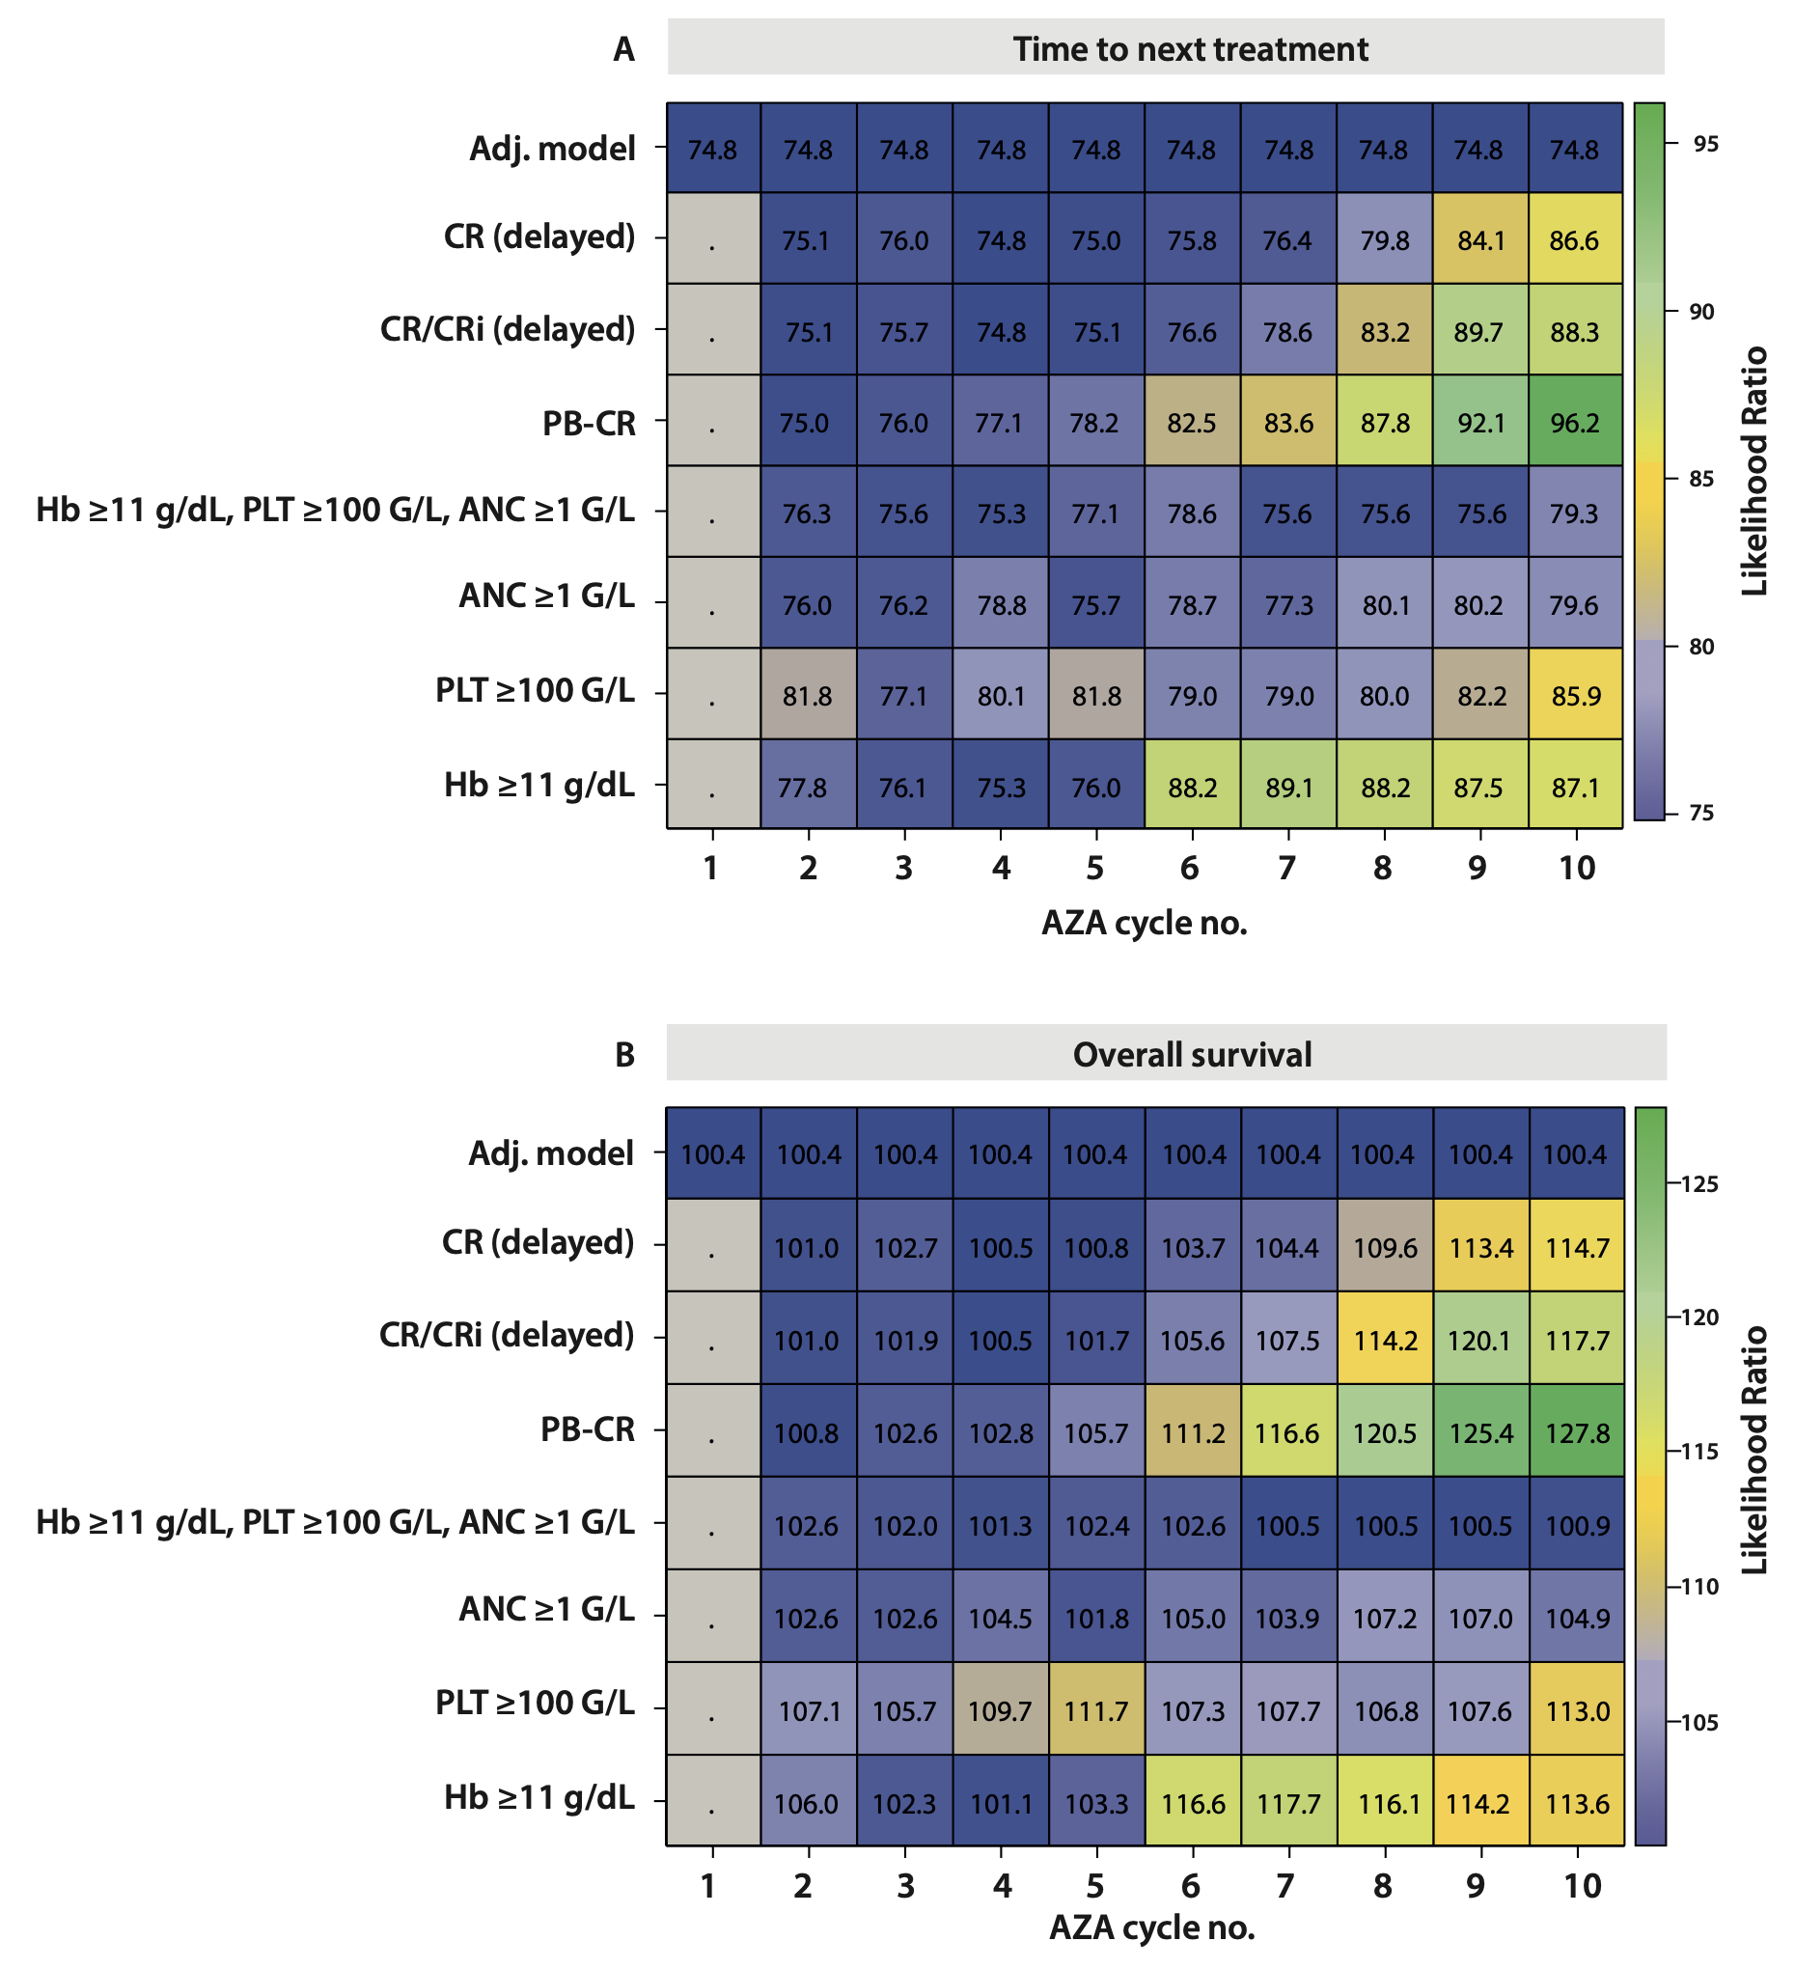
¹Adjusted for all 17 baseline covariates remaining in the final Cox model. Only patients who received ≥10 cycles of azacitidine (approved schedule: 75mg/m² on days 1-7, q=28 days) and for whom all 17 covariates from the final CPH model (Table S17) were available were included (n=436).

Figure S5. Multivariate-adjusted¹ KM-curves by achievement of PB-CR, performance of a BM evaluation, and by endpoint. Analysis restricted to patients in whom a BM evaluation was performed: (A) Endpoint time to next treatment (TTNT). (B) Endpoint overall survival (OS). Analysis restricted to patients in whom a BM evaluation was not performed: (C) Endpoint time to next treatment (TTNT). (D) Endpoint overall survival (OS).
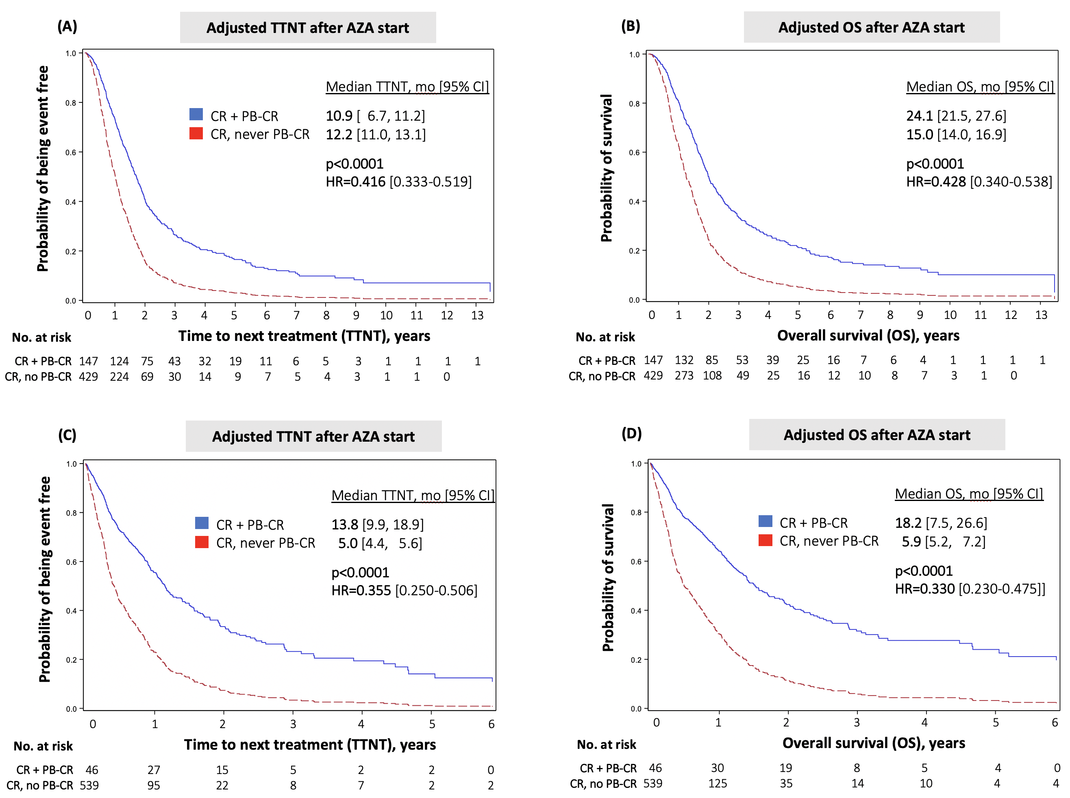
PB-CR indicates peripheral blood complete remission; mo, months.
¹Adjusted for all 17 baseline covariates at azacitidine treatment start remaining in the final CPH model (Table S17). Only patients for whom all 17 covariates were available were included (n=1161), and in whom a BM evaluation was (n=576), or was not performed (n=585) during treatment with azacitidine.

Figure S6. Multivariate-adjusted¹ KM-curves by response type and endpoint. (A) Stratification by CR and PB-CR at any time in patients with a BM evaluation during azacitidine treatment.² Endpoint overall survival (OS). (B) Endpoint time to next treatment (TTNT). (C) Stratification by CR/CRi and PB-CR at any time in patients with a BM evaluation during azacitidine treatment.² Endpoint OS. (D) Endpoint TTNT.
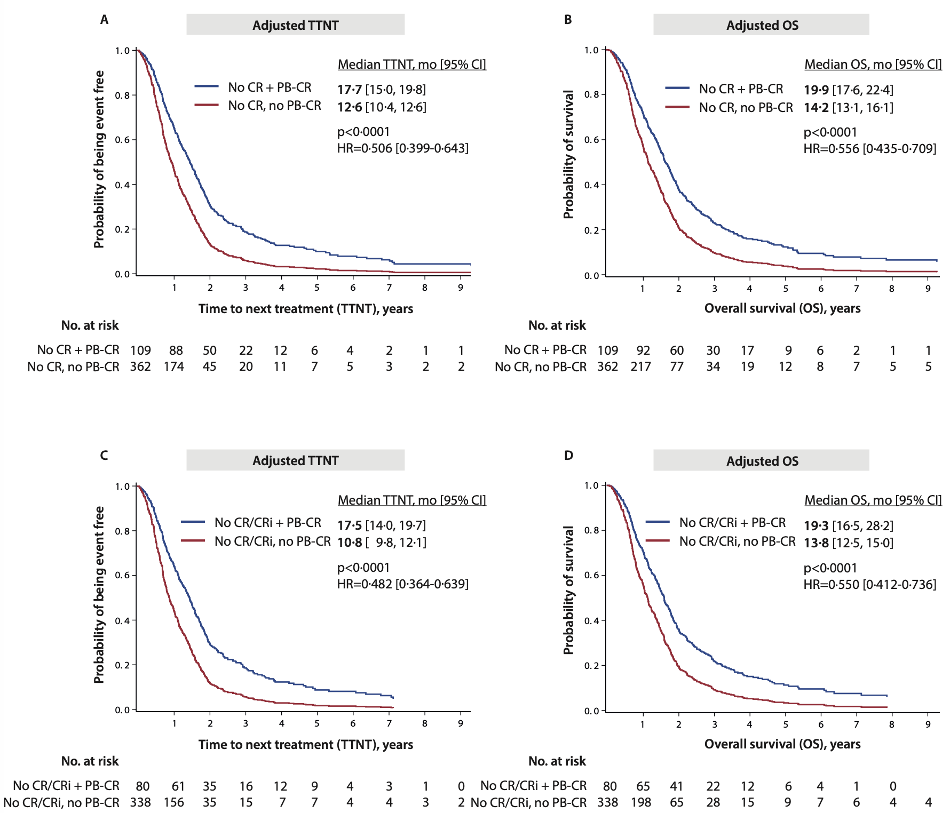

CR indicates complete morphologic remission; CRi, CR with incomplete blood count recovery; PB-CR, peripheral blood complete remission; mo, months.
¹Adjusted for all 17 baseline covariates at azacitidine treatment start remaining in the final CPH model (Table S17). Only patients for whom all 17 covariates were available were included (n=1161). ²Only patients for whom all 17 covariates were available and who had a BM evaluation during treatment with azacitidine and who experienced the respective response type were included.
Figure S7. Violin plots.¹ Permutation-based feature importances of PB-CR and CR/CRi are significantly different by diagnosis at azacitidine start and by endpoint.
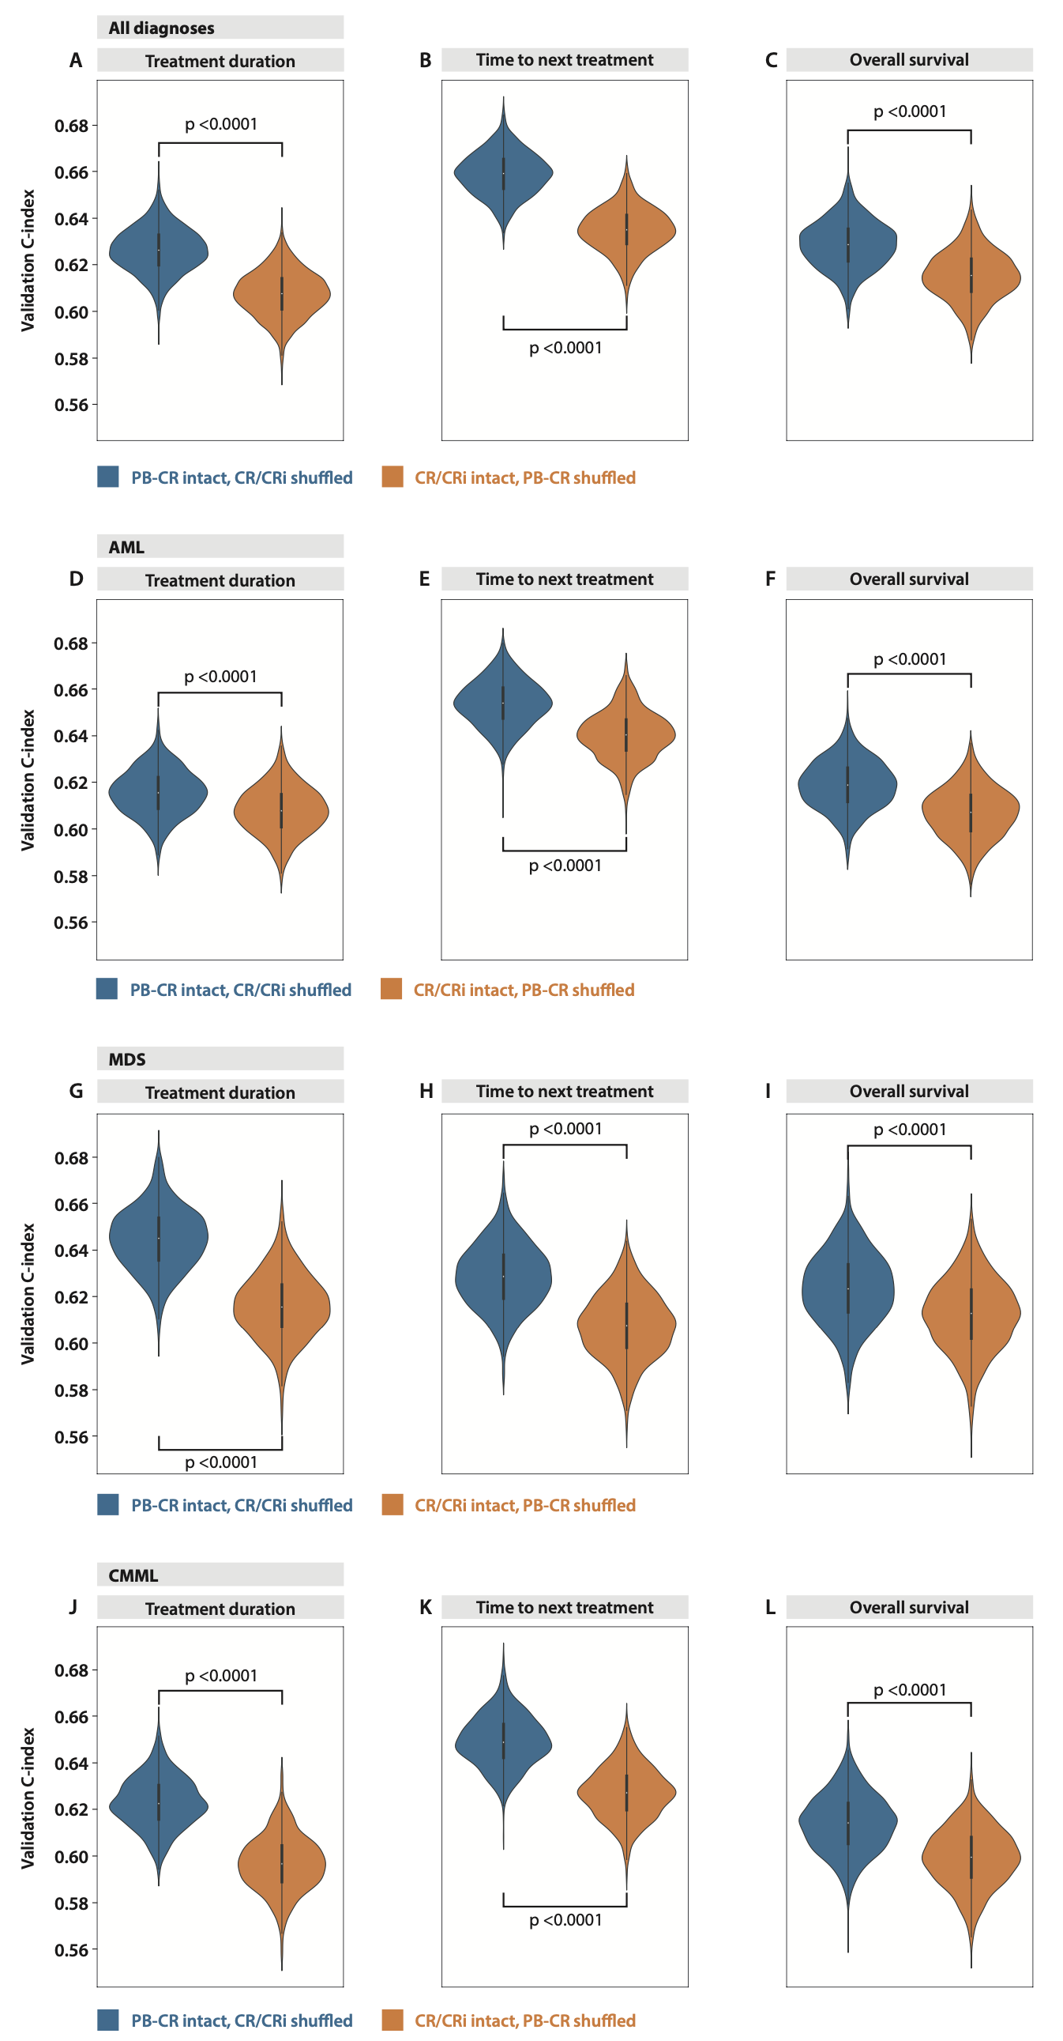

1. Dohner H, Wei AH, Appelbaum FR, et al. Diagnosis and management of AML in adults: 2022 recommendations from an international expert panel on behalf of the ELN. Blood 2022; 140(12): 1345-77.
2. Cheson BD, Greenberg PL, Bennett JM, et al. Clinical application and proposal for modification of the International Working Group (IWG) response criteria in myelodysplasia. Blood 2006; 108(2): 419-25.
3. Kvamme H, Borgan O, Scheel I. Time-to-Event Prediction with Neural Networks and Cox Regression. Journal of Machine Learning Research 2019; 20: 1-30.
4. Paszke A, Gross S, Massa F, et al. PyTorch: An Imperative Style, High-Performance Deep Learning Library. Advances in Neural Information Processing Systems: Curran Associates, Inc.; 2019. p. 8024-35.
5. Katzman JL, Shaham U, Cloninger A, Bates J, Jiang T, Kluger Y. DeepSurv: personalized treatment recommender system using a Cox proportional hazards deep neural network. BMC Med Res Methodol 2018; 18(1): 24.
6. Kingma DB, J. Adam: A Method for Stochastic Optimization. International COnference on learning representations (ICLR) 2015. San Diegao, CA, USA. p. 1-15.

