Figure S1: Genome wide differential expression and differential loops. A. Genes expressing differential expression FDR < 0.05 in Neurons (5,379) and undifferentiated LUHMES (6,455), overlapping region (11,138) was calculated by subtracting all genes with an FDR < 0.05 from the total gene pool that had at least one read count in any sample (22,972). B. Differential loops determined by the lower stringency analysis method described in HiChIP methods.
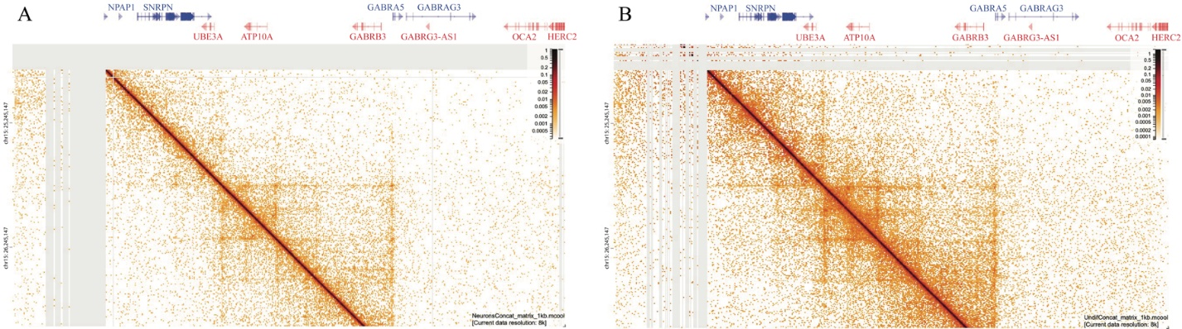

Figure S2: HiChIP contact matrix. HiChIP contact matrix generated using HiGlass(69), gray areas represent regions lacking contact (hg19; chr15:24073444-28488587 vs chr15:24611987-26881716) A. Neurons B. Undifferentiated LUHMES

Figure S3: 4C validates the HiChIP loop anchors exclusive to neurons. Called interaction peaks shown in red (hg19). A. The loop observed from MAGEL2 to SNRPN in the HiChIP data was replicated by an interaction from the SNRPN viewpoint (chr15:25,092,529) to a region which included MAGEL2 (chr15:23,885,650-23,902,345). B. In contrast, from the same viewpoint in undifferentiated LUHMES, a different loop interaction was detected spanning 97,966 bp (chr15:25,318,254-25,332,219). C. PWAR1 viewpoint in neurons (chr15:25,382,560) shows two nearby interactions between the 5’ end of the SNORD115 cluster (chr15:25,411,021-25,514,112) and a region encompassing UBE3A (chr15:25,514,112-25,689,001), validating the PWAR1-UBE3A interaction we saw using the less stringent HiChIP analysis. D. The PWAR1-UBE3A interaction was not present in undifferentiated LUHMES, demonstrating preference for neurons. E. Using a viewpoint centered on the UBE3A promoter (chr15:25,684,119), we confirmed that UBE3A interacted with the PWAR1 region from chr15:25,371,923-25,384,018. F. In contrast, the undifferentiated LUHMES with the same viewpoint interacted with three entirely different regions forming three loops between the SNORD115 cluster (chr15:25,549,549-25,561,569), the 5’ end of UBE3A (chr15:25,562,286-25,583,229), and a third downstream region close to ATP10A from chr15: 25907922-25926082.

Figure S4: LUHMES HiChIP and non-phased methylation profile. Methylation from the positive strand, 2 replicates stacked and shown in different colors for contrast, values representing the sum of their percent methylation (max 200). A combined track stacking 2 neurons and 2 undifferentiated replicates (max 400). ChIP-seq Peaks from ENCODE 3 for CTCF in bipolar neuron and neuronal progenitor (hg19; chr15:23,832,378-25,962,021).

Figure S5: Paternal and maternal DMRs for neurons vs undifferentiated LUHMES. Few DMRs are seen when viewing at a large portion of chr15 comparing the paternal allele in neurons vs the paternal allele in undifferentiated cells as well as comparing the maternal allele in neurons vs the maternal allele in undifferentiated cells (hg19; chr15:20,141,900-95,560,739). We can also view how clustered the paternal vs maternal DMRs are for both cell types in the 15q11-q13 region.

Figure S6: Bioinformatic phasing of HiChIP data. WashU epigenome browser depiction of CTCF HiChIP long-range chromatin interactions bioinformatically phased using heterozygous LUHMES SNPs. HiChIP loops are shown as arches. The height of the loops represents the loop score, with a scale provided for reference, FDR=0.05, all-to-all setting. A. Paternal neuron shows persistence of the neuron exclusive PWAR1-UBE3A chromatin loop. B. Maternal neuron also demonstrates presence of the same loop. C. No PWAR1-UBE3A interaction was seen in the undifferentiated paternal or D. maternal alleles.

