Supplemental Material

Application of the international criteria for optic neuritis in the Acute Optic Neuritis Network

Supplemental figure 1. Overview of included patients from each center.
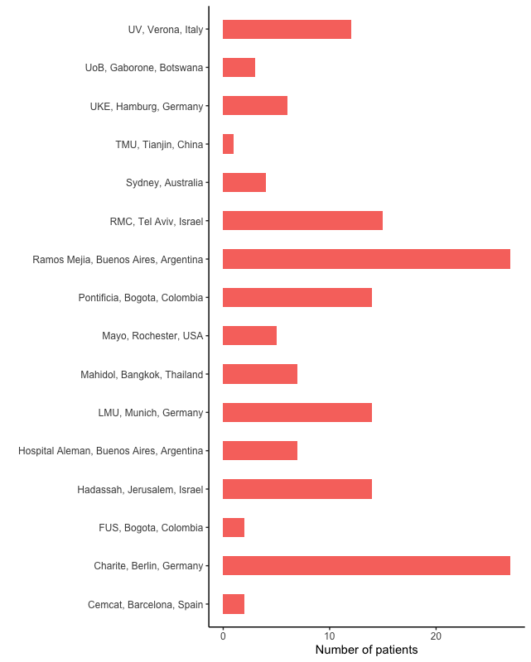
Abbreviations: Cemcat, Centre d’Esclerosi Múltiple de Catalunya; FUS, Fundación Universitaria Sanitas; LMU, Ludwig-Maximilians-Universität; RMC, Rabin Medical Center; TMU, Tianjin Medical University; UKE, Universitätsklinikum Hamburg-Eppendorf; UoB, University of Botswana; UV, University of Verona
Supplemental table 1. Results of CSF analysis across the entire cohort.

 | Overall  N = 160 | SION  N = 78 | MS-ON  N = 41 | NMOSD-ON  N = 15 | MOGAD-ON  N = 26
White blood cell count in cells/μl (mean, SD) | 7.4 (15.6) | 4.2 (4.1) | 10.3 (12.4) | 4.9 (4.7) | 12.2 (31.4)
Total protein in mg/dl (mean, SD) | 74 (129) | 75 (110) | 99 (180) | 36 (36) | 51 (104)
Oligoclonal bands in CSF (present, n (%)) | 49 (42%) | 16 (30%) | 29 (91%) | 1 (10%) | 3 (13%)
Abbreviations: CSF, cerebrospinal fluid; MOGAD, myelin oligodendrocyte glycoprotein antibody-associated disease; MS, multiple sclerosis; NMOSD, neuromyelitis optica spectrum disease; OCB, oligoclonal bands; SD, standard deviation; SION, single isolated optic neuritis

