**Supporting Information (SI)**

**Modulating the mucosal drug delivery efficiency of polymeric nanogels by tuning their redox response and surface charge**

Jakes Udabe1, Amanda Muñoz2, Belal Tafech3, Maria Soledad Orellano1, Sarah Hedtrich3,4, Anna Laromaine2, Marcelo Calderón1,5*

1POLYMAT, Applied Chemistry Department, Faculty of Chemistry, University of the Basque Country UPV/EHU. Paseo Manuel de Lardizabal 3, 20018, Donostia - San Sebastián, Spain. 2Institut de Ciència de Materials de Barcelona, ICMAB-CSIC, Campus UAB, 08193 Bellaterra, Spain. 3 University of British Columbia, Faculty of Pharmaceutical Sciences, 2405 Wesbrook Mall, Vancouver V6T1Z3, BC, Canada. 4 Berlin Institute of Health @ Charité Universitätsmedizin, Lindenberger Weg 80, 13125 Berlin, Germany. 5IKERBASQUE, Basque Foundation for Science, Plaza Euskadi 5, 48009, Bilbao, Spain.

**INDEX**

**Scheme S1**. Synthesis of NGs 3

**Scheme S2.** Rhodamine B labeling of the NGs. 3

**Table S1.** Hydrodynamic diameter measured by DLS (intensity distribution), polydispersity index (PDI), surface zeta potential, cloud-point temperature measured by turbidity, reaction yield, and Rhodamine B labeled NG characterization4

**Table S2.** Hydrodynamic diameter measured by DLS (intensity distribution), PDI, and surface zeta potential of the initial NGs, and NGs incubated with mucin. All samples were measured in ultra-pure water4

**Table S3.** Encapsulation efficiency, loading capacity, and release under refrigerated storage conditions 4

**Table S4.** Values of the regression of the cumulative drug release 5

**Table S5.** Experimental details of the synthesis of the 5 different NGs5

**Table S6.** Diameter of nanogels when no stimulus is applied and with 10 mM GSH applied over 1 week measured in SEM5

**Table S7.** Summary table of various characterizations assessing the effects of redox-responsiveness and charge effects6

**Figure S1.** Stability characterization of nanogels7

**Figure S2.** Reaction kinetics measured by 1H-NMR of p(NIPAM-HEMA) (BIS)8

**Figure S3.** Reaction kinetics measured by 1H-NMR of p(NIPAM-HEMA-DMAEMA)(BIS) (+)8

**Figure S4.** Reaction kinetics measured by 1H-NMR of p(NIPAM-HEMA-AMPS)(BIS) (-)9

**Figure S5.** Reaction kinetics measured by 1H-NMR of p(NIPAM-(S-S)-HEMA)(BIS:BAC)9

**Figure S6.** Reaction kinetics measured by 1H-NMR of p(NIPAM-(S-S)-HEMA)(BAC).10

**Figure S7**. 1H-NMR spectra of the NGs11

**Figure S8**. FTIR spectra of the prepared NGs11

**Figure S9.** SEM micrographs of the NGs. 12

**Figure S10**. AFM micrographs of the NGs12

**Figure S11**. Hydrodynamic diameter determined by DLS (intensity distribution) of NGs incubated in 0 mM, 0.5 mM, 5 mM, and 10 mM of GSH measured after 2 h, 24 h, and 1 week13

**Figure S12.** Degradation behavior of redox-responsive nanogels.13

**Figure S13.** Retention time measured in GPC of of NGs incubated in 0 mM, 0.5 mM, 5 mM, and 10 mM of GSH measured after 2 h, 24 h, and 1 week14

**Figure S14.** NGs release studies of BSA-FITC measured at (1) 37 °C, (2) 37ºC + 0.5 mM GSH (3) 37 °C + 5 mM GSH, (4) 37 °C + 10 mM GSH, (5) RT (6) RT + 0.5 mM GSH, (7) RT + 5 mM GSH, (8) RT + 10 mM GSH15

**Figure S15**. Mucus penetration assessment of Rhodamine B-labelled NGs loaded with BSA-FITC through a mucosal layer of mucus isolated from bovine small intestine.16

**Figure S16**. Optical microscope of *C. elegans* after 24h of exposure towards 17

**Figure S17**. Anatomy of the intestinal tail of the worm.18

**Figure S18**. Mean Read fluorescence intensity of A) NGs that have crossed the intestinal barrier and B) those retained in the intestinal lumen. Data represents mean ± SEM18

**Figure S19**. A) Volume and B) Area of extraintestinal vesicles19

**Figure S20**. Excretion of NGs. 19



**Scheme S1**. Synthesis of (A) p(NIPAM-HEMA)(BIS), (B) p(NIPAM-HEMA-DMAEMA)(BIS)(+), (C) p(NIPAM-HEMA-AMPS)(BIS)(-), (D) p(NIPAM-(S-S)-HEMA)(BIS:BAC), (E) p(NIPAM-(S-S)-HEMA)(BAC). Where 'APS' indicates ammonium persulfate, 'TEMED' refers to tetrametiletilendiamina, and 'SDS' stands for sodium dodecyl sulfate.

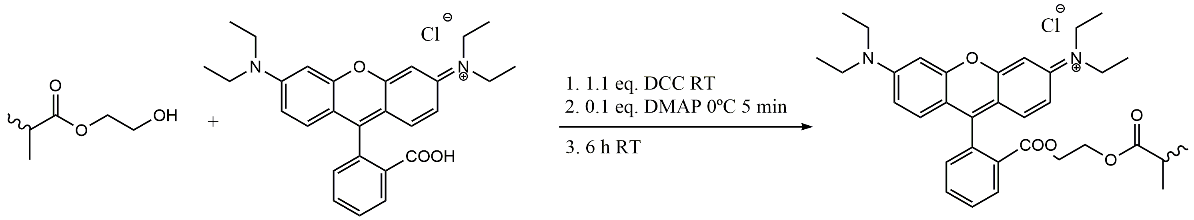

**Scheme S2.** Rhodamine B labeling of the NGs. Where “DCC” refers to N,N'-diciclohexilcarbodiimida and “DMAP” to 4-Dimethylaminopyridine.

**Table S1.** Hydrodynamic diameter measured by DLS (intensity distribution), polydispersity index (PDI), surface zeta potential, cloud-point temperature measured by turbidity, reaction yield, and Rhodamine B labeled NG characterization. All data is presented by mean ± SD (n=3). All samples were measured in ultra-pure water. Surface zeta potential was measured in 10 mM PBS pH 7.4 solution.

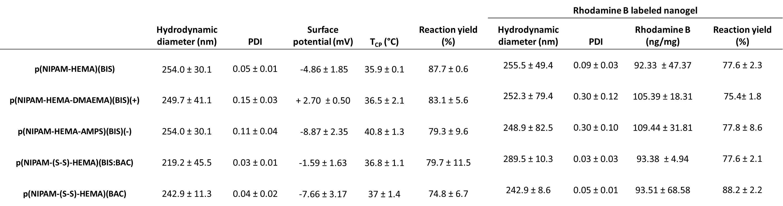

**Table S2.** Hydrodynamic diameter measured by DLS (intensity distribution), PDI, and surface zeta potential of the initial NGs, and NGs incubated with mucin. All samples were measured in ultra-pure water. Surface zeta potential was measured in 10 mM PBS pH 7.4 solution.

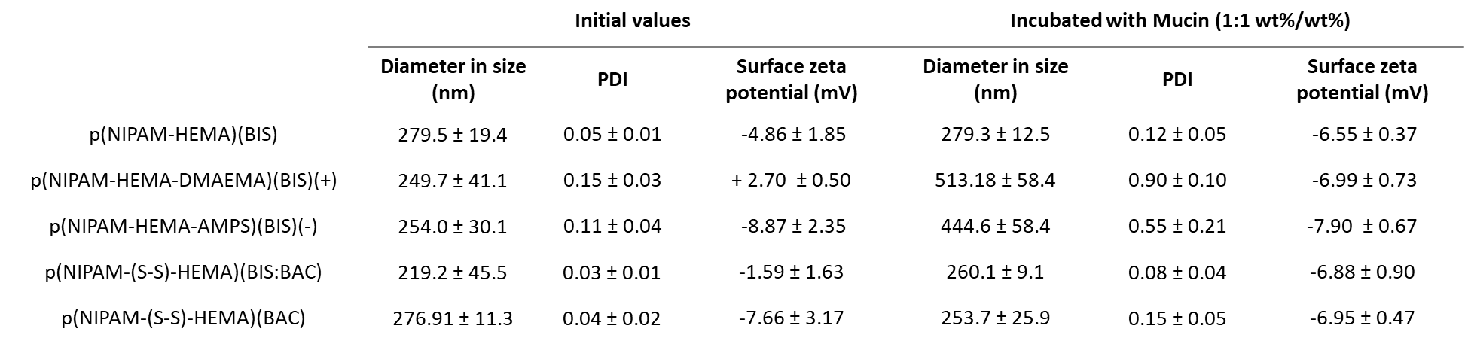

**Table S3.** Encapsulation efficiency, loading capacity, and release under refrigerated storage conditions of BSA-FITC in wt%.

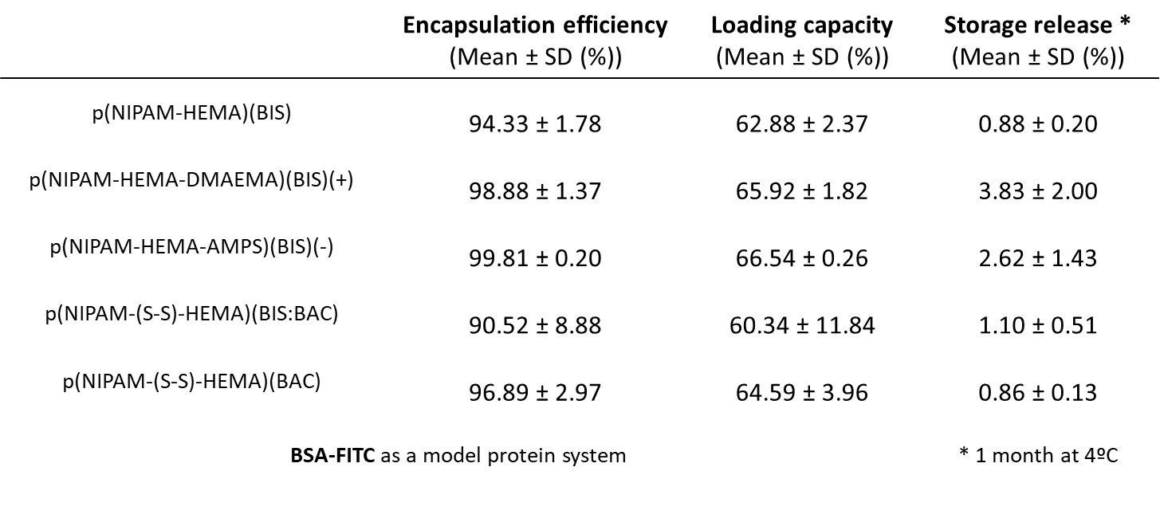

**Table S4.** Values of the regression of the cumulative drug release curve adjusted fitted in different theoretical models are shown.

|  |  |  |  |  |
| --- | --- | --- | --- | --- |
| **Model/equation** | **5 mM p(NIPAM-(S-S)-HEMA)(BIS:BAC)** | **10 mM p(NIPAM-(S-S)-HEMA)(BIS:BAC)** | **5 mM p(NIPAM-(S-S)-HEMA)(BAC)** | **10 mM p(NIPAM-(S-S)-HEMA)(BAC)** |
| Zero Order | 0.9843 | **0.996** | 0.9858 | **0.9762** |
| First Order | 0.9207 | 0.8952 | 0.9618 | 0.7792 |
| Hixson and Crowell | 0.9964 | 0.9032 | 0.9849 | 0.6977 |
| Baker and Lonsdale | 0.9673 | 0.7235 | **0.9955** | 0.8274 |
| Higuchi | **0.9998** | 0.7766 | 0.9419 | 0.6667 |

**Table S5.** Experimental details of the synthesis of the 5 different NGs.

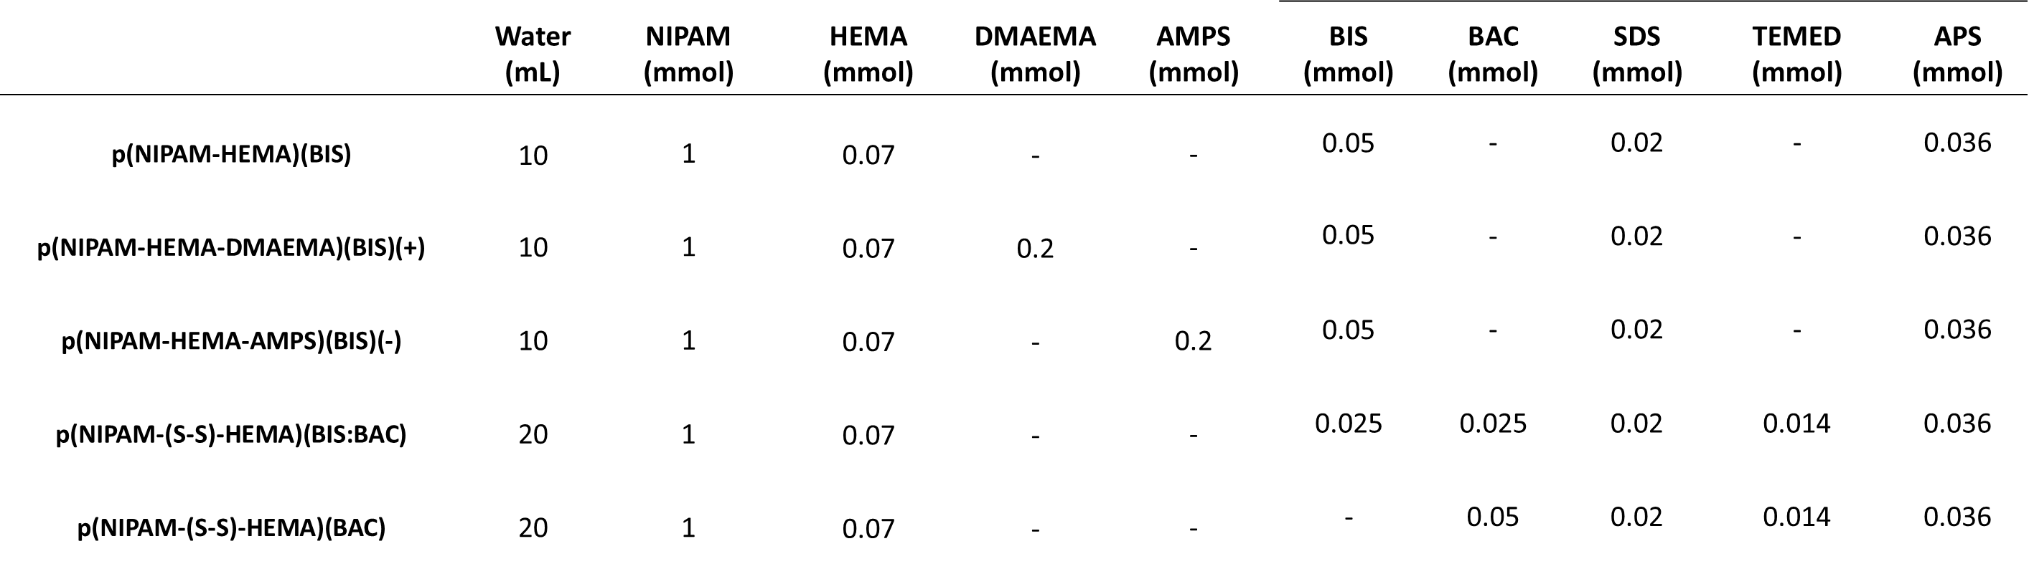

**Table S6.** Diameter (nm, Mean ± SD) of nanogels when no stimulus is applied and with 10 mM GSH applied over 1 week measured in SEM (n = 30).

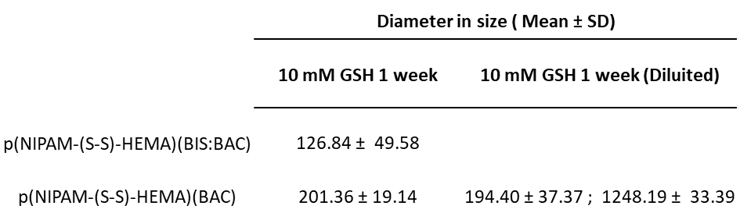

**Table S7.** Summary table of various characterizations assessing the effects of redox-responsiveness and charge effects.

|  |  |  |
| --- | --- | --- |
| **NGs’ interaction with mucosal barrier** | | |
| **Experimental model** | **Redox-Response Effect** | **Charge Effect** |
| Bioadhesive Force | Redox-responsive nanogels increase bond strength | No significant differences |
| Transwell Assay | No significant differences | No significant differences |
| Median Diffusion Mobility Assay | Redox-responsive nanogels move faster in mucus containing GSH | No significant differences |
| Cell Viability and Cellular Uptake | Redox-responsive nanoparticles enhance cellular uptake | Positively charged nanoparticles reduce cell viability; nanogels enhance cellular uptake |
|  | | |
| **Effect of the protein release in mucosal barrier** | | |
| **Experimental model** | **Redox-Response Effect** | **Charge Effect** |
| *In vitro* Release Study | Redox-responsive nanoparticles improve release in GSH conditions; increasing GSH concentration enhances release | No significant differences |
| *Ex vivo* Study using Small Intestine | Redox-responsive nanoparticles enhance BSA-FITC penetration depth in *ex vivo* mucus | Positively charged nanoparticles enhance interaction with mucosal barrier, thereby enhancing protein permeation |
| *In vivo* Study using C. elegans | Redox-responsive nanoparticles enhance release over *C. elegans* | Positively charged nanoparticles reduce cell viability; |



**Figure S1.** Stability characterization of nanogels using DLS across physiological and C.elegans-Relevant Media (N=3). M9 is a replicate of C. elegans growing media; it is a solution containing 0.3 wt.% KH2PO4, 0.6 wt.% Na2HPO4, 0.5 wt.% NaCl, and 0.1 wt.% MgSO4.

The stability of the nanogels was measured using Dynamic Light Scattering by assessing the polydispersity and the hydrodynamic size of the nanoparticles at different times over the course of a week. Measurements were taken in two relevant media: a physiological medium used in most of the studies in this work (PBS pH 7.4, 10 mM) and a medium relevant for the assays with *C. elegans* (M9). It was observed that the hydrodynamic size and polydispersity barely varied throughout the week in either medium, indicating that the nanogels are stable in these environments.

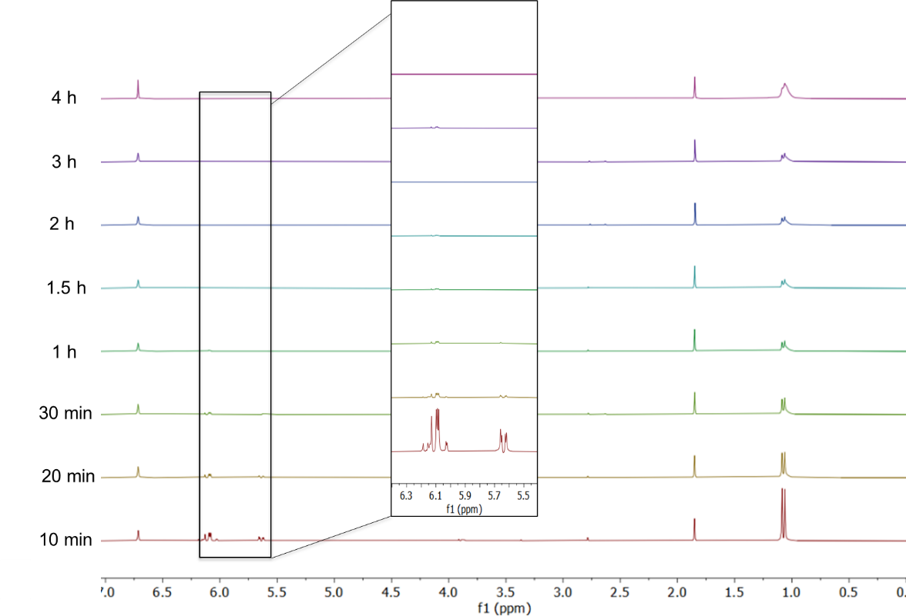

**Figure S2.** Reaction kinetics measured by 1H-NMR of p(NIPAM-HEMA) (BIS). The zoom has been done at 5.5-6.5 ppm, indicative of the acrylic reactive group of the monomers.

C:\Users\polymat\AppData\Local\Microsoft\Windows\INetCache\Content.Word\DMAEMA HNMR.tif

**Figure S3.** Reaction kinetics measured by 1H-NMR of p(NIPAM-HEMA-DMAEMA)(BIS) (+). The zoom has been done at 5.5-6.5 ppm, indicative of the acrylic reactive group of the monomers.

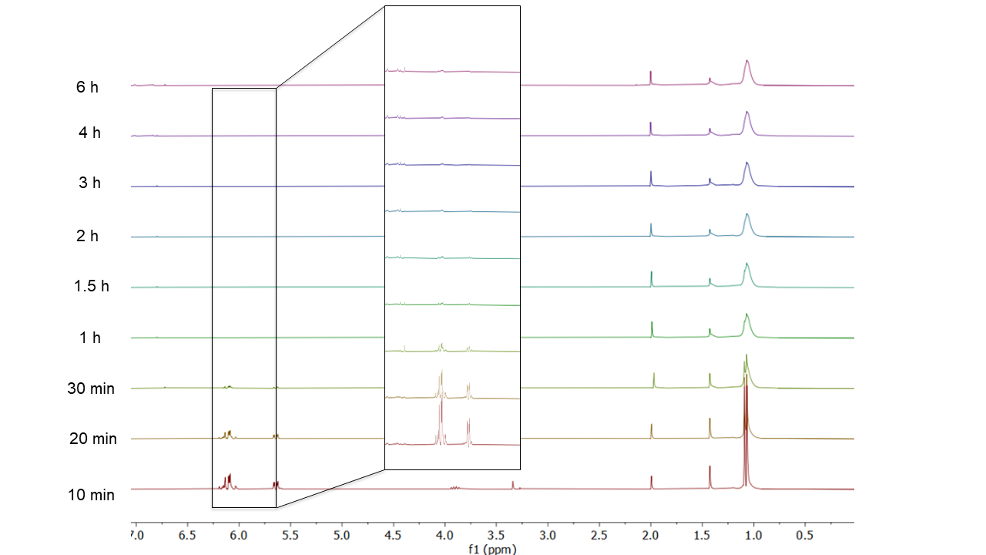

**Figure S4.** Reaction kinetics measured by 1H-NMR of p(NIPAM-HEMA-AMPS)(BIS) (-). The zoom has been done at 5.5-6.5 ppm, indicative of the acrylic reactive group of the monomers.

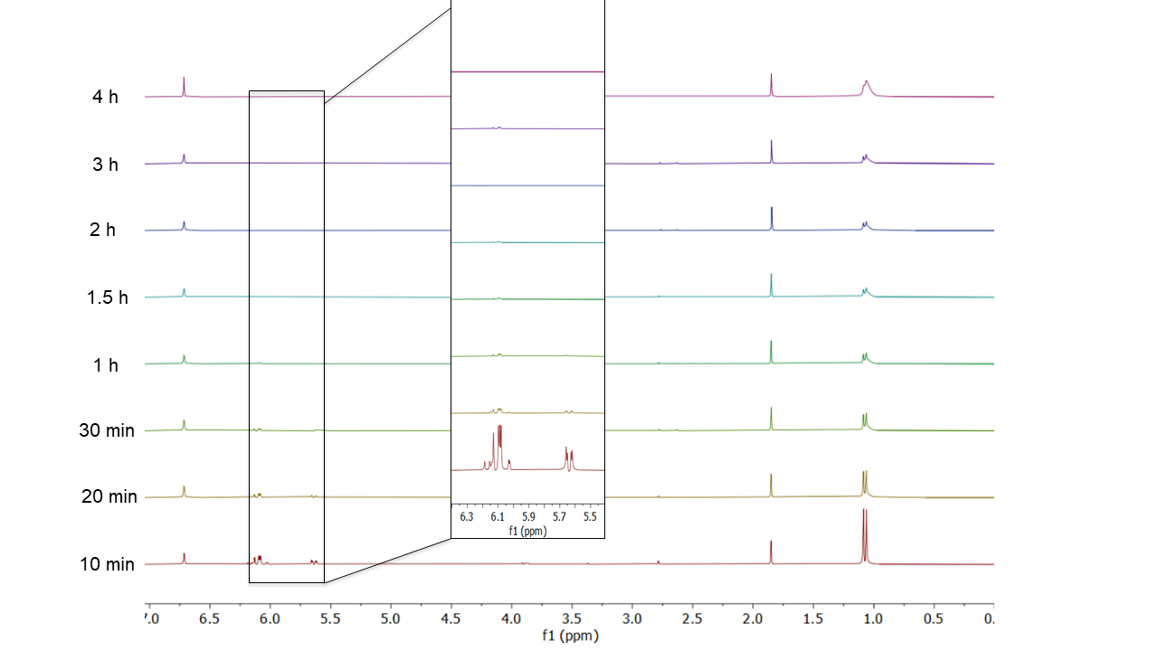

**Figure S5.** Reaction kinetics measured by 1H-NMR of p(NIPAM-(S-S)-HEMA)(BIS:BAC). The zoom has been done at 5.5-6.5 ppm, indicative of the acrylic reactive group of the monomers.

C:\Users\polymat\AppData\Local\Microsoft\Windows\INetCache\Content.Word\BAC HNMR.tif

**Figure S6.** Reaction kinetics measured by 1H-NMR of p(NIPAM-(S-S)-HEMA)(BAC). The zoom has been done at 5.5-6.5 ppm, indicative of the acrylic reactive group of the monomers.

The reaction kinetics was characterized by 1H-NMR observing the disappearance of the acryl signals at δ = 6.10 ppm. For that, 1 mL-aliquot of the reaction mixture was taken at certain time points, and then 100 µL of HQ (1 wt.%) and 200 µL of NaAc (0.05 wt.%) were added. Finally, the samples were characterized by 1H-NMR dissolving the solution in a ratio of 90:10 Sample:D2O (v./v. %). The reaction yielding was determined by gravimetric measurement.

In **Figures S1-5** (SI) it is observed that the reactions of all NGs are approximately 2 h except for p(NIPAM-HEMA-DMAEMA)(BIS)(+) and p(NIPAM-(S-S)-HEMA)(BAC). The NG copolymerized with DMAEMA has a slower kinetics, probably due to the fact that the addition of this monomer is done 1 h after the reaction has started or due to the slower kinetics that this monomer presents. On the other hand, the NG totally crosslinked with BAC has one of the slowest kinetics. It is expected that due to this kinetics the crosslinker and its disulfide bridges are presented more on the surface of the NG.

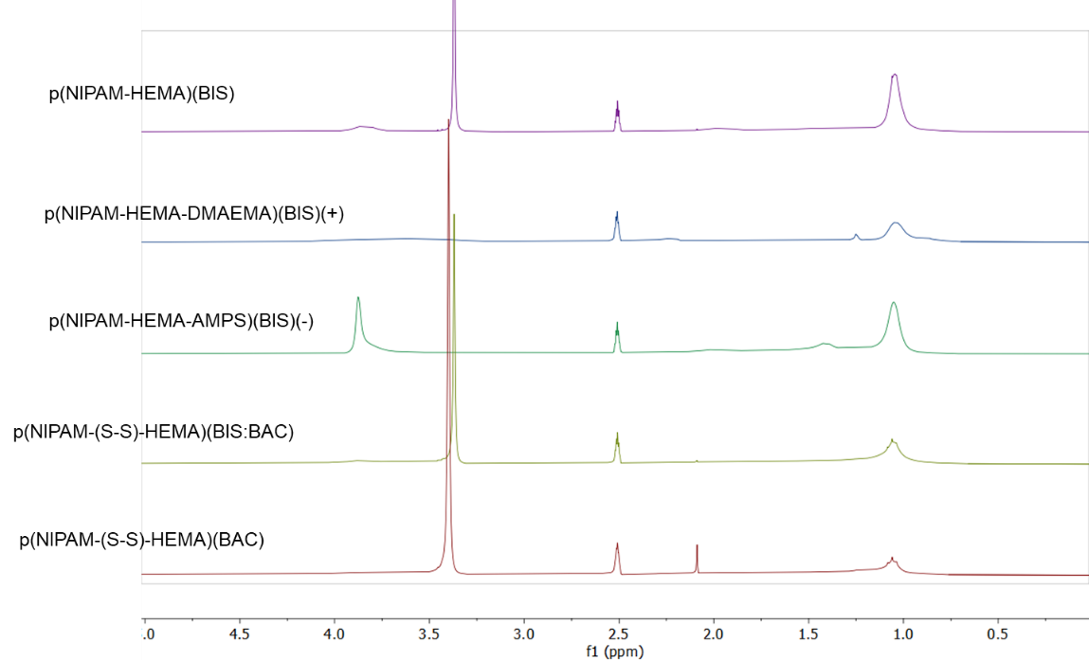

**Figure S7**. 1H-NMR spectra of the NGs.

The 1H-NMR spectra of the NGs are presented in **Figure S9.** It confirms the chemical structure of the prepared materials. For these NGs, the characteristic signals are as follows: δ = 0.78 - 1.25 ppm (–CH2, a, polymer chain); δ = 2.24 ppm (–CH2-NH–); δ = 3.46 ppm (–CH2-OH); δ = 3.80 ppm (–NH–).

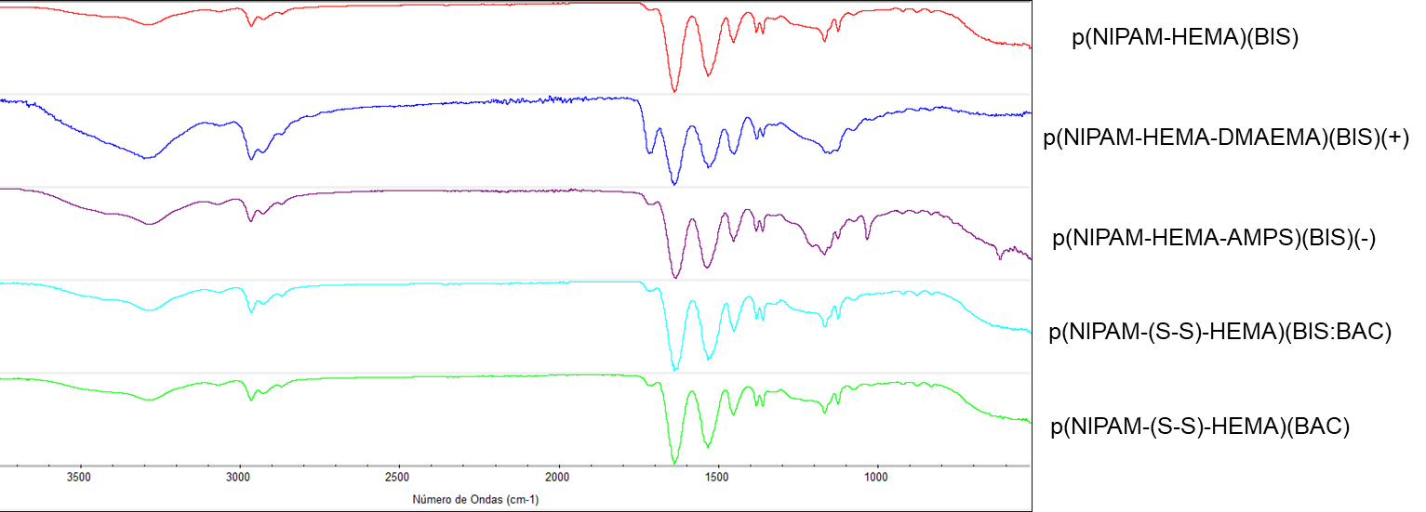

**Figure S8**. FTIR spectra of the prepared NGs.

The FTIR spectra of the NGs are presented in **Figure S10.** The following functional groups can be observed: v = 3550-3200 cm-1 (O-H stretching; N-H stretching); v = 2349 cm-1 (O=C=O stretching, p(NIPAM-HEMA-DMAEMA)(BIS) (+) is more prominent as expected due to the higher acrylic content coming from DMAEMA); v = 2275-2250 cm-1 (N=C=O stretching); v = 1250-1020 cm-1 (N-C bending).

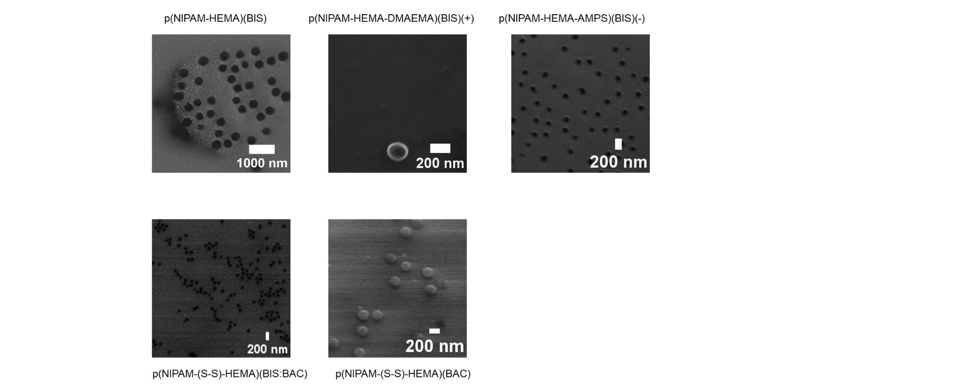

**Figure S9.** SEM micrographs of the NGs.

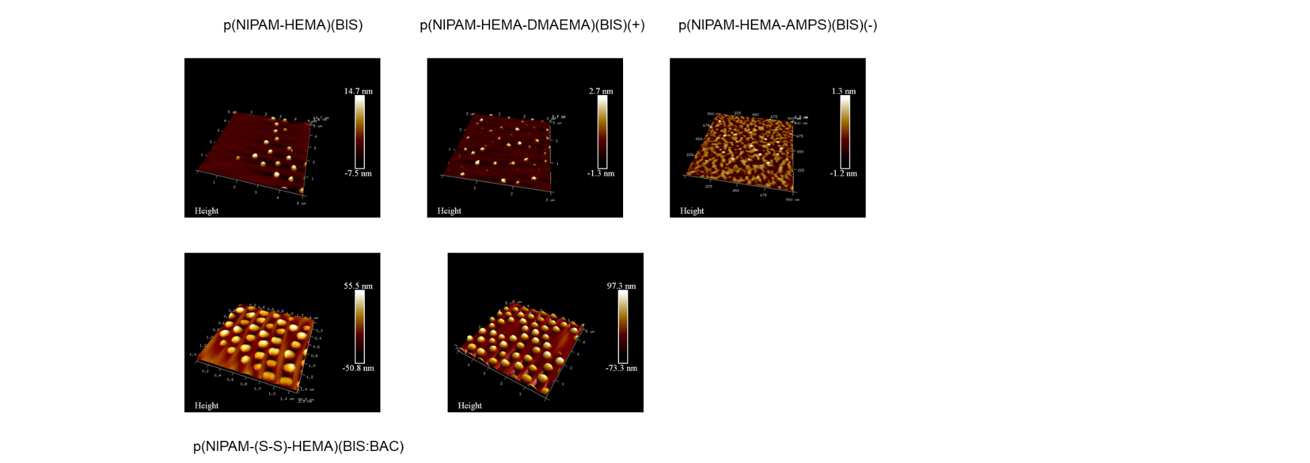

**Figure S10**. AFM micrographs of the NGs.



**Figure S11**. Hydrodynamic diameter determined by DLS (intensity distribution) of NGs incubated in 0 mM, 0.5 mM, 5 mM, and 10 mM of GSH measured after 2 h, 24 h, and 1 week.



**Figure S12.** Degradation behavior of redox-responsive nanogels. Raman spectroscopy with/without 10 mM tris(2-carboxyethyl)phosphine (TCEP) treatment.

|  |  |
| --- | --- |
|  | **Figure S13.** Retention time measured in GPC of of NGs incubated in 0 mM, 0.5 mM, 5 mM, and 10 mM of GSH measured after 2 h, 24 h, and 1 week. |

|  |
| --- |
| **Figure S14.** NGs release studies of BSA-FITC measured at (1) 37 °C, (2) 37ºC + 0.5 mM GSH (3) 37 °C + 5 mM GSH, (4) 37 °C + 10 mM GSH, (5) RT (6) RT + 0.5 mM GSH, (7) RT + 5 mM GSH, (8) RT + 10 mM GSH. |



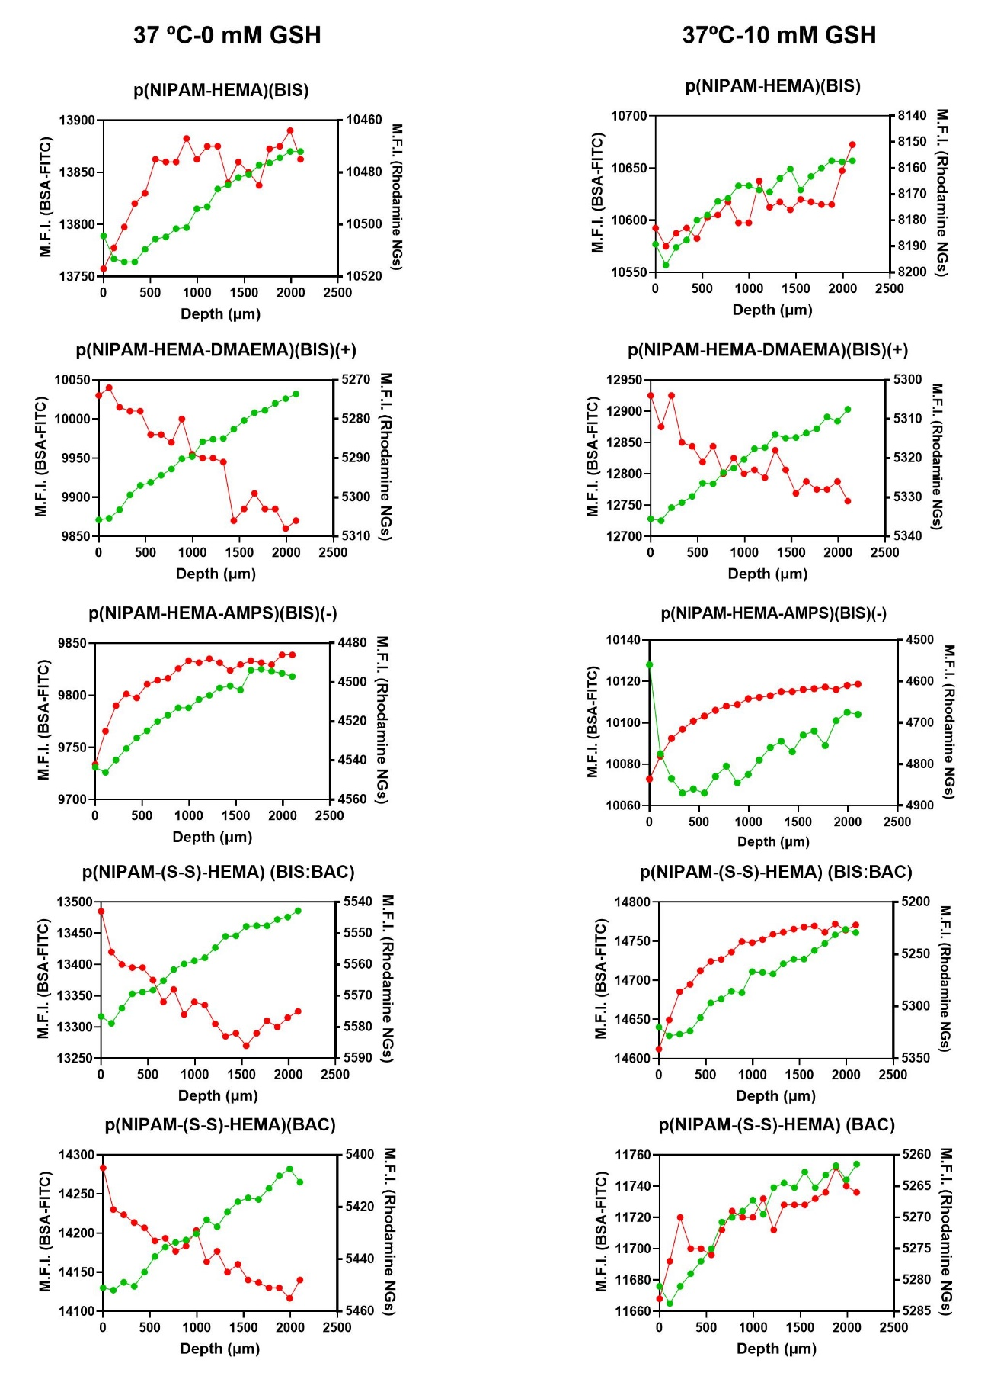

**Figure S15**. Mucus penetration assessment of Rhodamine B-labelled NGs loaded with BSA-FITC through a mucosal layer of mucus isolated from bovine small intestine. The mean fluorescence intensity (M.F.I.) of green and red channels of each xy plane was quantified at different z depths and plotted as of z-axis profile using ImageJ software. The green fluorescence intensity is comparable in all the samples since it is the same cargo for all the formulations, meanwhile, the red fluorescence intensity is only comparable within the two conditions for the same sample since the NG samples have different intensities of labeling.

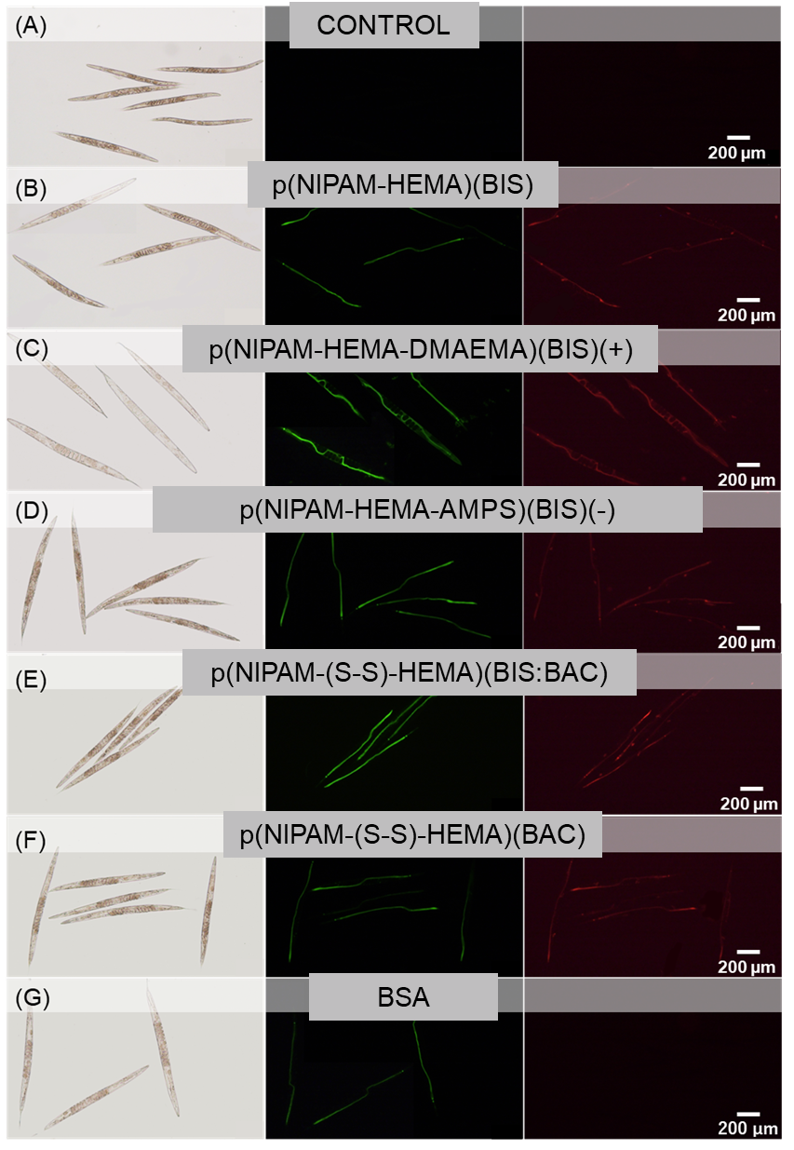

**Figure S16**. Optical microscope of *C. elegans* after 24h of exposure towards A) control, B) p(NIPAM-HEMA)(BIS), C) p(NIPAM-HEMA-DMAEMA)(BIS) (+), D) p(NIPAM-HEMA-AMPs)(BIS) (-), E) p(NIPAM-(S-S)-HEMA)(BIS:BAC), F) p(NIPAM-(S-S)-HEMA)(BAC). G) We also treated worms with free BSA as a control. Optical, green fluorescence channel, and red fluorescence image of each condition.

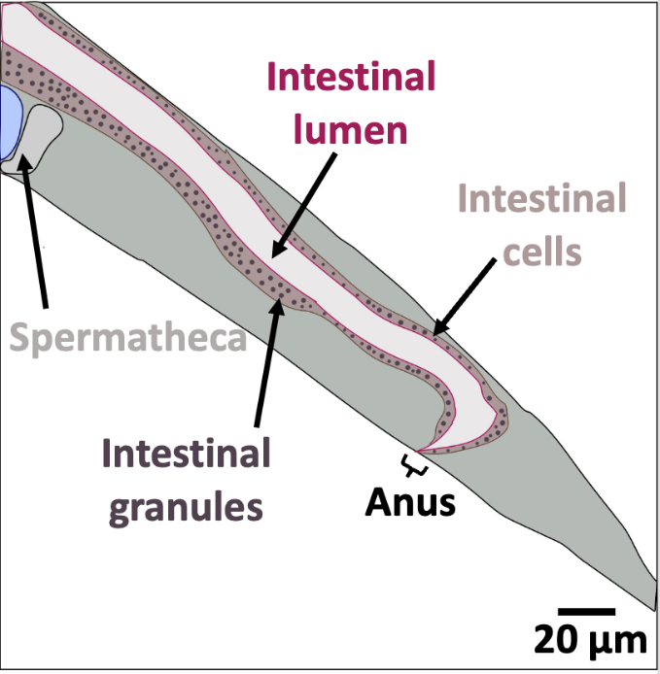

**Figure S17**. Anatomy of the intestinal tail of the worm. The image highlights the intestinal lumen where nanogels are if they do not translocate the intestinal barrier. The intestinal granules inside intestinal cells can accumulate substances from the intestinal lumen or contain enzymes to finish digestion. Then it shows the anus, through which material is excreted.

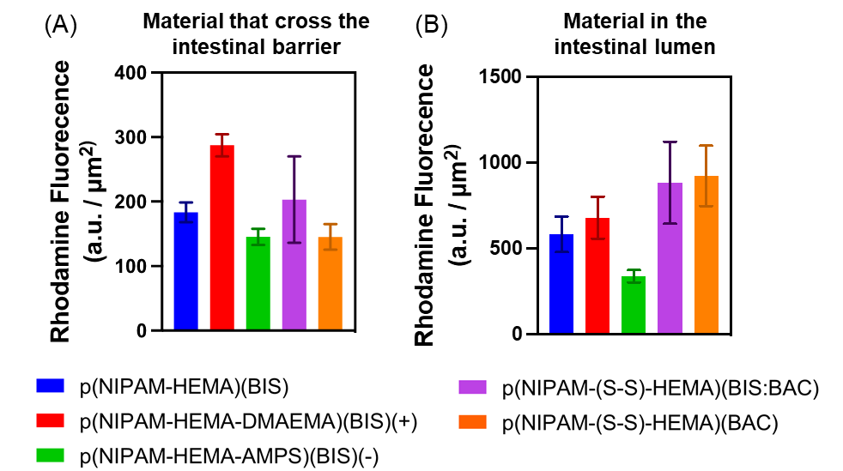

**Figure S18**. Mean Read fluorescence intensity of A) NGs that have crossed the intestinal barrier and B) those retained in the intestinal lumen. Data represents mean ± SEM.

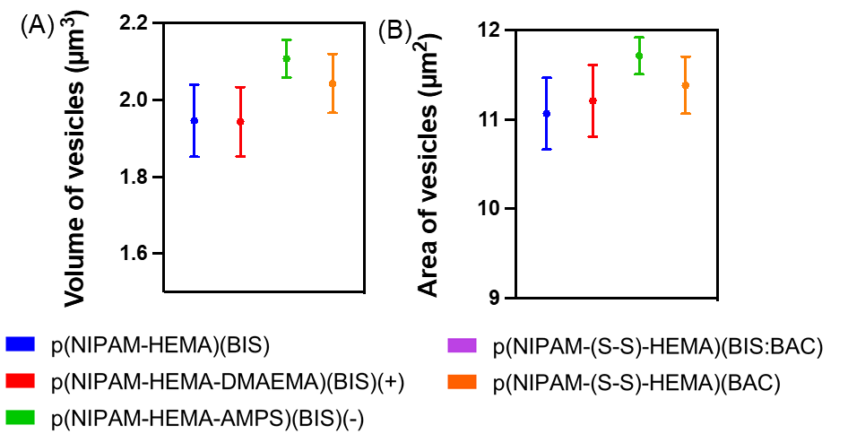

**Figure S19**. A) Volume and B) Area of extraintestinal vesicles.

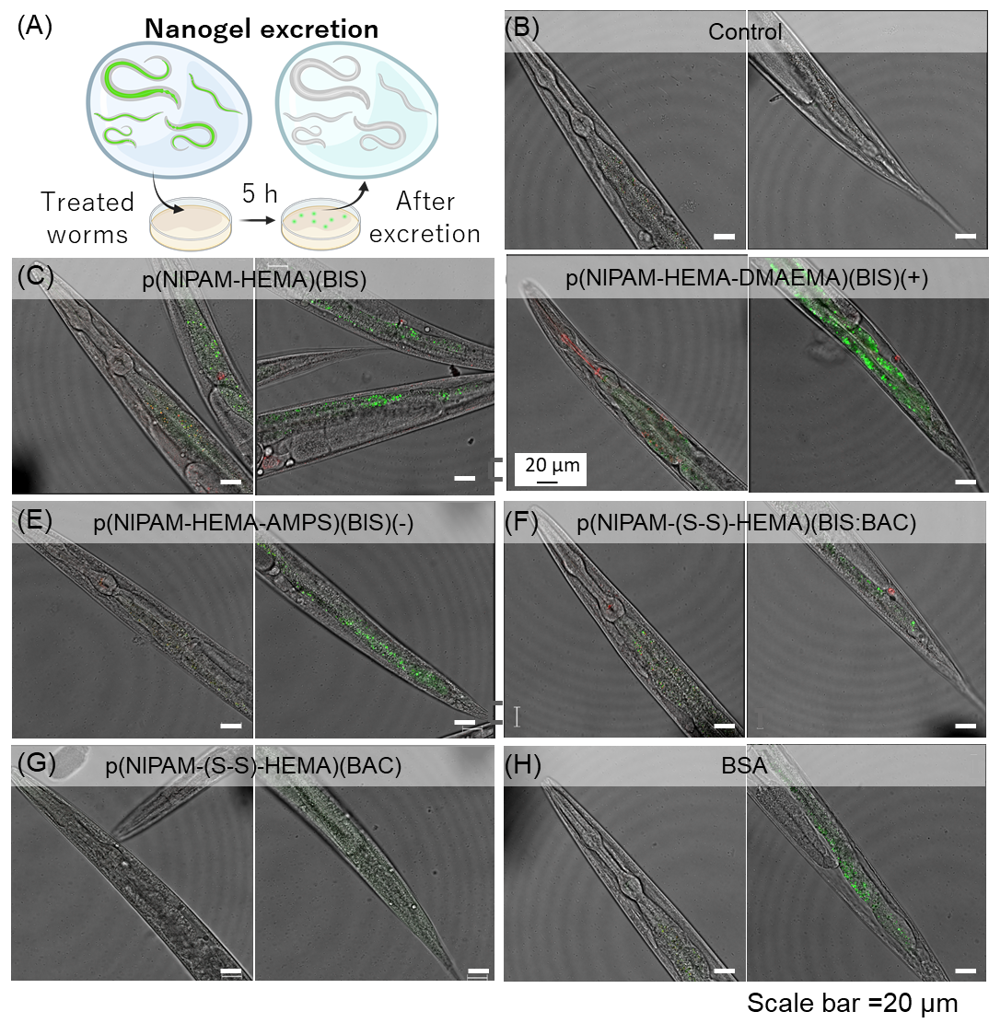

**Figure S20**. Excretion of NGs. A) Experimental procedure. 24h-treated worms were transferred to fresh OP50 plates for 5h and then were anesthetized and imaged with a confocal microscope. Head and tail of B) control, C) p(NIPAM-HEMA)(BIS), D) p(NIPAM-HEMA-DEMAEM)(BIS) (+), E) p(NIPAM-HEMA-AMPs)(BIS) (-), F) p(NIPAM-(S-S)-HEMA)(BIS:BAC), G) p(NIPAM-(S-S)-HEMA)(BAC) and H) BSA-FICTC.